Command to create raw disk 20G - qemu-img create -f raw disk_raw.img 20G

Command to create qcow2 image - qemu-img create -f qcow2 disk_qcow2.img 20G

qemu-img create -f raw disk_raw.img 20G

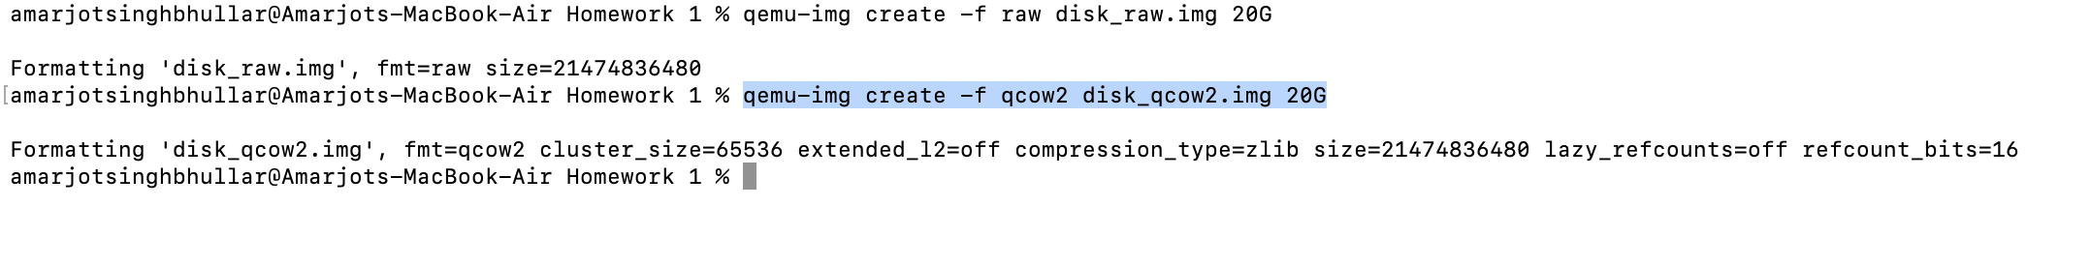

Install Ubuntu in qcow2 disk command –

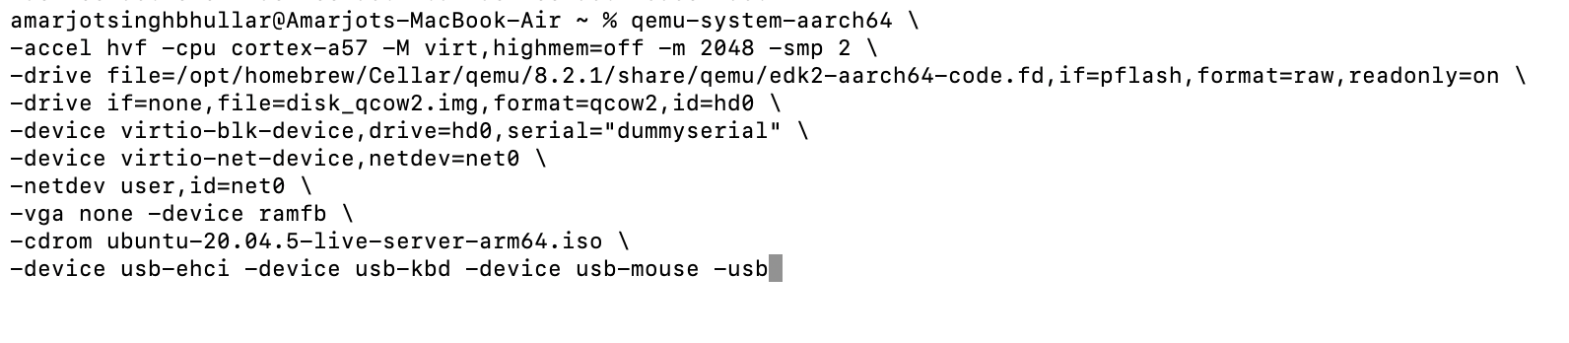

Install Ubuntu in raw disk command –

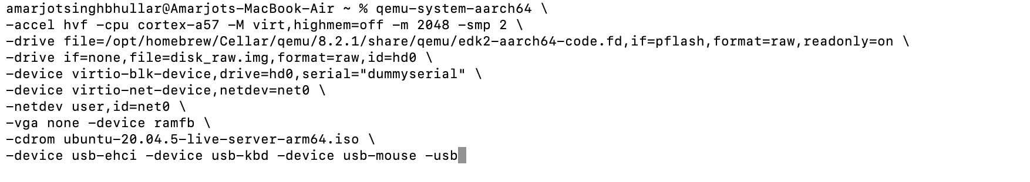

Reboot into installed ubuntu

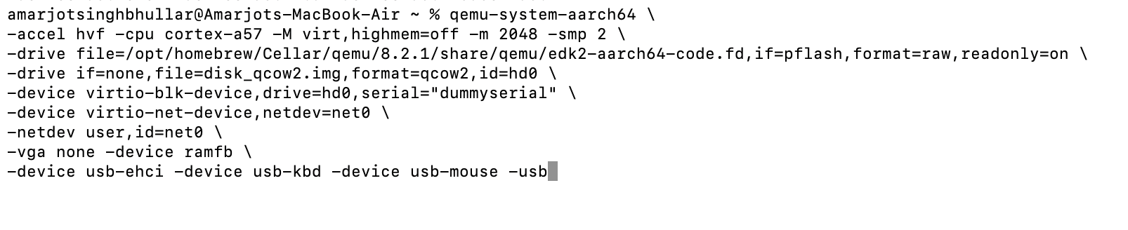

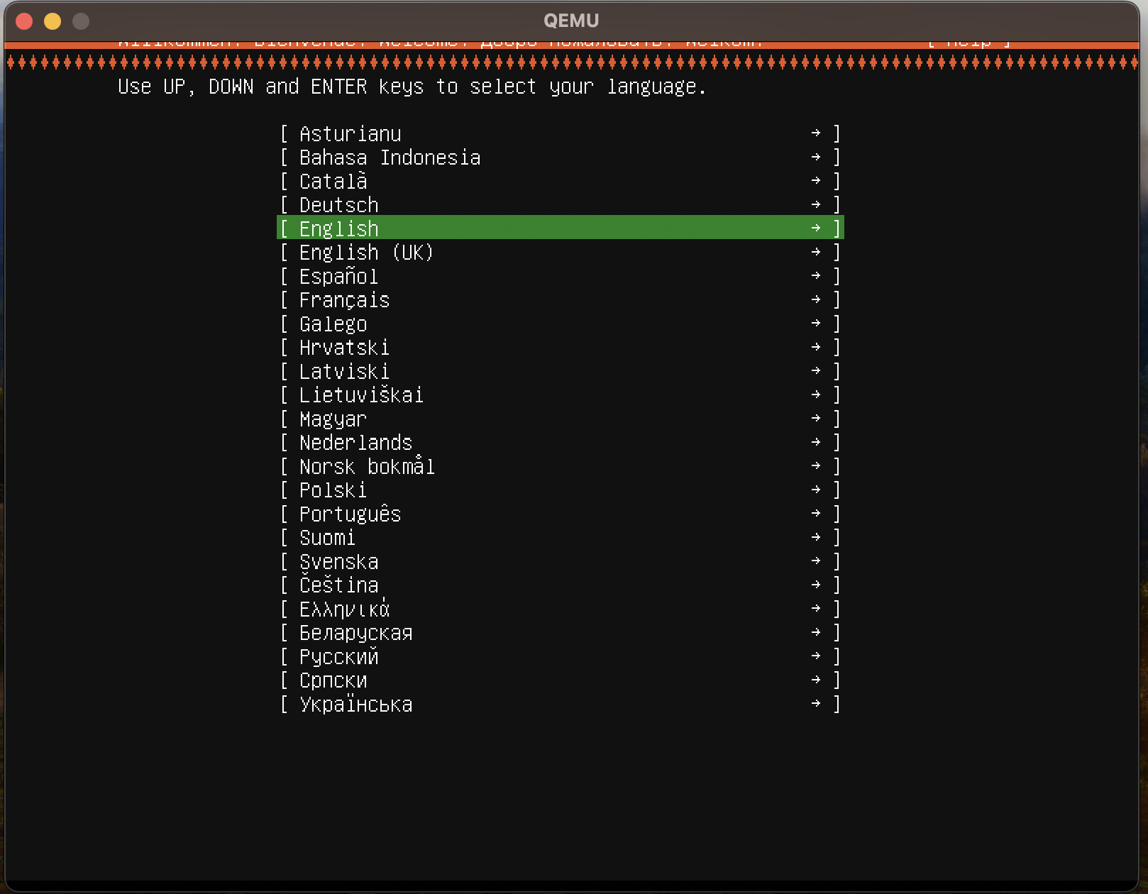

Post-Installation raw and qcow2–

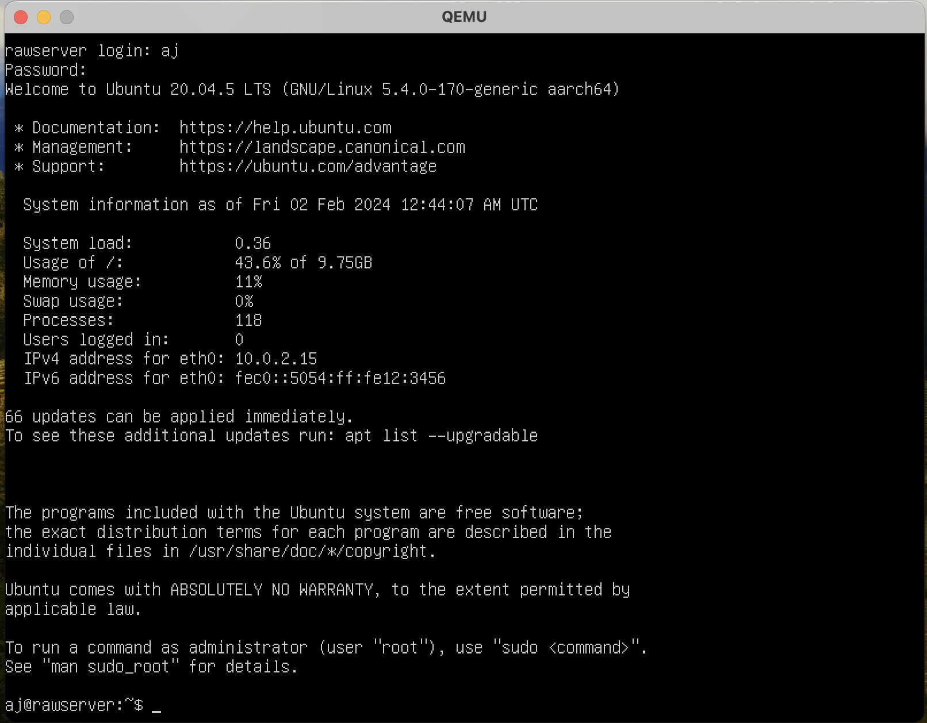

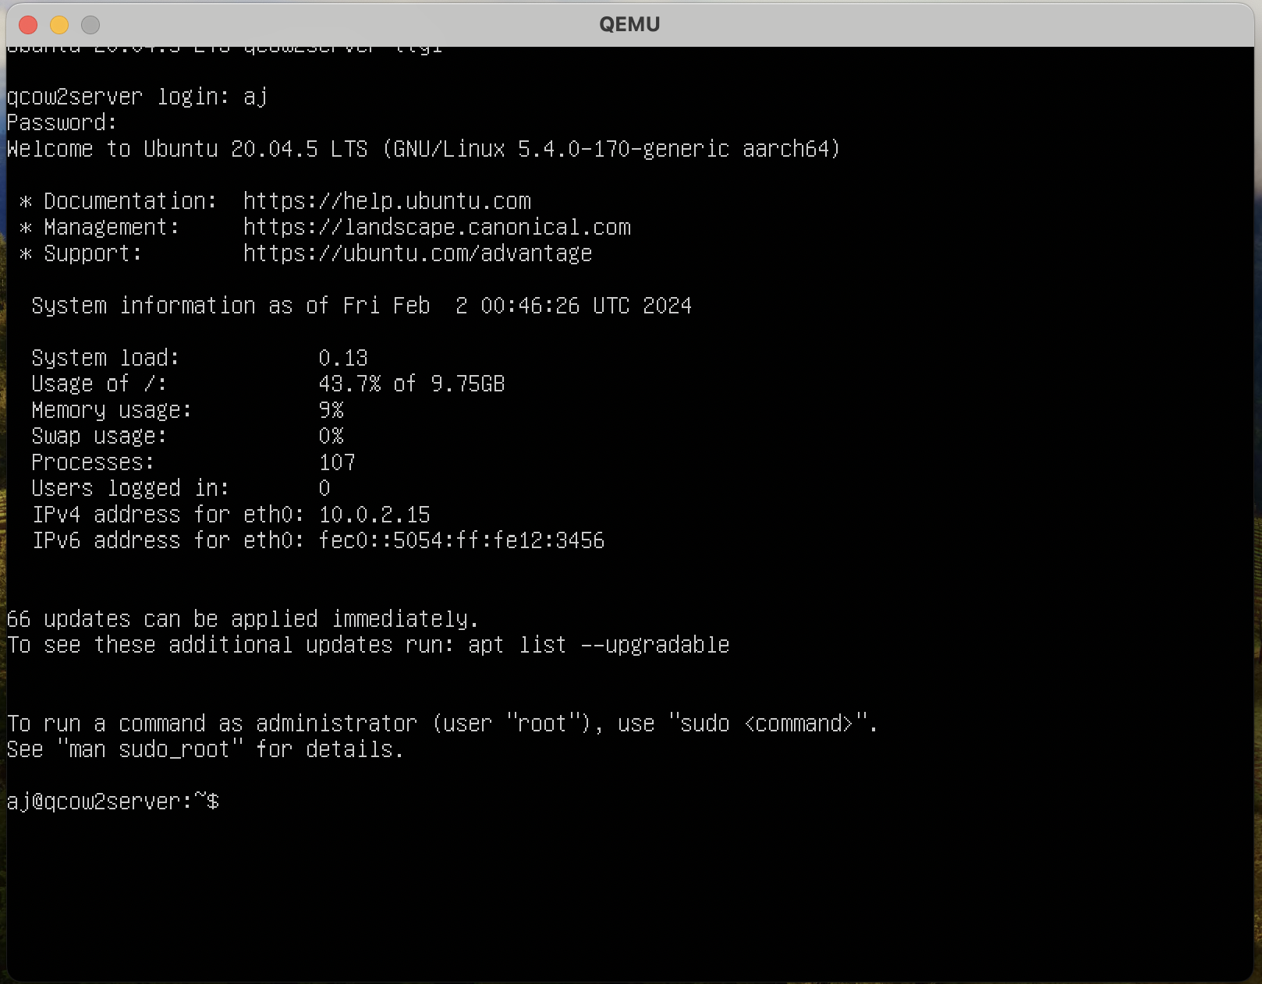

Tests –

**CPU – 2 cores**

**RAM – 2Gb**

**CPU Test**

Command - sysbench cpu --threads=4 --cpu-max-prime=10000 --time=10 run

Max prime = 10000

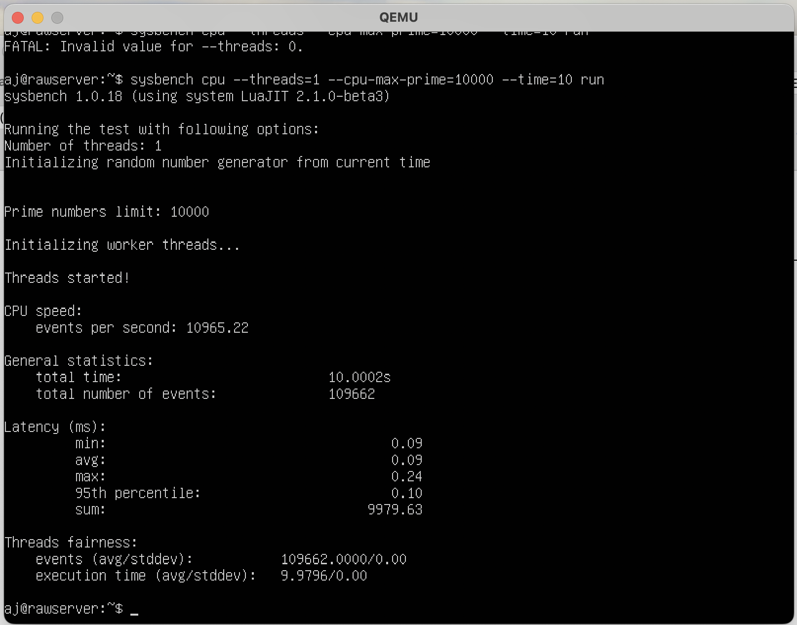

Max Prime= 1000000

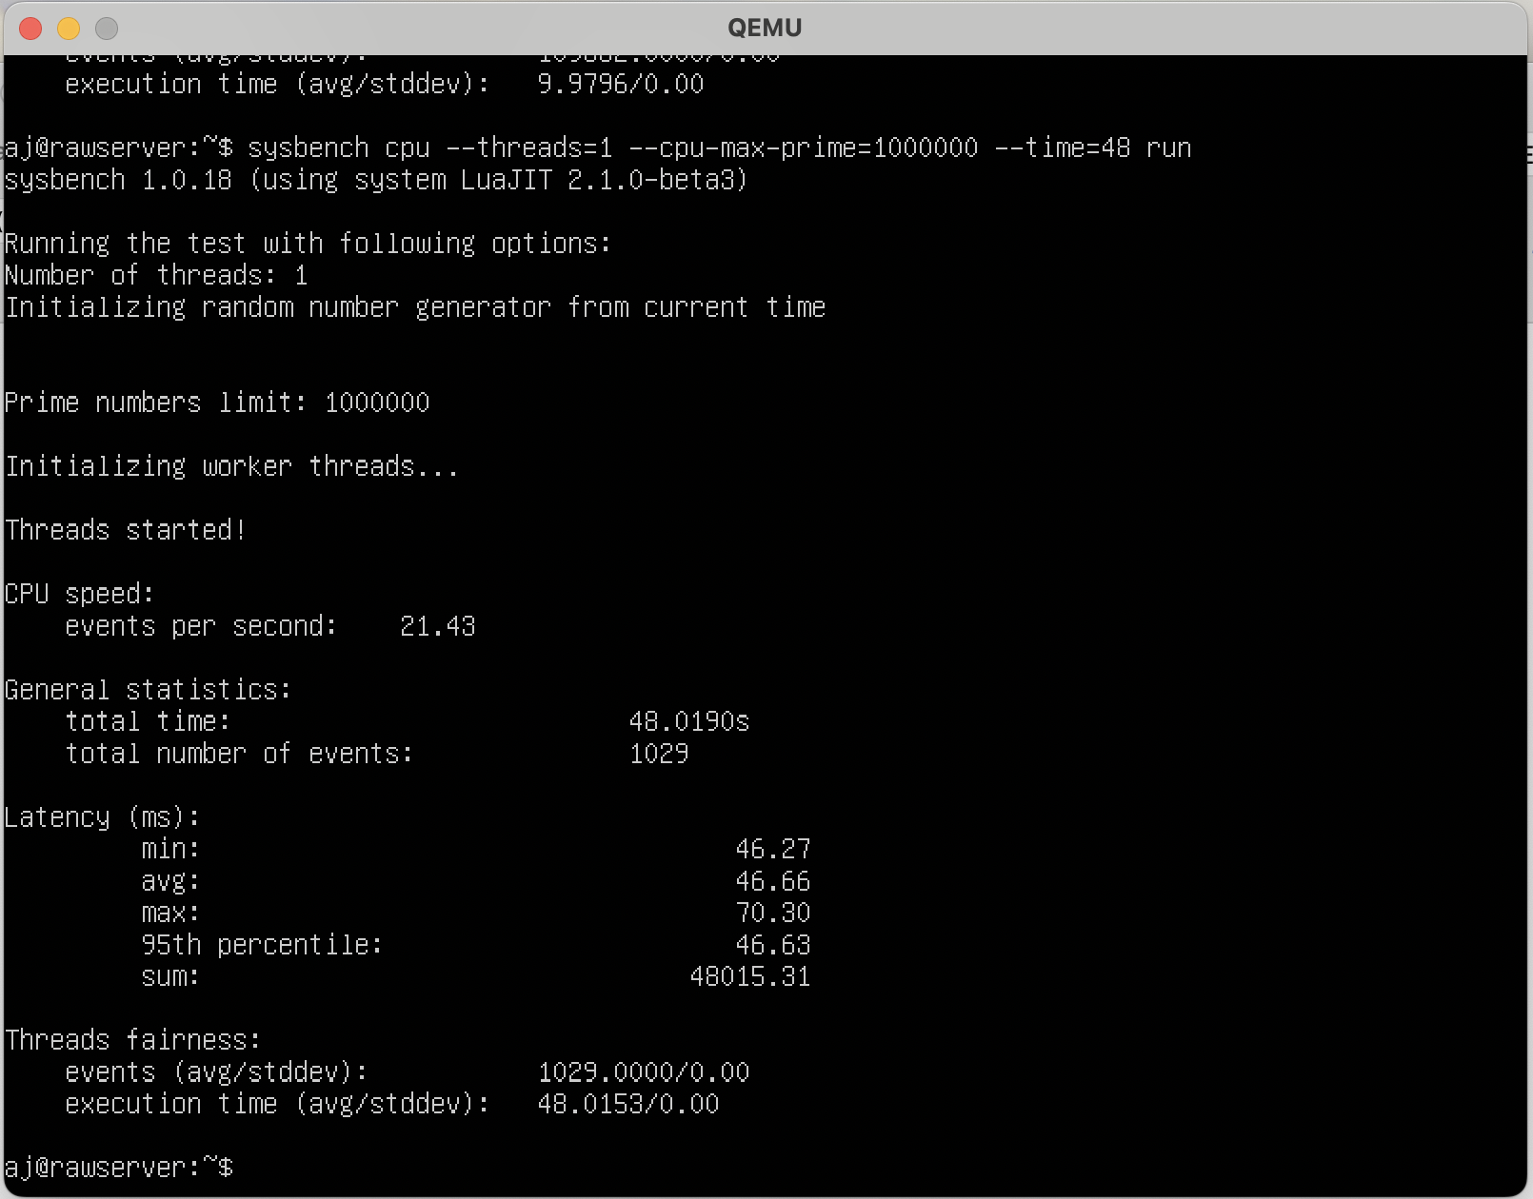

**FILE I/O-**

Prepare command –

sysbench fileio --threads=1--file-total-size=2G --file-test-mode=rndwr prepare

Run command –

sysbench fileio --threads=1--file-total-size=2G --file-test-mode=rndwr run

Cleanup Command –

sysbench fileio --threads=1--file-total-size=2G --file-test-mode=rndwr cleanup

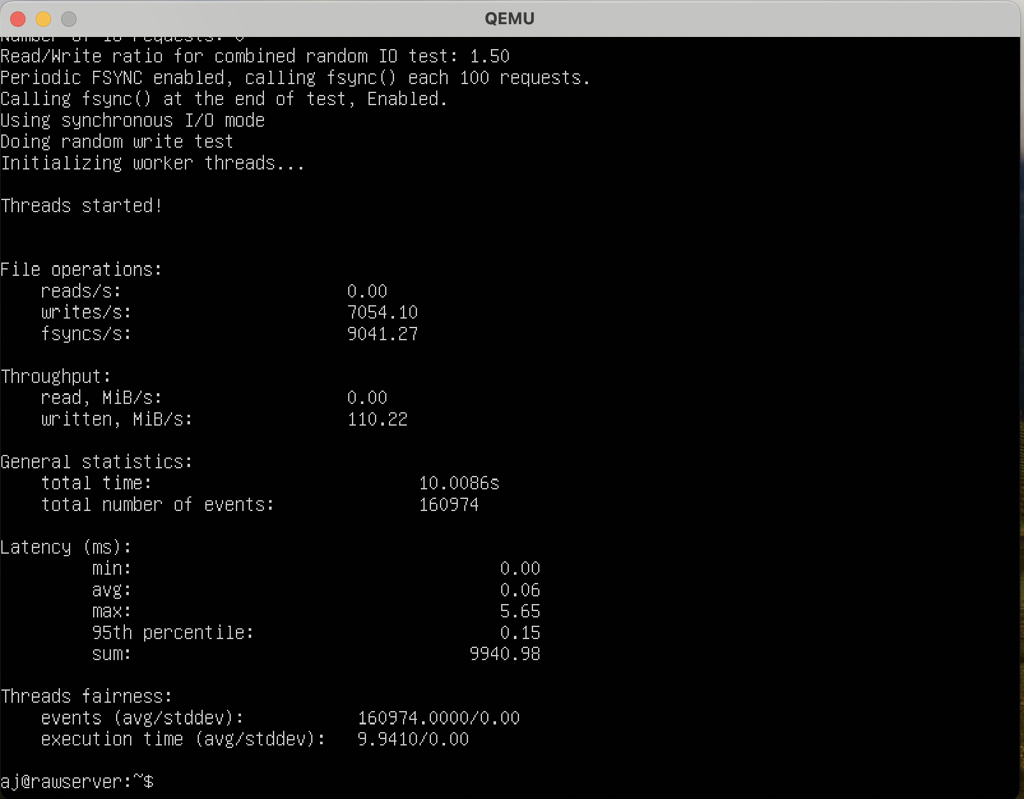

Prepare command –

sysbench fileio --threads=2 --file-total-size=4G --file-test-mode=rndwr prepare

Run command –

sysbench fileio --threads=2 --file-total-size=4G --file-test-mode=rndwr run

Cleanup Command –

sysbench fileio --threads=2--file-total-size=4G --file-test-mode=rndwr cleanup

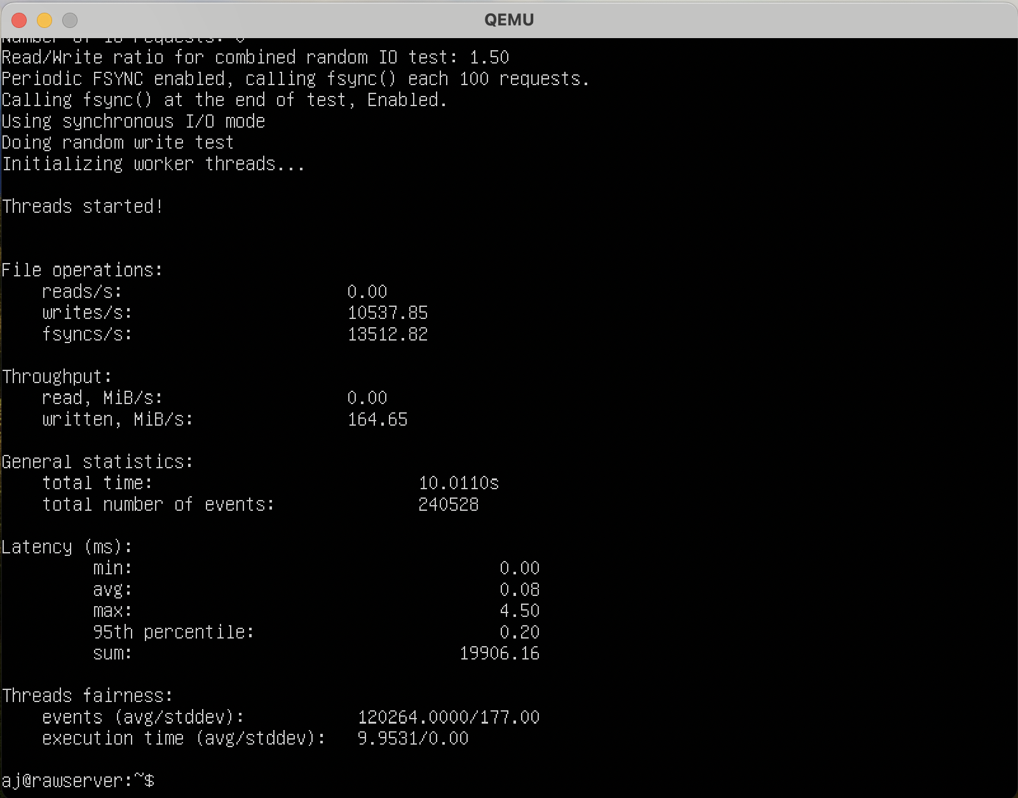

**Memory test –**

Command - sysbench memory --memory-block-size=16M run

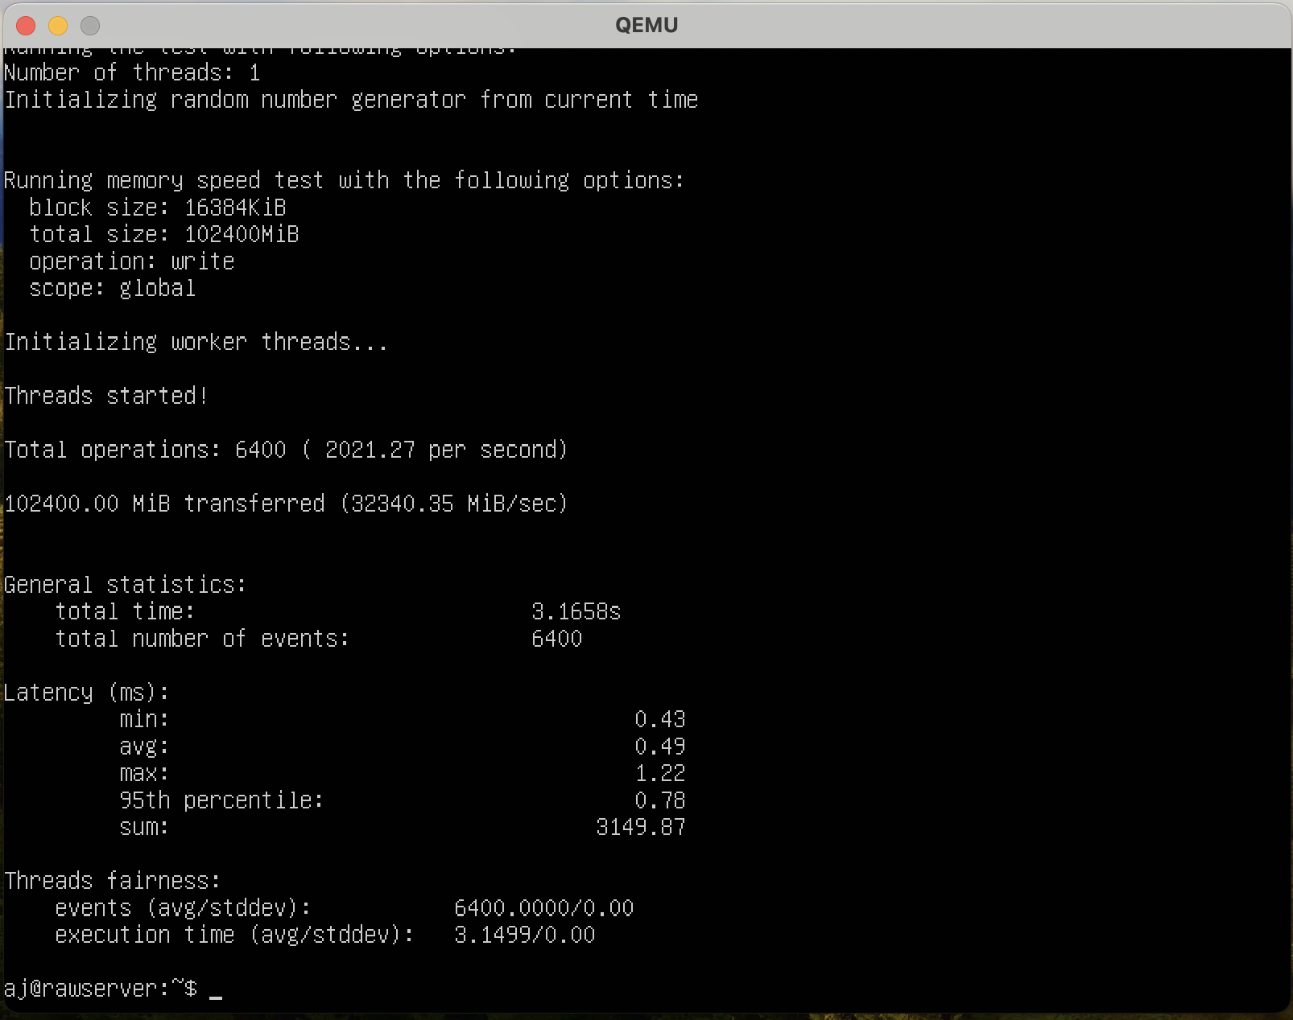

Command - sysbench memory --memory-block-size=32M run

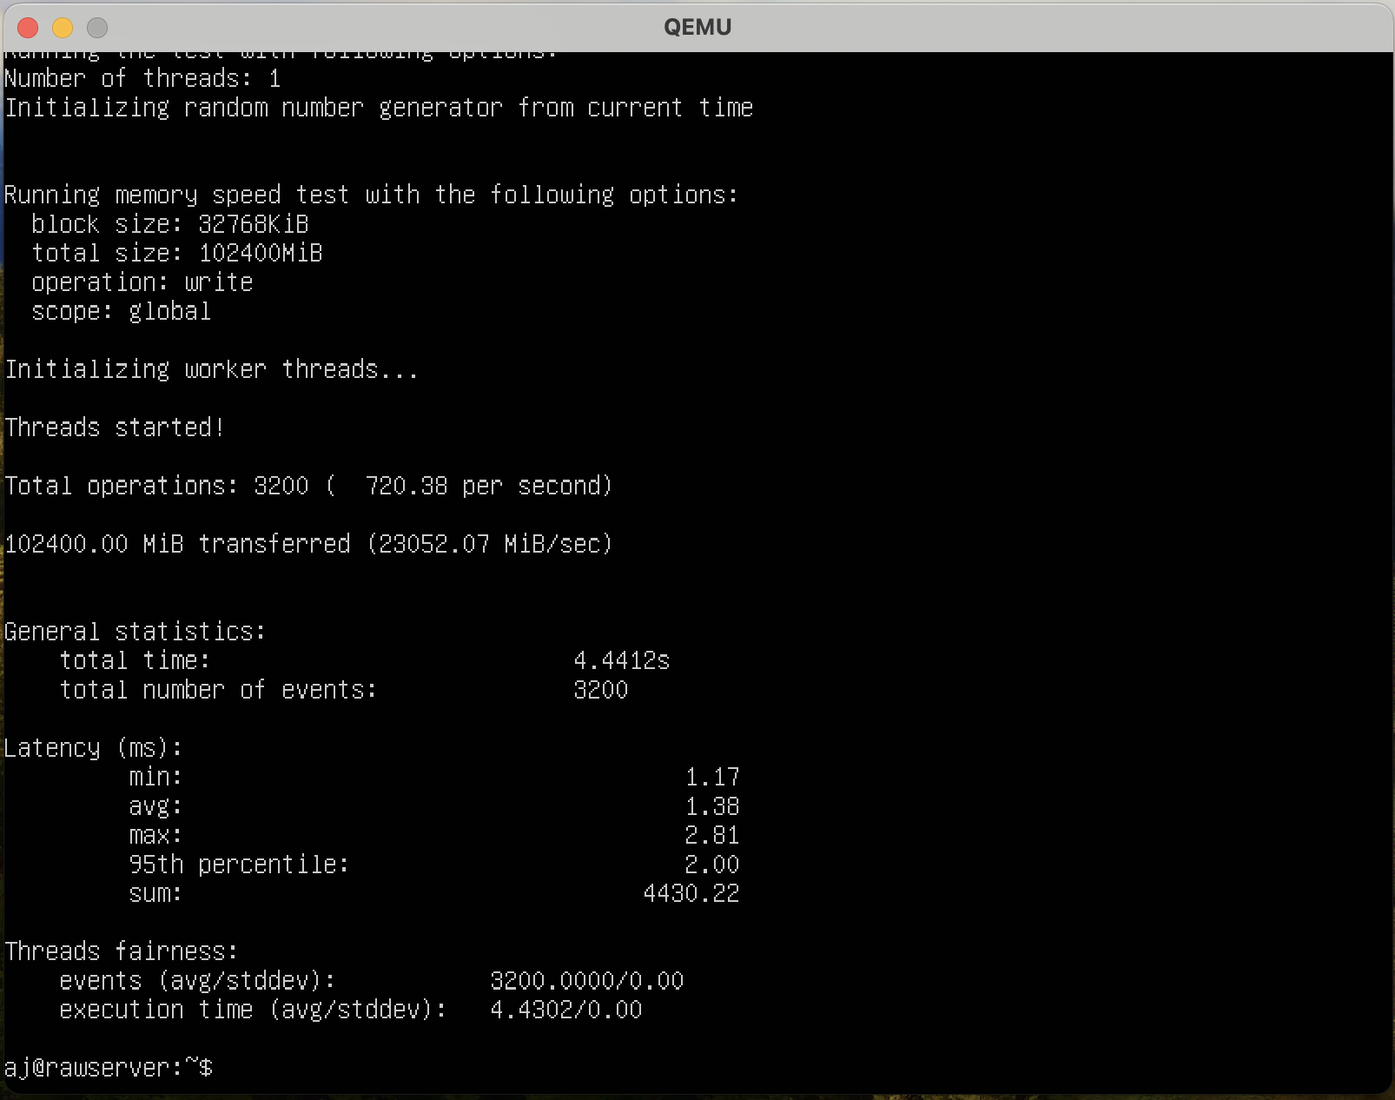

**CPU – 4 cores**

**RAM – 2Gb**

**CPU Test**

Command - sysbench cpu --threads=4 --cpu-max-prime=10000 --time=10 run

Max prime = 10000

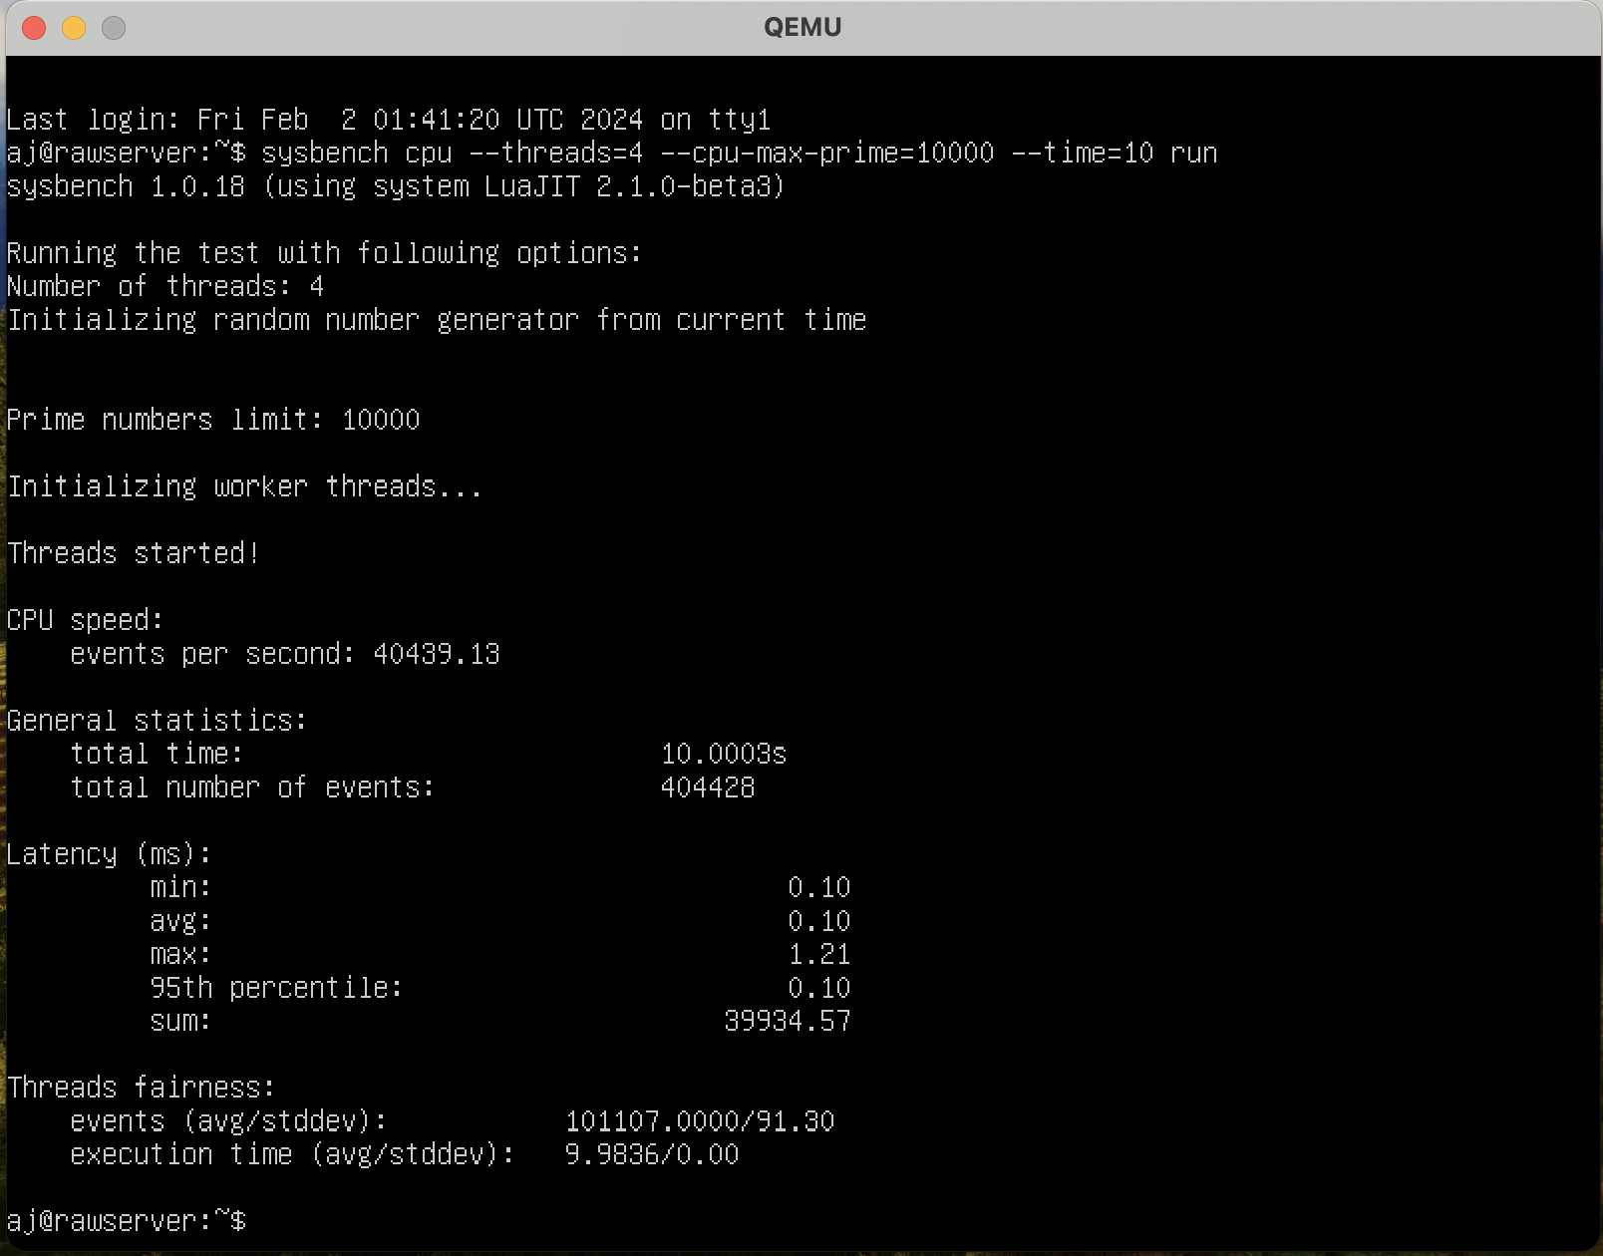

Max prime = 1000000

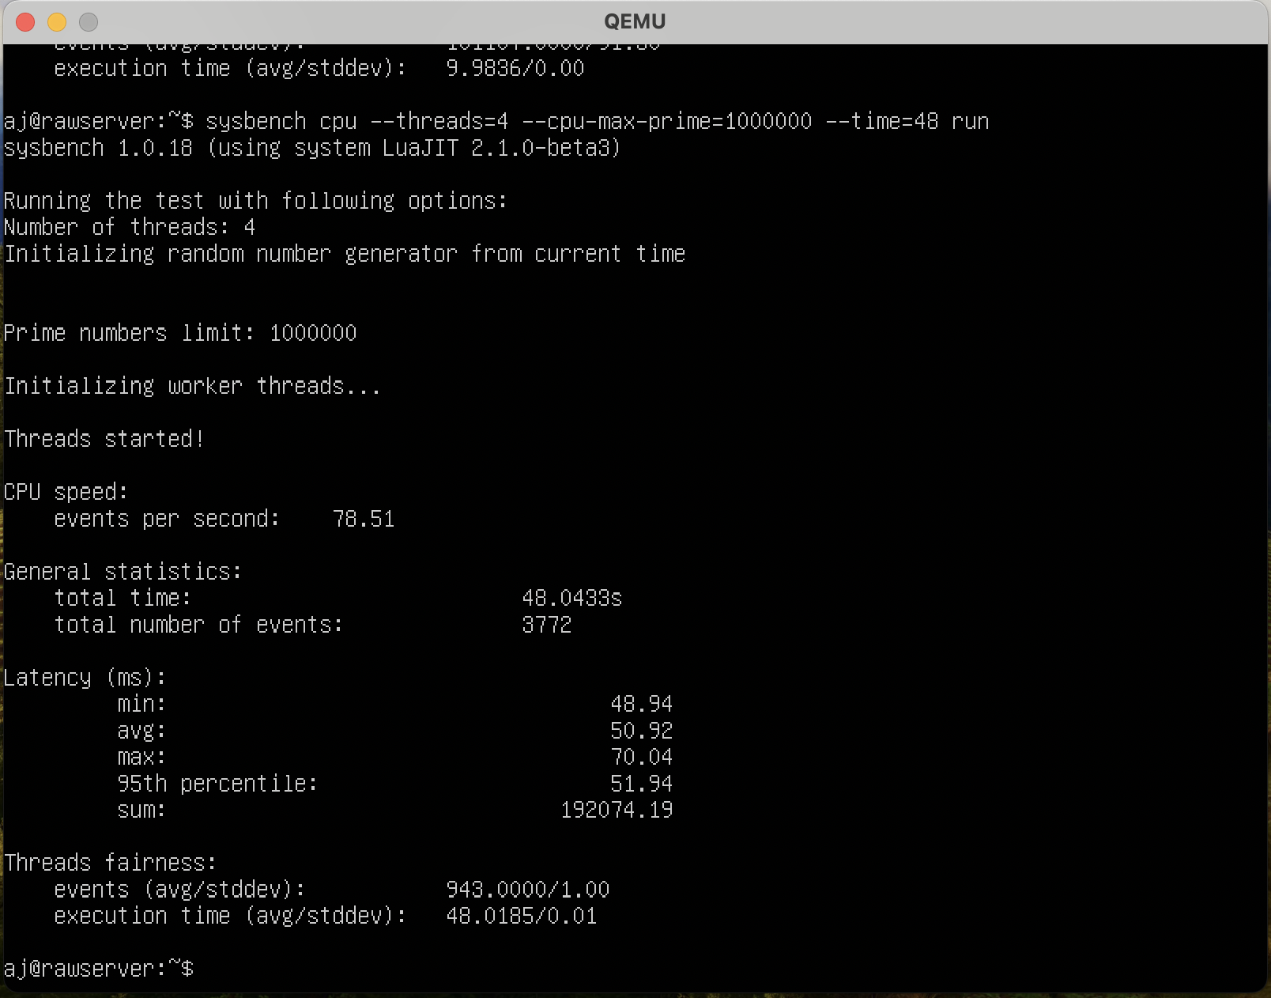

**FILE I/O-**

Prepare command –

sysbench fileio --threads=1--file-total-size=2G --file-test-mode=rndwr prepare

Run command –

sysbench fileio --threads=1--file-total-size=2G --file-test-mode=rndwr run

Cleanup Command –

sysbench fileio --threads=1--file-total-size=2G --file-test-mode=rndwr cleanup

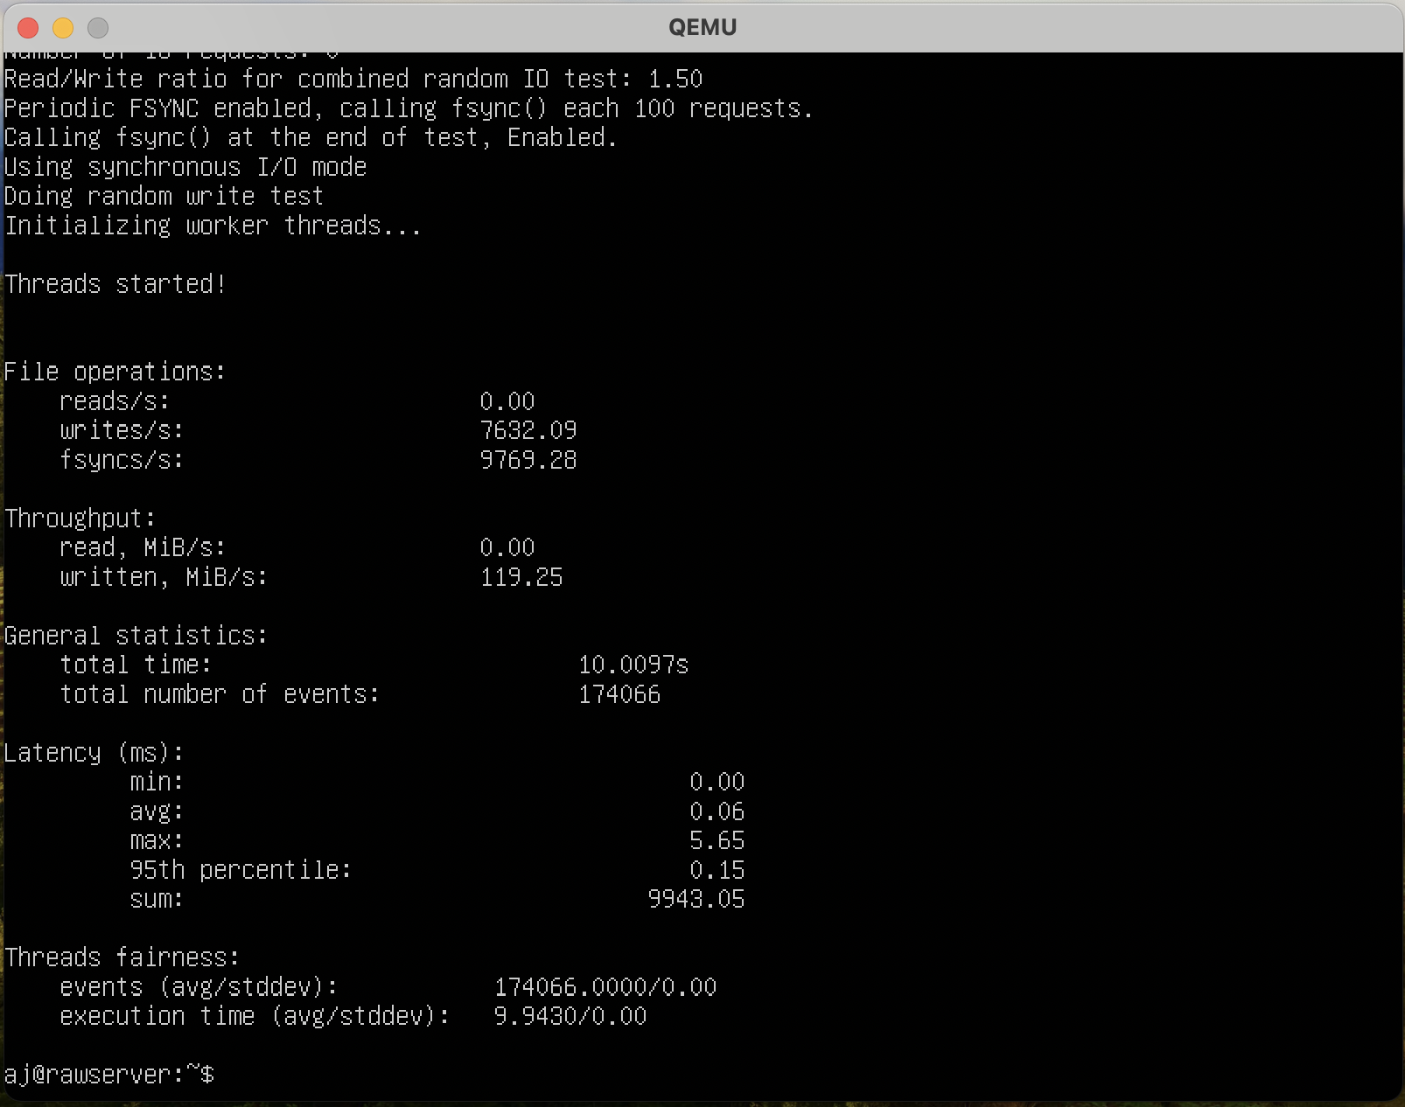

Prepare command –

sysbench fileio --threads=2 --file-total-size=4G --file-test-mode=rndwr prepare

Run command –

sysbench fileio --threads=2 --file-total-size=4G --file-test-mode=rndwr run

Cleanup Command –

sysbench fileio --threads=2 --file-total-size=4G --file-test-mode=rndwr cleanup

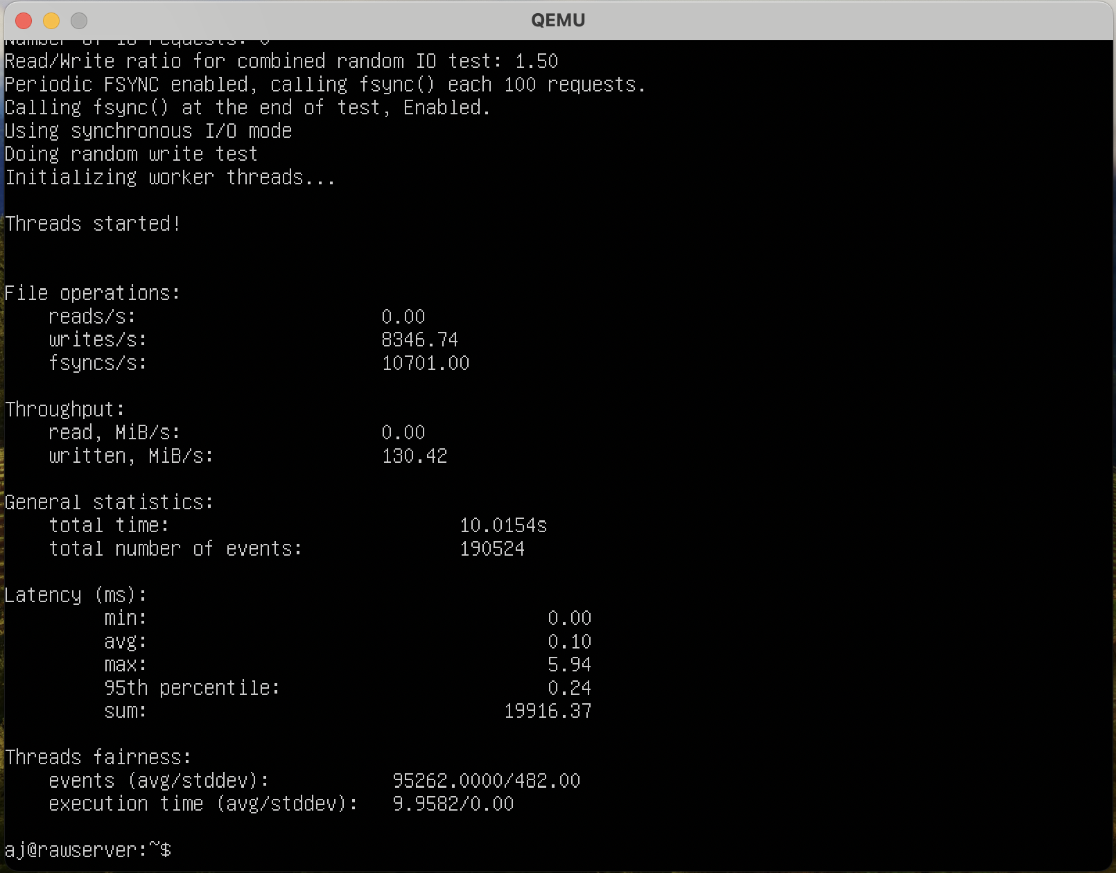

**Memory test –**

Command - sysbench memory --memory-block-size=16M run

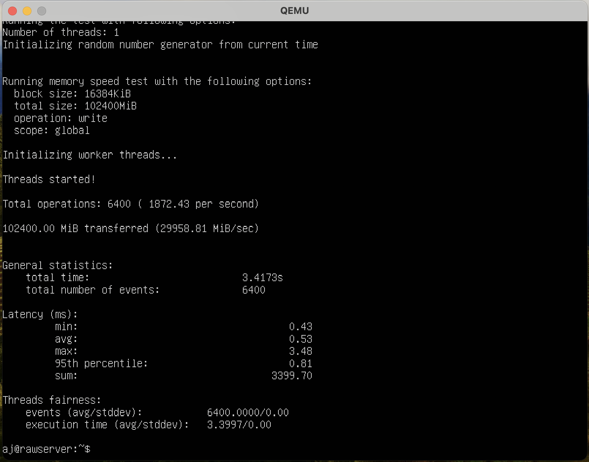

Command - sysbench memory --memory-block-size=32M run

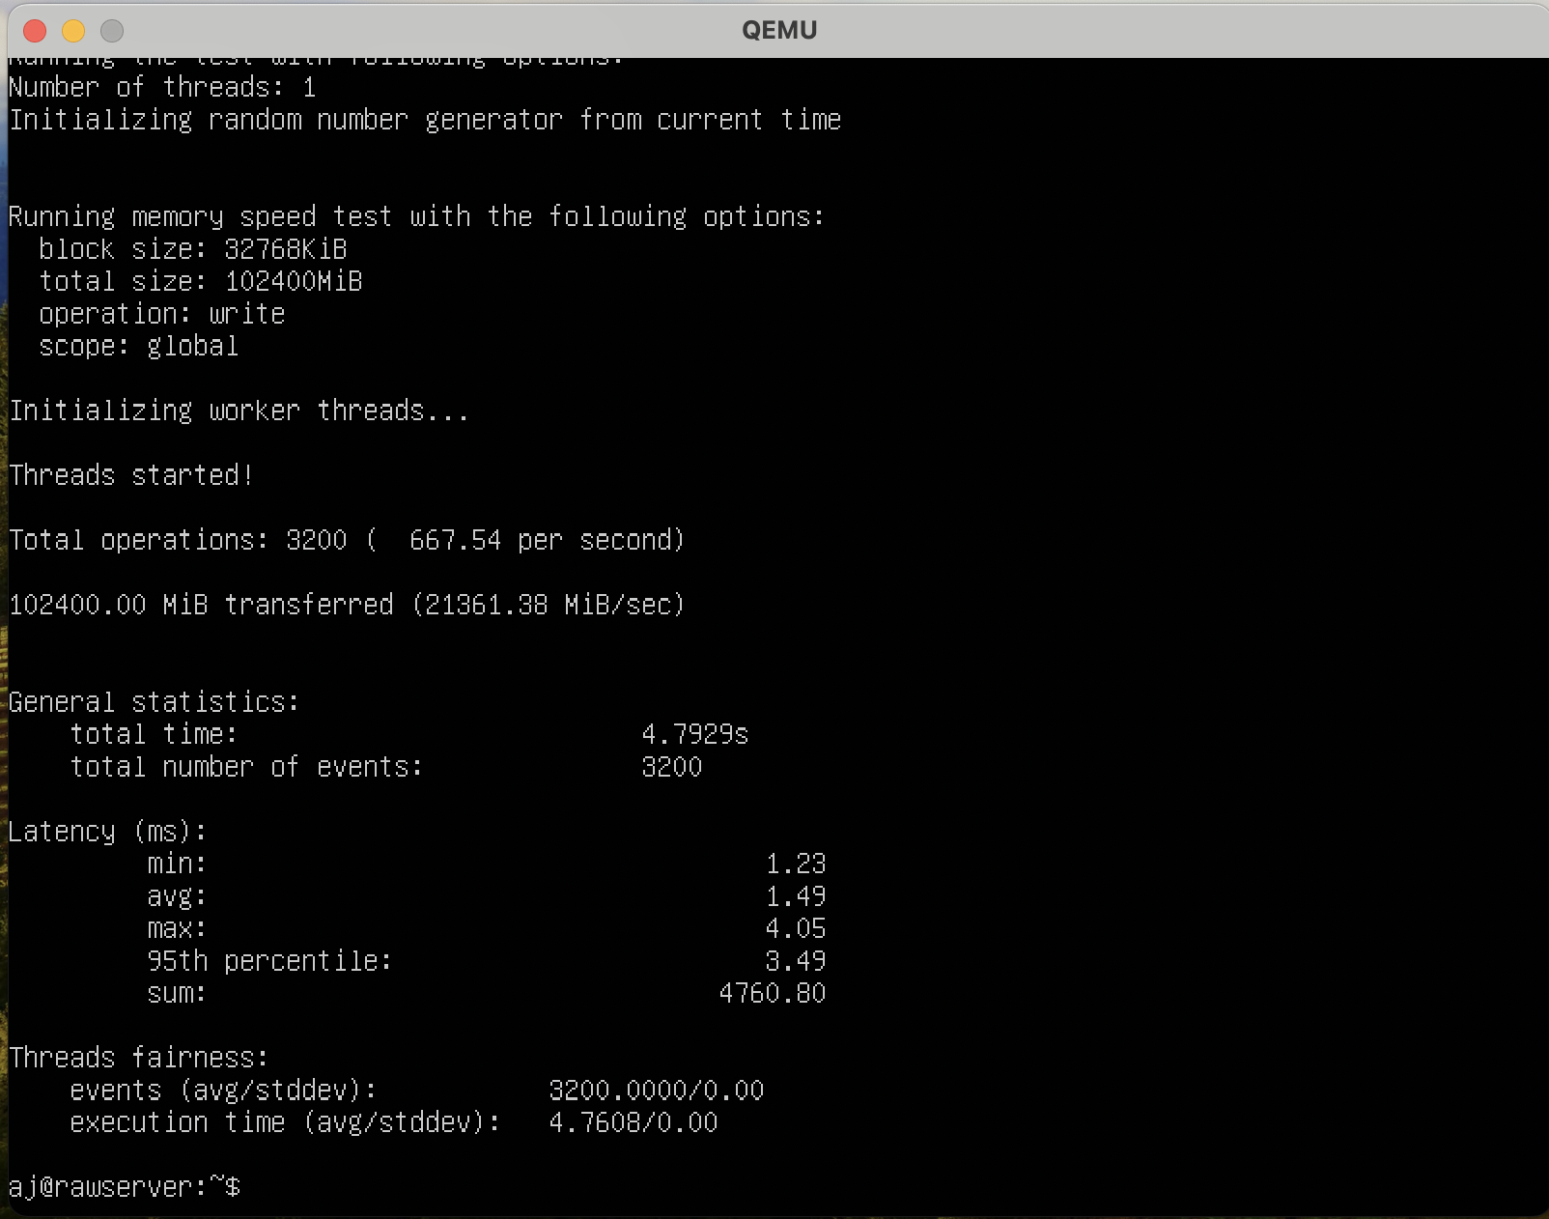

**CPU – 4 cores**

**RAM – 1Gb**

**CPU Test**

Command - sysbench cpu --threads=4 --cpu-max-prime=10000 --time=10 run

Max prime = 10000

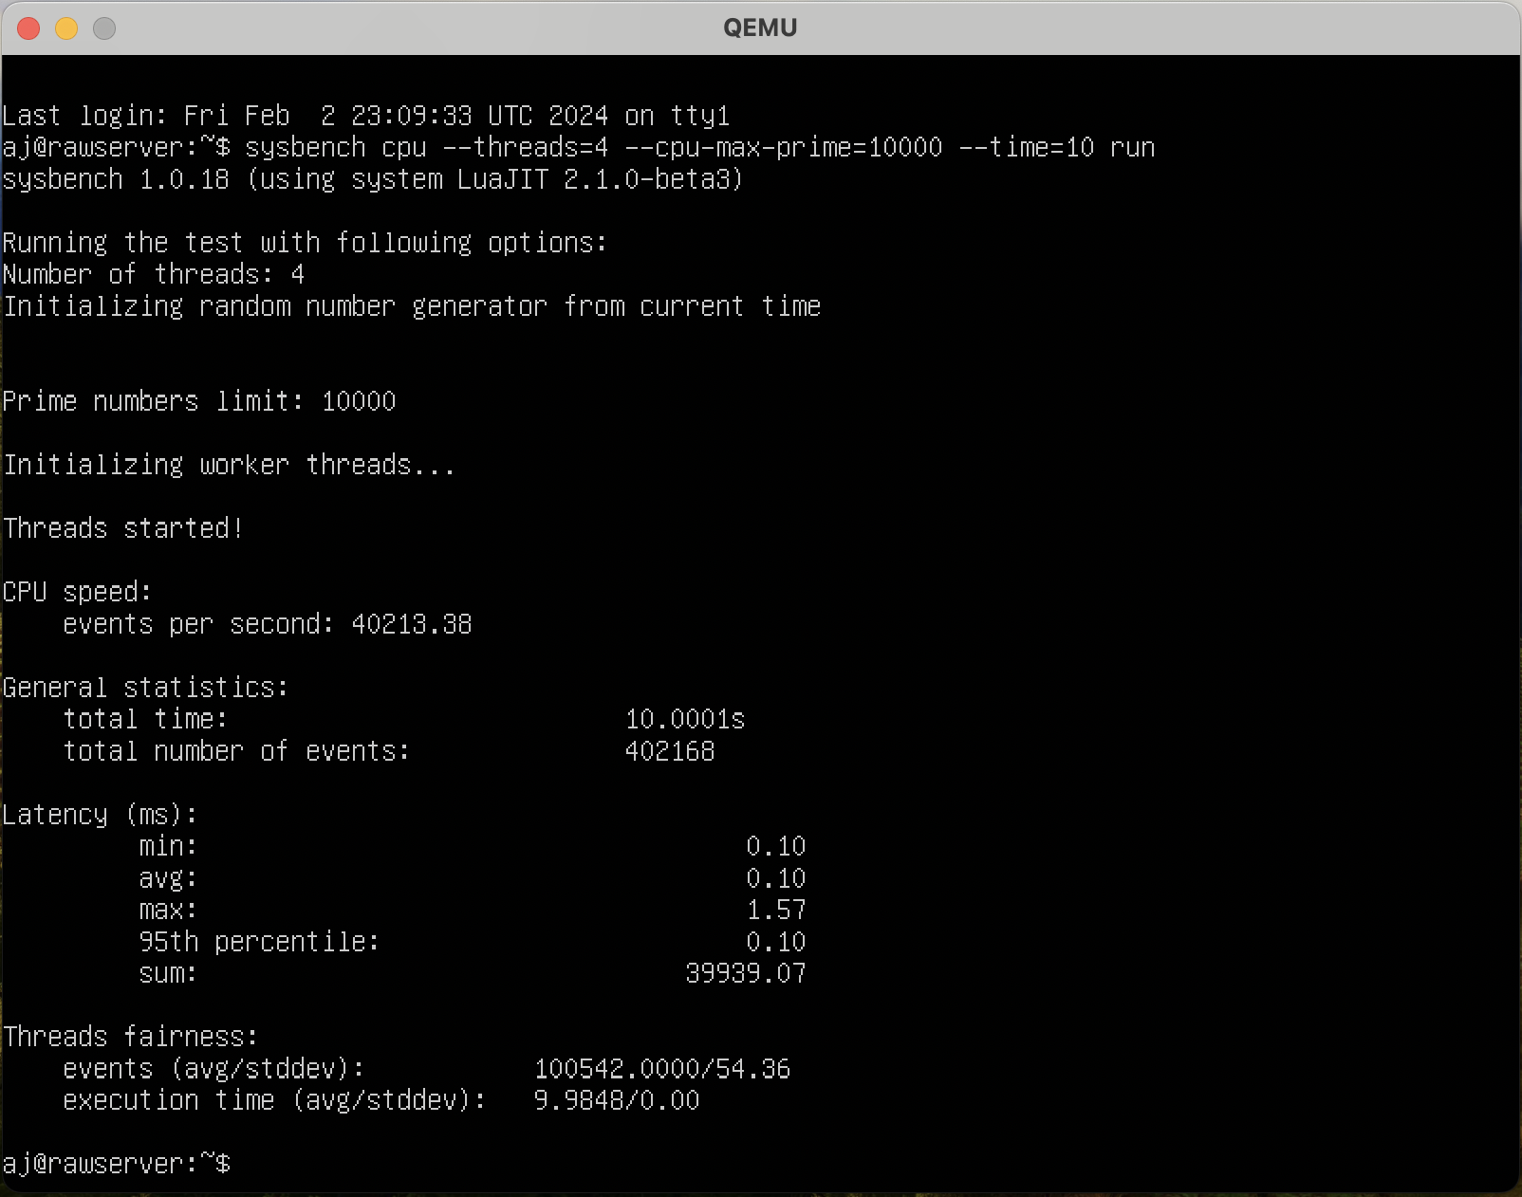

Max prime = 1000000

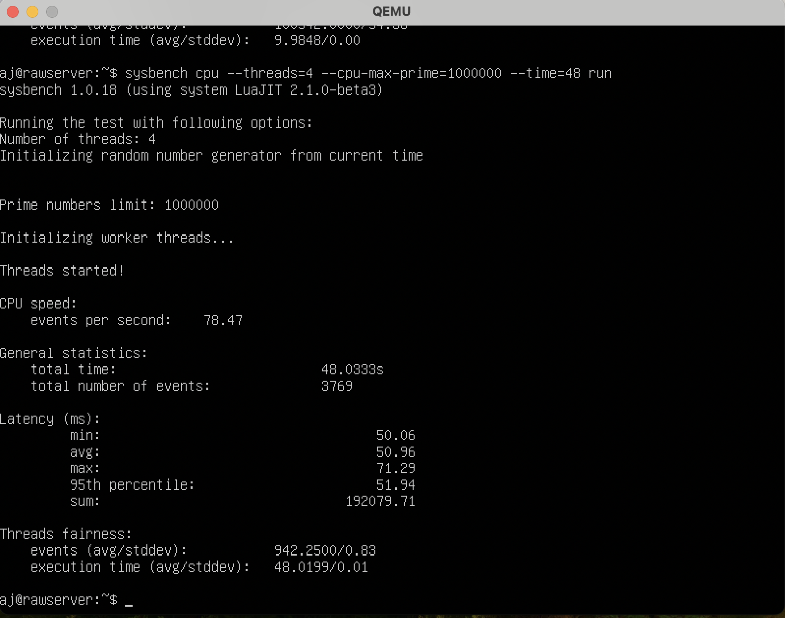

**FILE I/O-**

Prepare command –

sysbench fileio --threads=1--file-total-size=2G --file-test-mode=rndwr prepare

Run command –

sysbench fileio --threads=1--file-total-size=2G --file-test-mode=rndwr run

Cleanup Command –

sysbench fileio --threads=1--file-total-size=2G --file-test-mode=rndwr cleanup

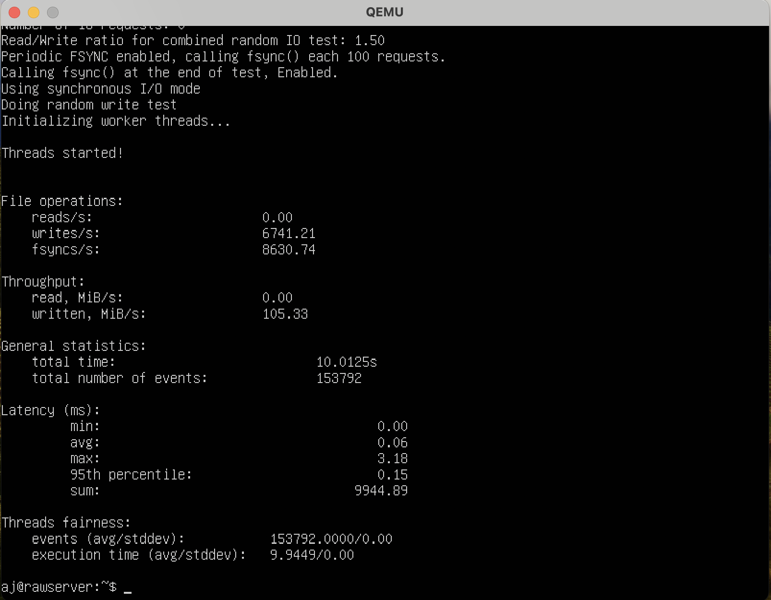

Prepare command –

sysbench fileio --threads=4--file-total-size=4G --file-test-mode=rndwr prepare

Run command –

sysbench fileio --threads=4 --file-total-size=4G --file-test-mode=rndwr run

Cleanup Command –

sysbench fileio --threads=4--file-total-size=4G --file-test-mode=rndwr cleanup

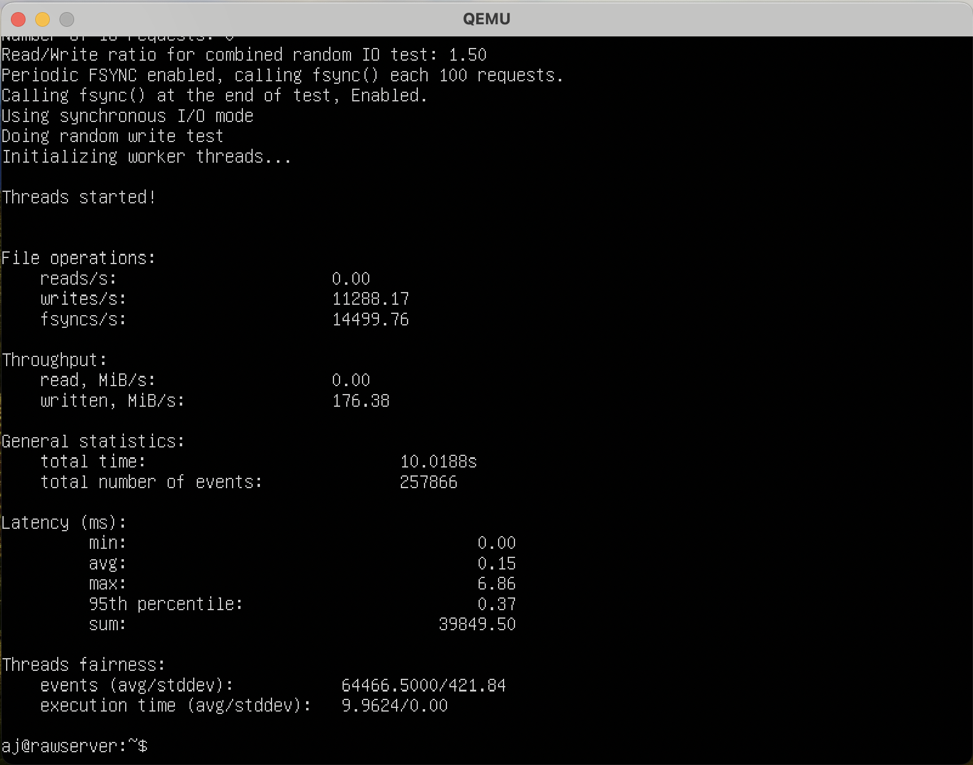

**Memory test –**

Command - sysbench memory --memory-block-size=16M run

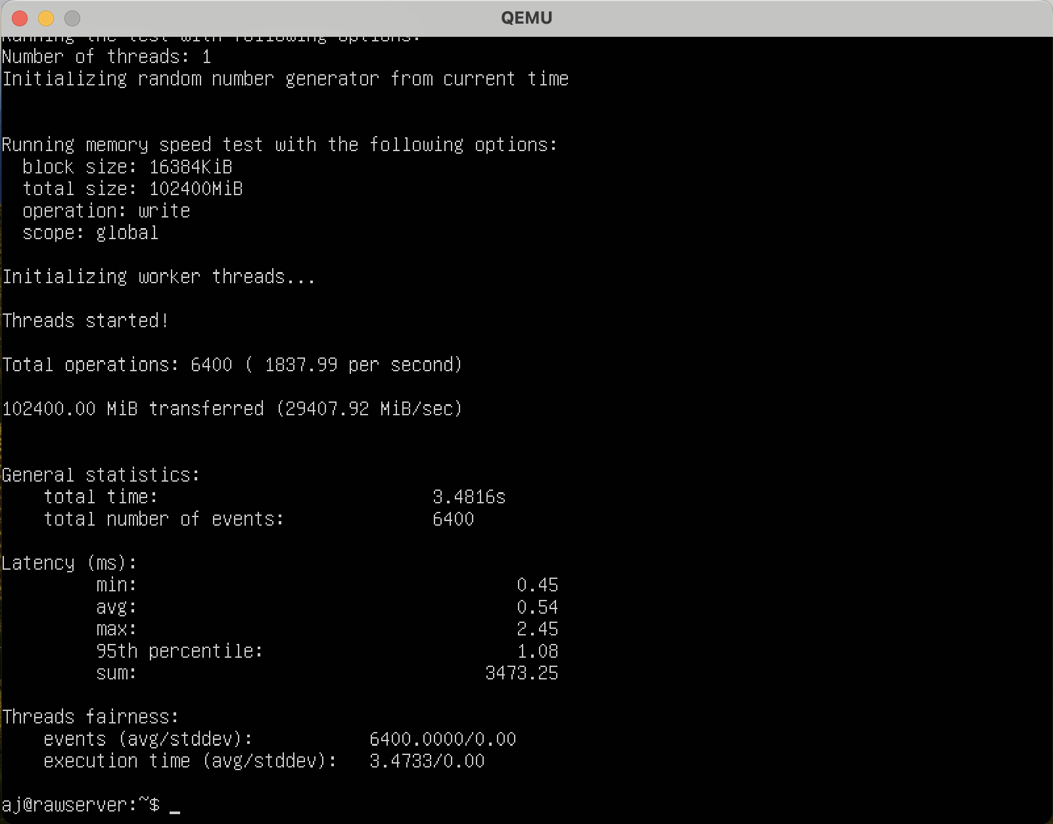

Command - sysbench memory --memory-block-size=32M run

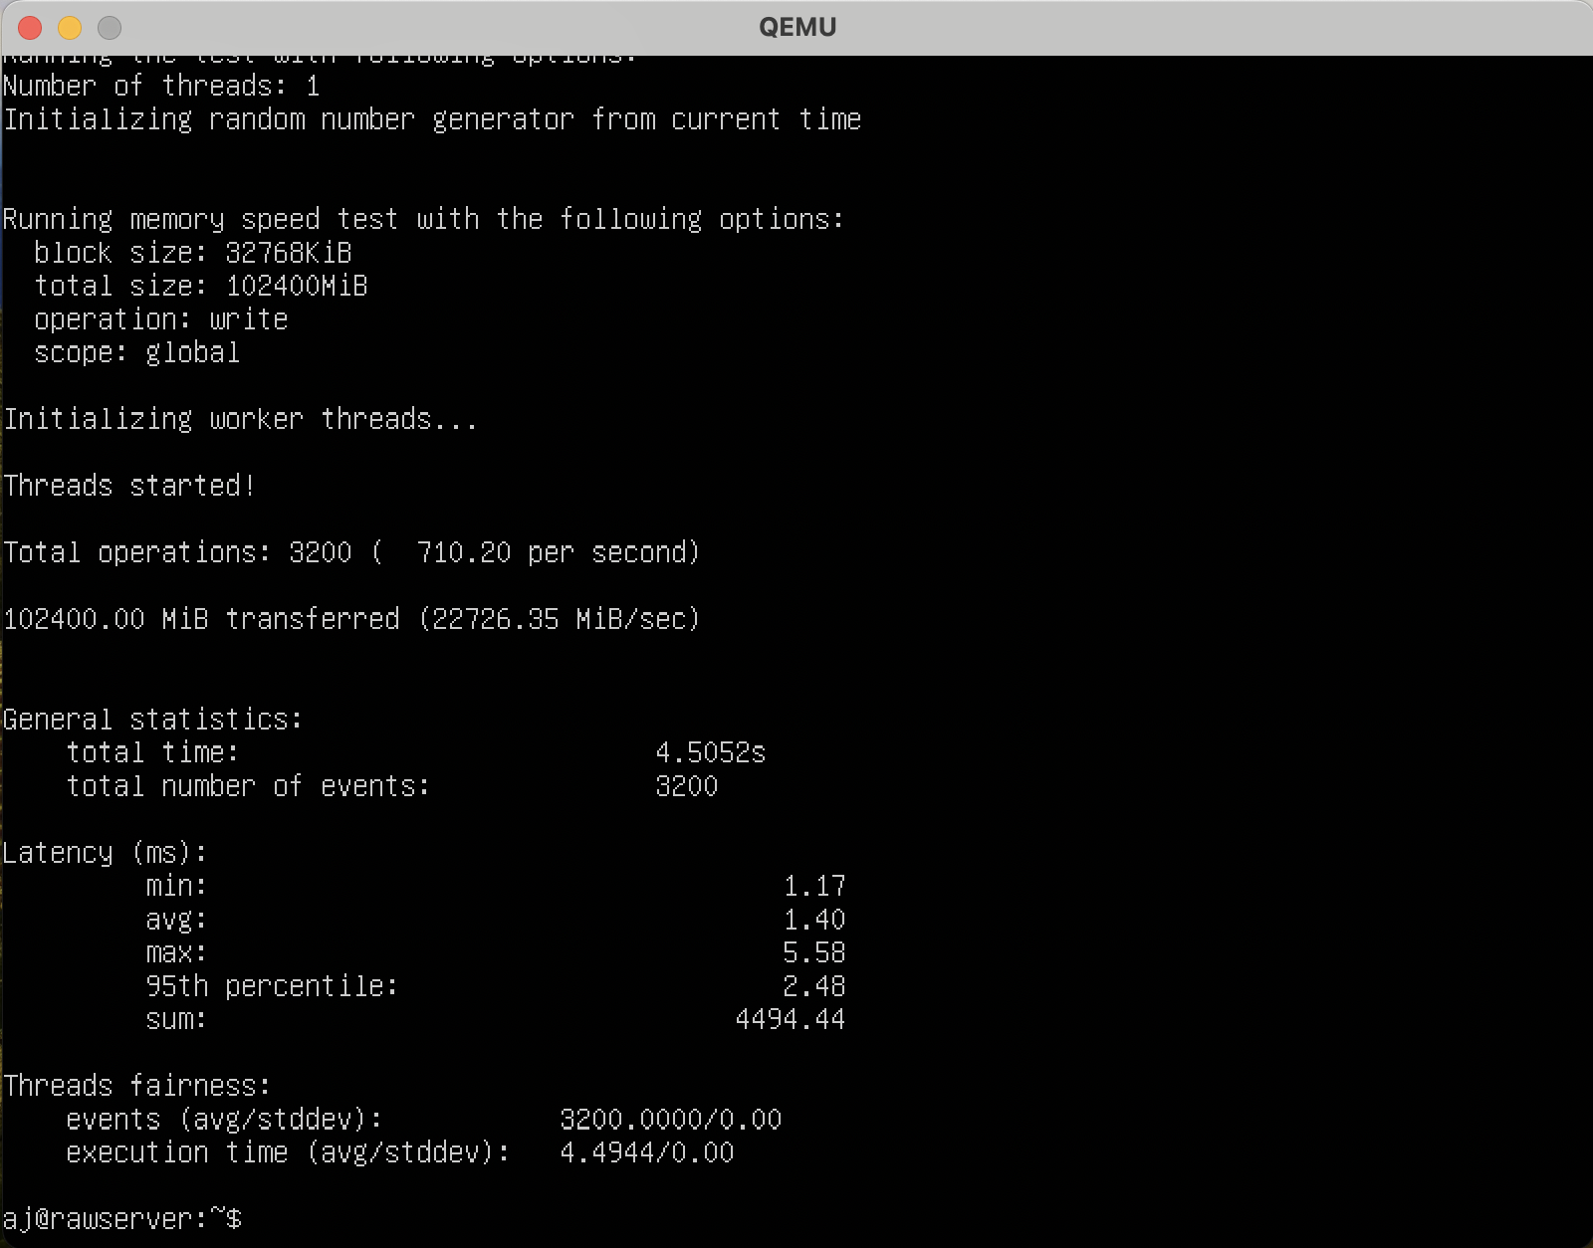

**CPU – 2 cores**

**RAM – 1Gb**

**CPU Test**

Command - sysbench cpu --threads=4 --cpu-max-prime=10000 --time=10 run

Max prime = 10000

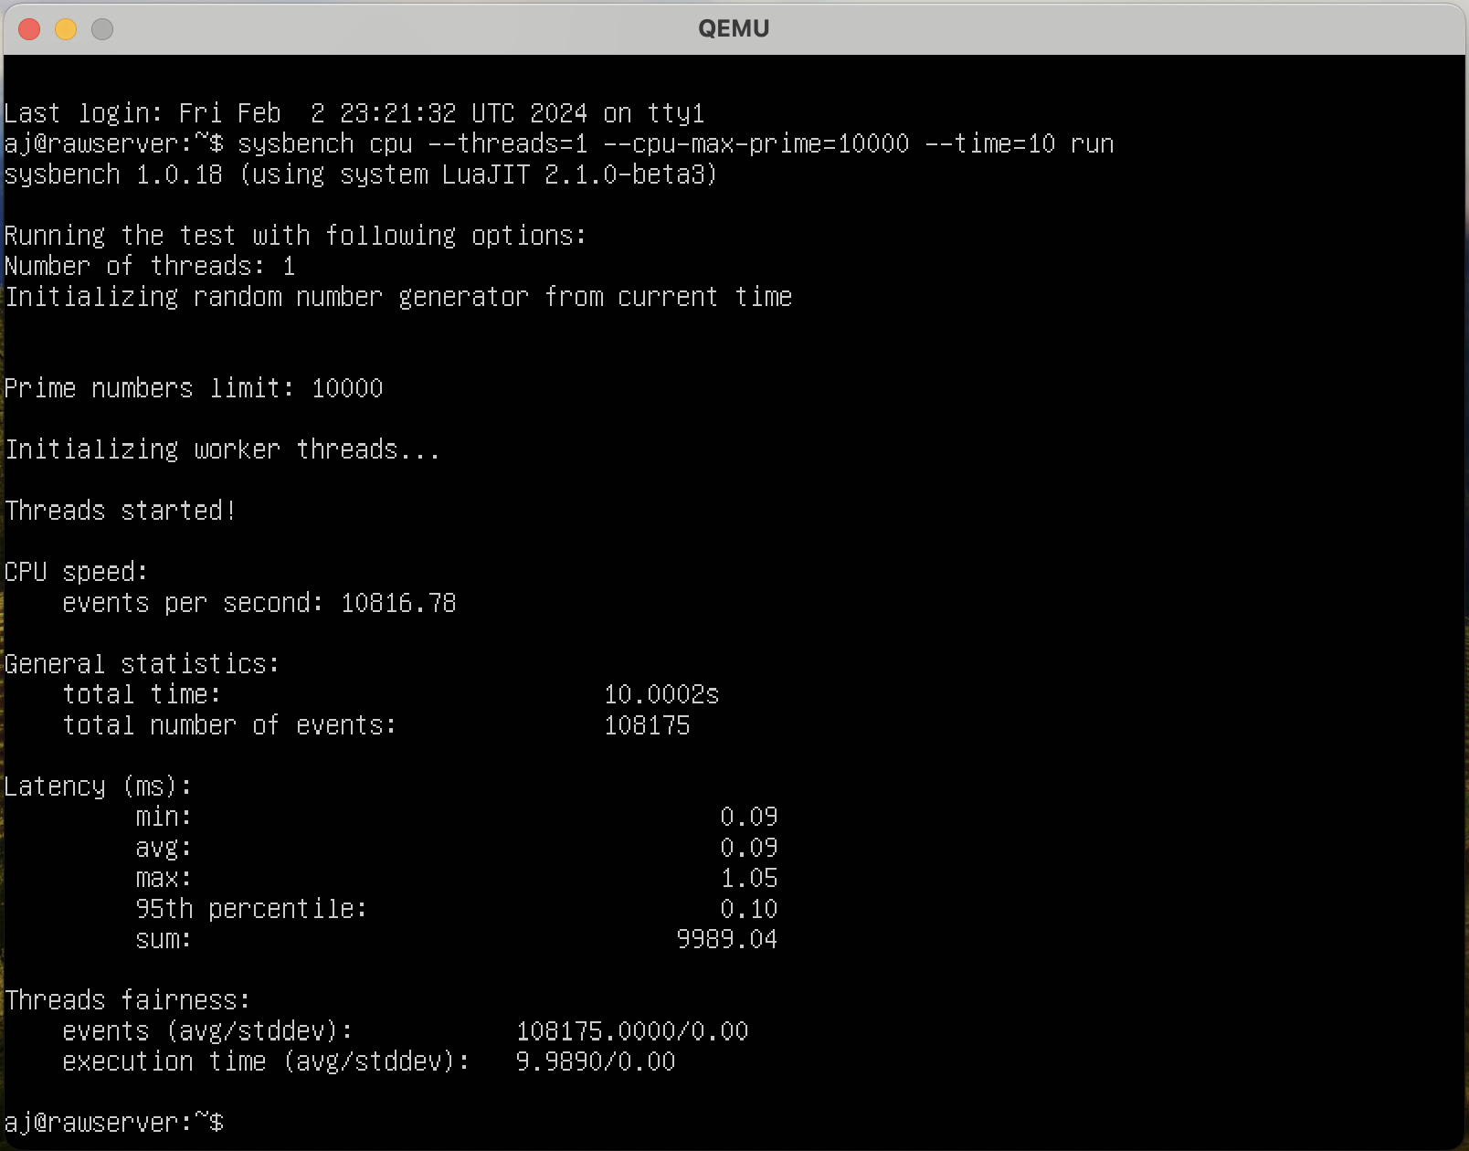

Command - sysbench cpu --threads=4 --cpu-max-prime=1000000 --time=48 run

Max prime = 1000000

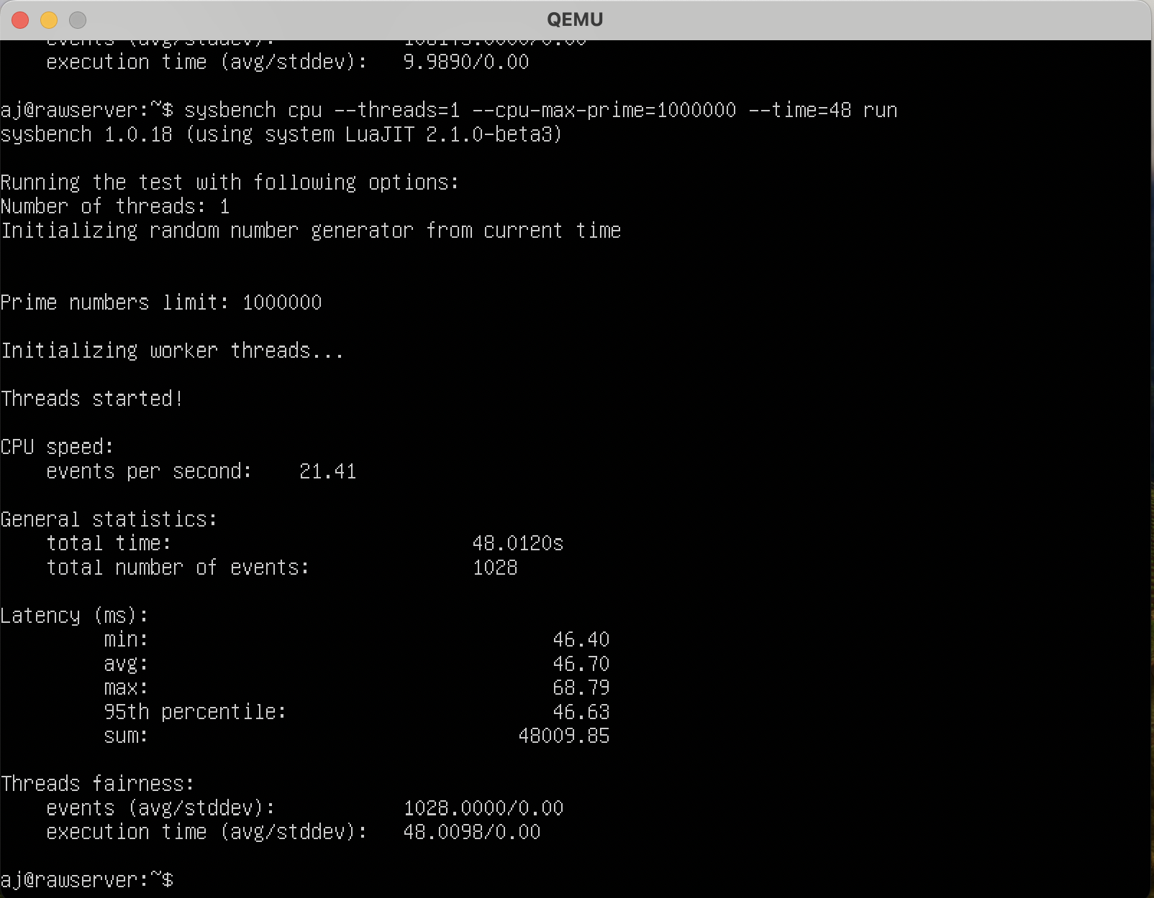

**FILE I/O-**

Prepare command –

sysbench fileio --threads=1--file-total-size=2G --file-test-mode=rndwr prepare

Run command –

sysbench fileio --threads=1--file-total-size=2G --file-test-mode=rndwr run

Cleanup Command –

sysbench fileio --threads=1--file-total-size=2G --file-test-mode=rndwr cleanup

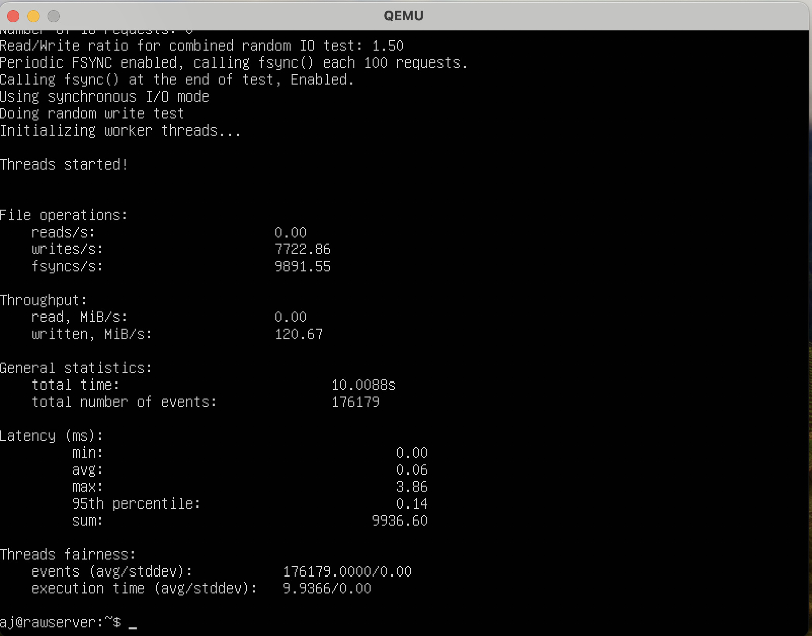

Prepare command –

sysbench fileio --threads=2 --file-total-size=4G --file-test-mode=rndwr prepare

Run command –

sysbench fileio --threads=2 --file-total-size=4G --file-test-mode=rndwr run

Cleanup Command –

sysbench fileio --threads=2 --file-total-size=4G --file-test-mode=rndwr cleanup

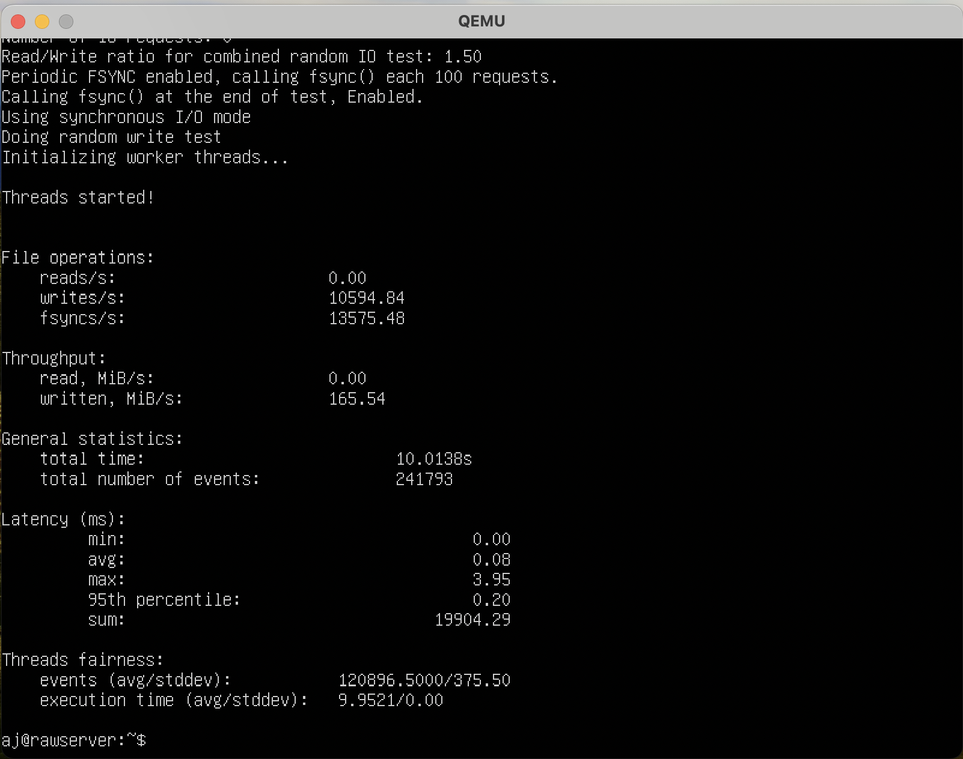

**Memory test –**

Command - sysbench memory --memory-block-size=16M run

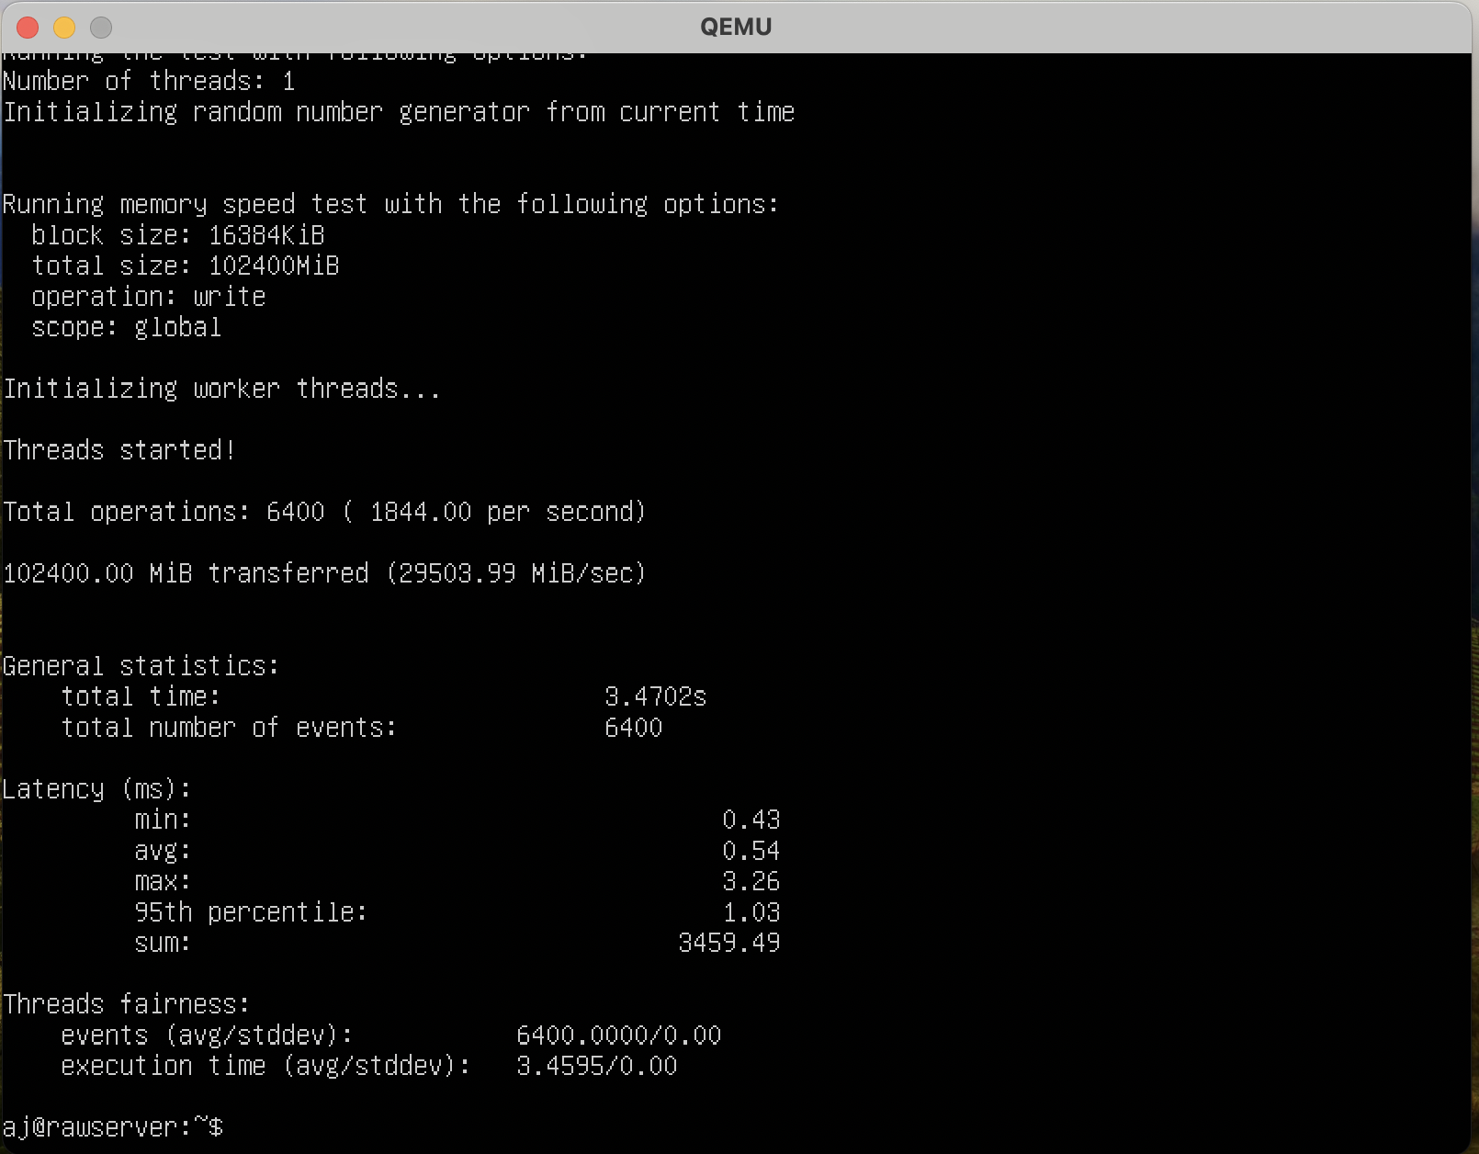

Command - sysbench memory --memory-block-size=32M run

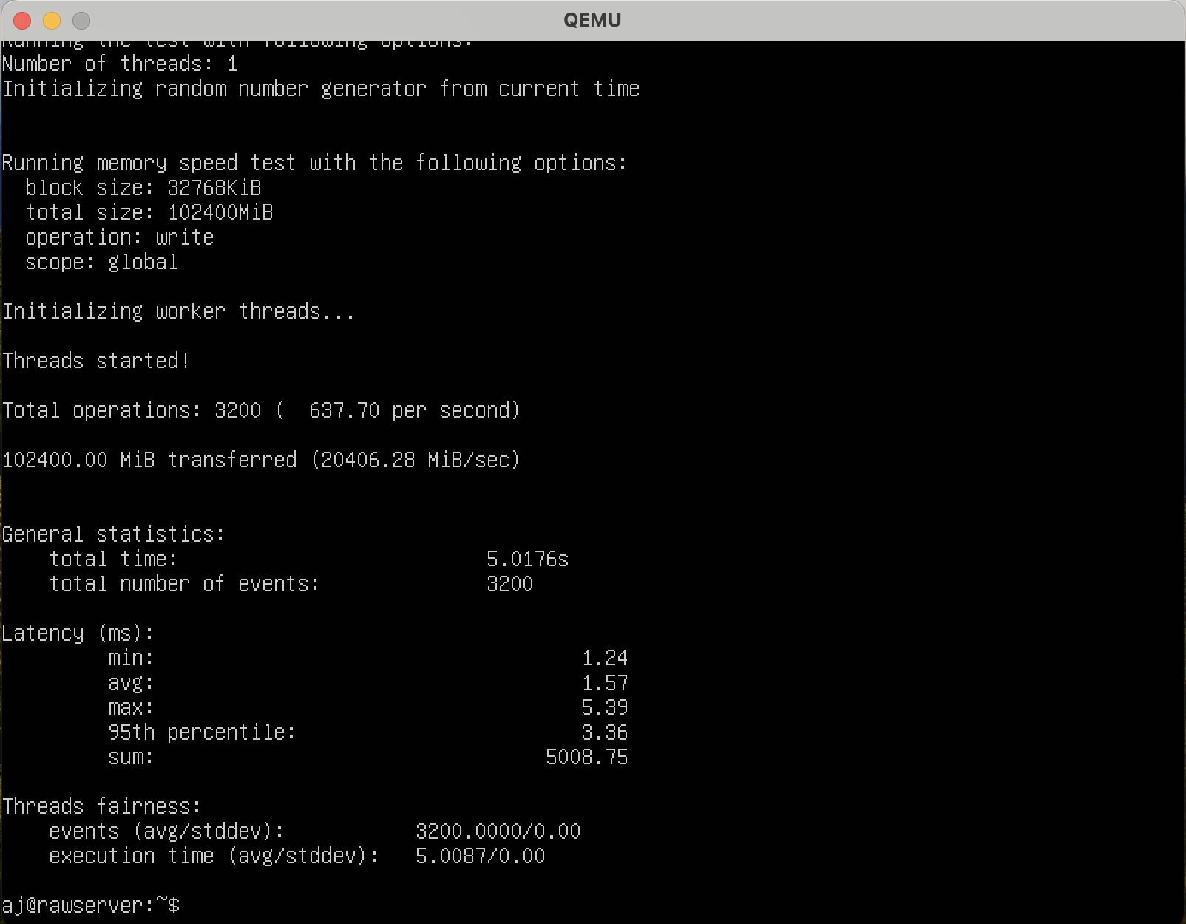

**QCOW2**

**CPU – 2 cores**

**RAM – 2Gb**

**CPU Test**

Command - sysbench cpu --threads=2 --cpu-max-prime=10000 --time=10 run

Max prime = 10000

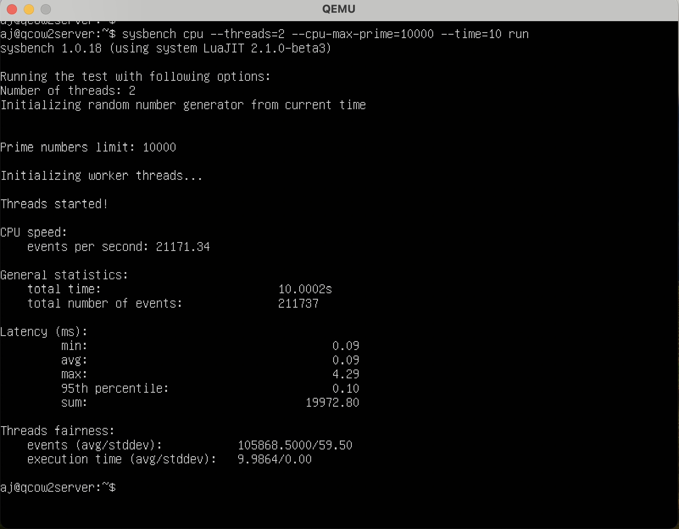

Command - sysbench cpu --threads=2 --cpu-max-prime=1000000 --time=48 run

Max prime = 1000000

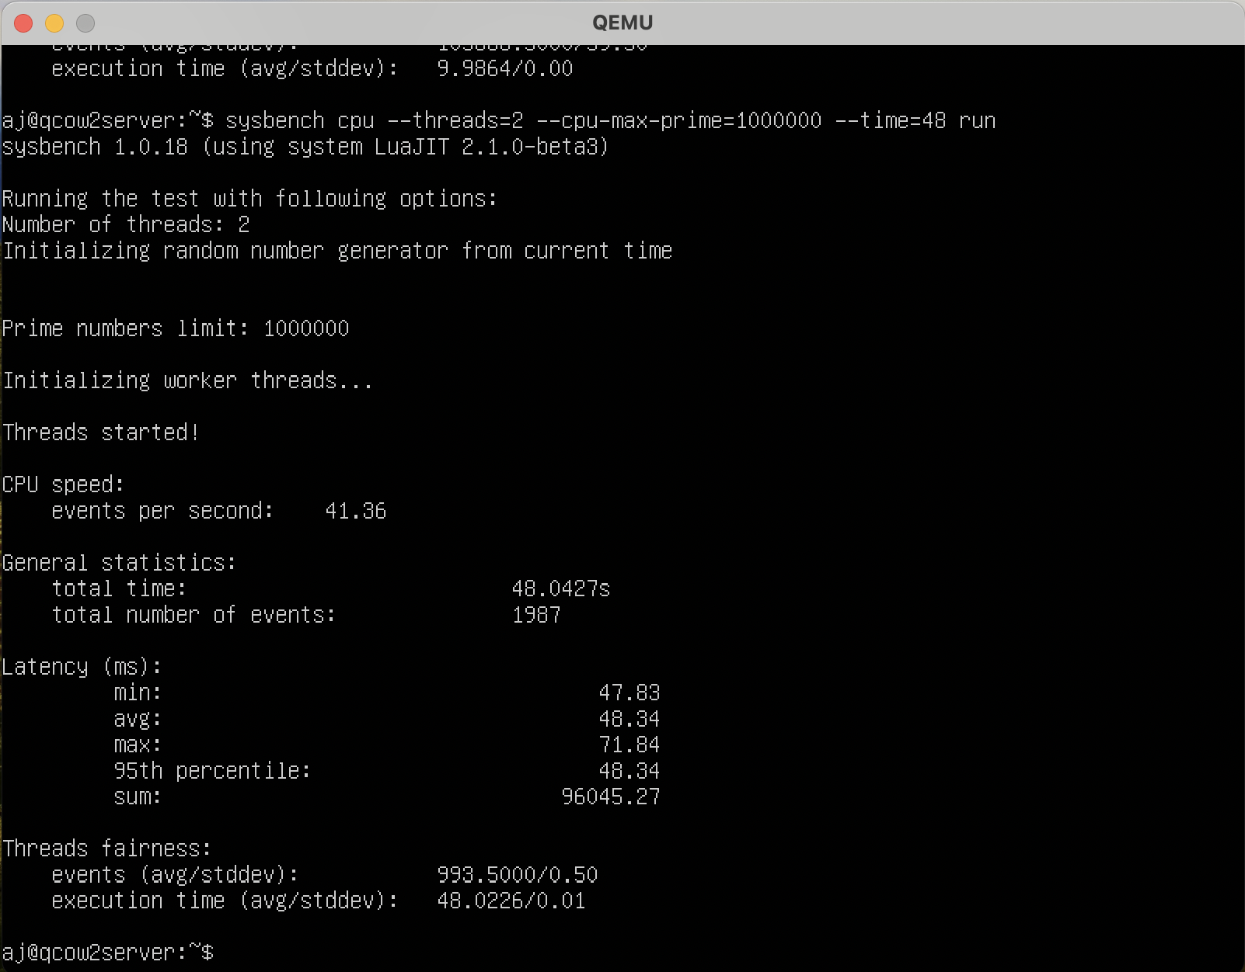

**FILE I/O-**

Prepare command –

sysbench fileio --threads=1--file-total-size=2G --file-test-mode=rndwr prepare

Run command –

sysbench fileio --threads=1--file-total-size=2G --file-test-mode=rndwr run

Cleanup Command –

sysbench fileio --threads=1--file-total-size=2G --file-test-mode=rndwr cleanup

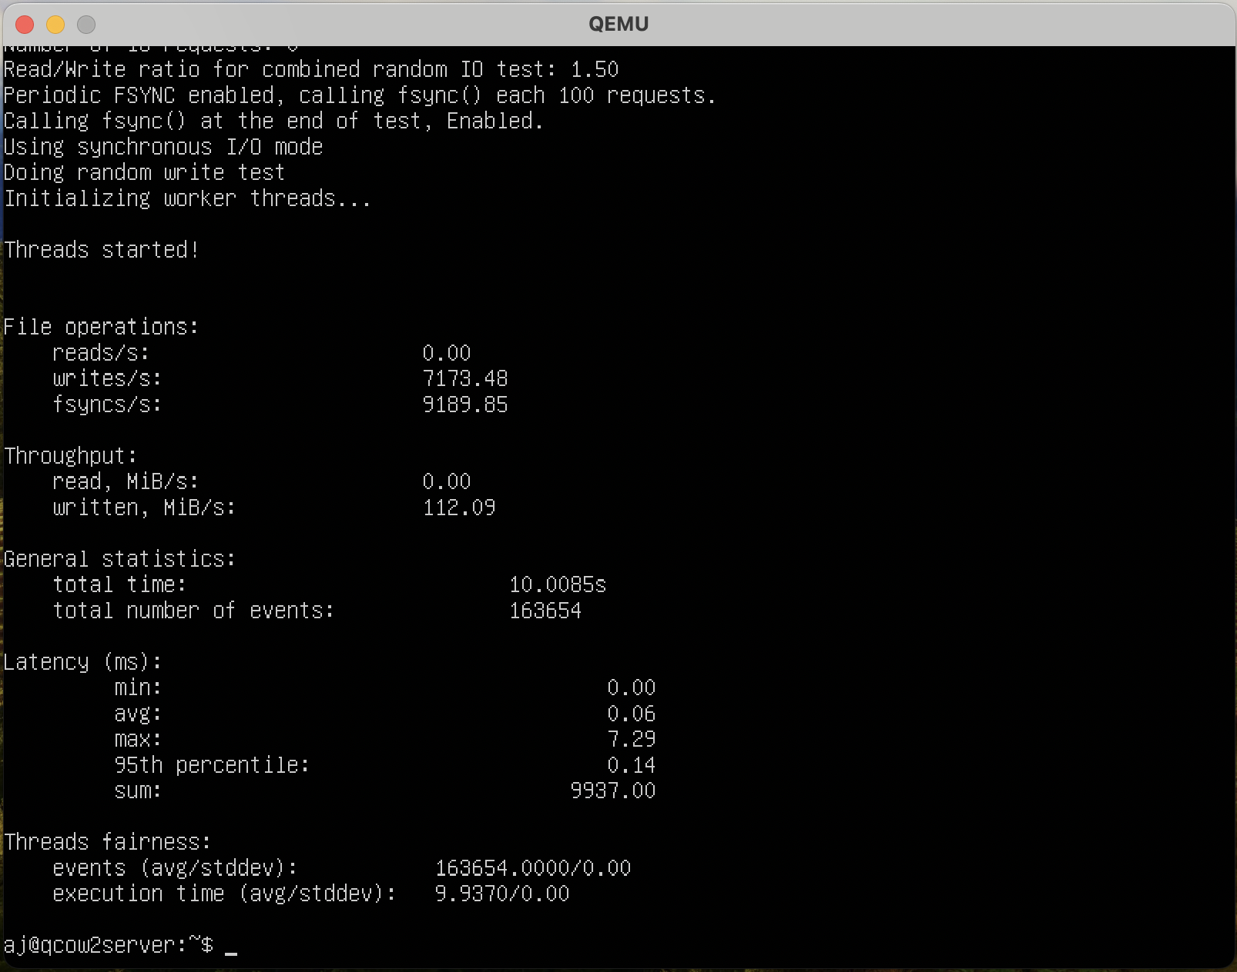

Prepare command-

sysbench fileio --threads=2 --file-total-size=4G --file-test-mode=rndwr prepare

Run command –

sysbench fileio --threads=2 --file-total-size=4G --file-test-mode=rndwr run

Cleanup Command –

sysbench fileio –threads=2 --file-total-size=4G --file-test-mode=rndwr cleanup

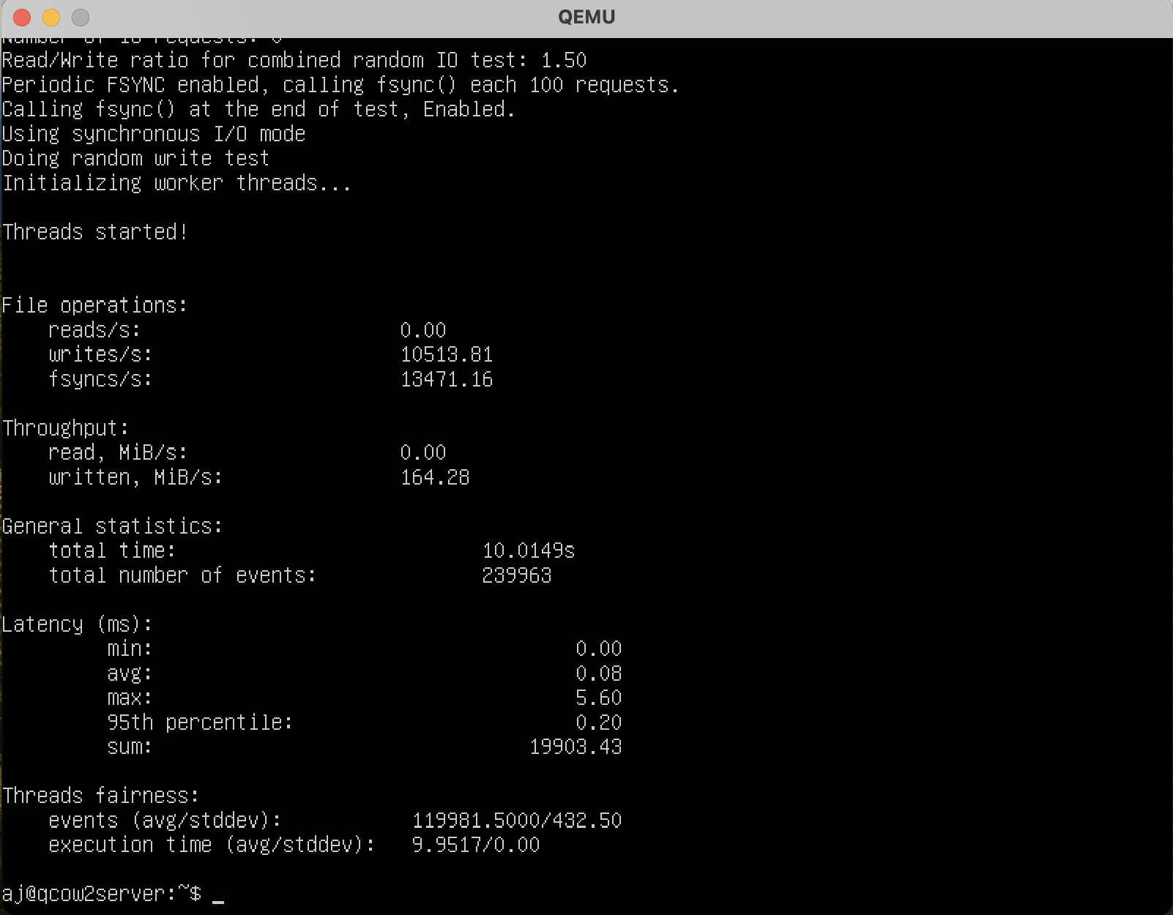

**Memory test –**

Command - sysbench memory --memory-block-size=16M run

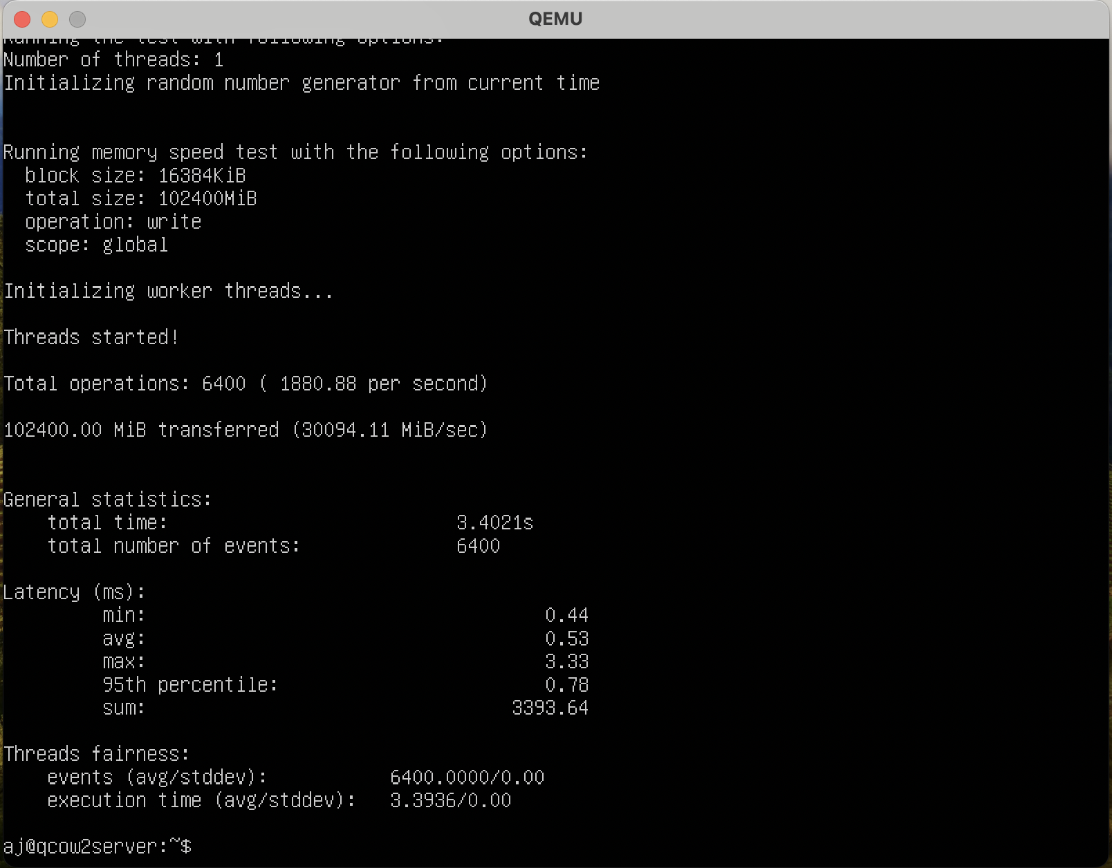

Command - sysbench memory --memory-block-size=32M run

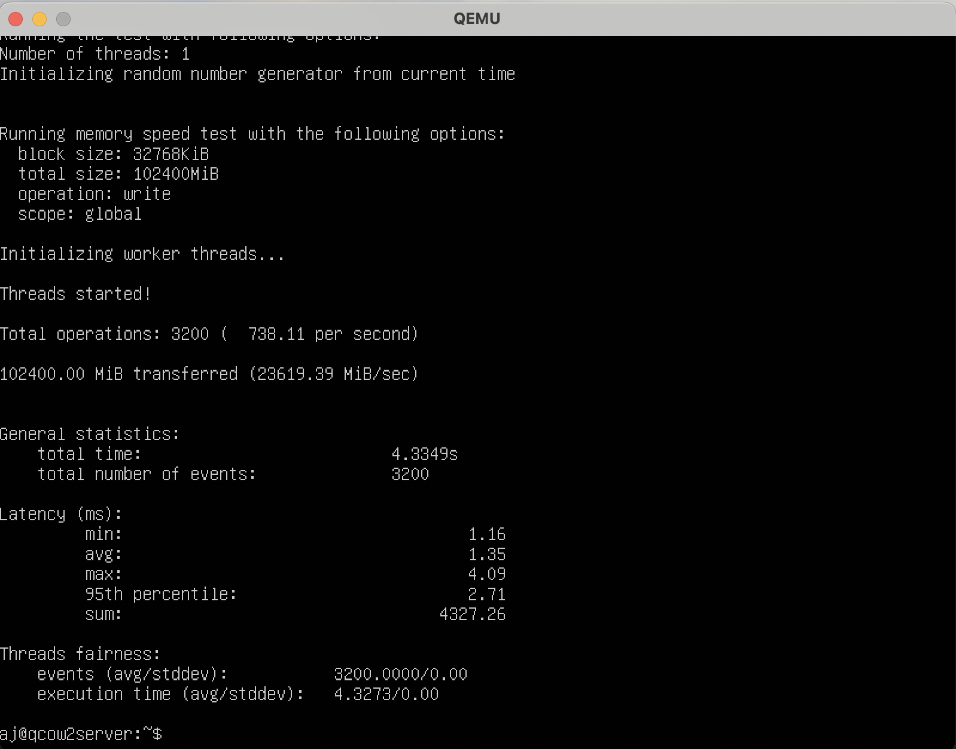

**CPU – 4 cores**

**RAM – 2Gb**

**CPU Test**

Command - sysbench cpu --threads=2 --cpu-max-prime=10000 --time=10 run

Max prime = 10000

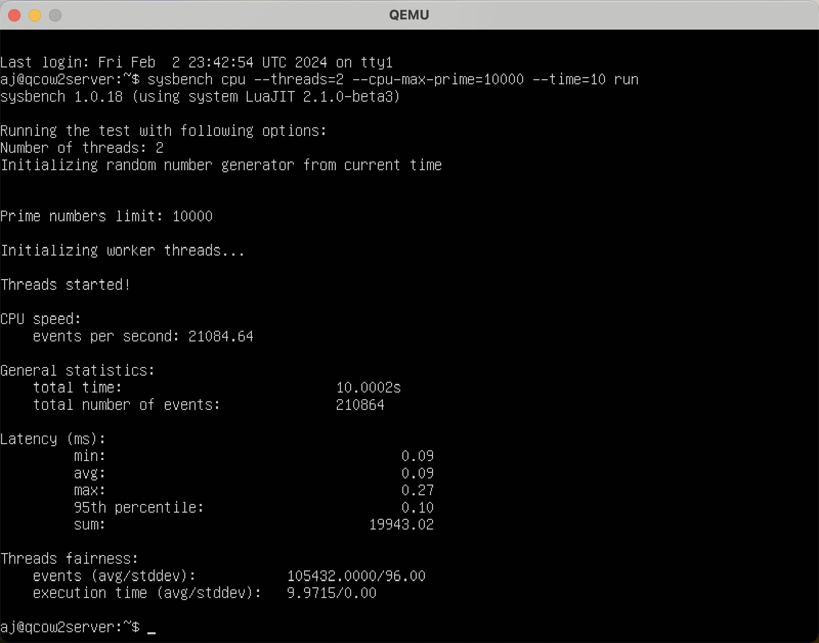

Command - sysbench cpu --threads=2 --cpu-max-prime=1000000 --time=48 run

Max prime = 1000000

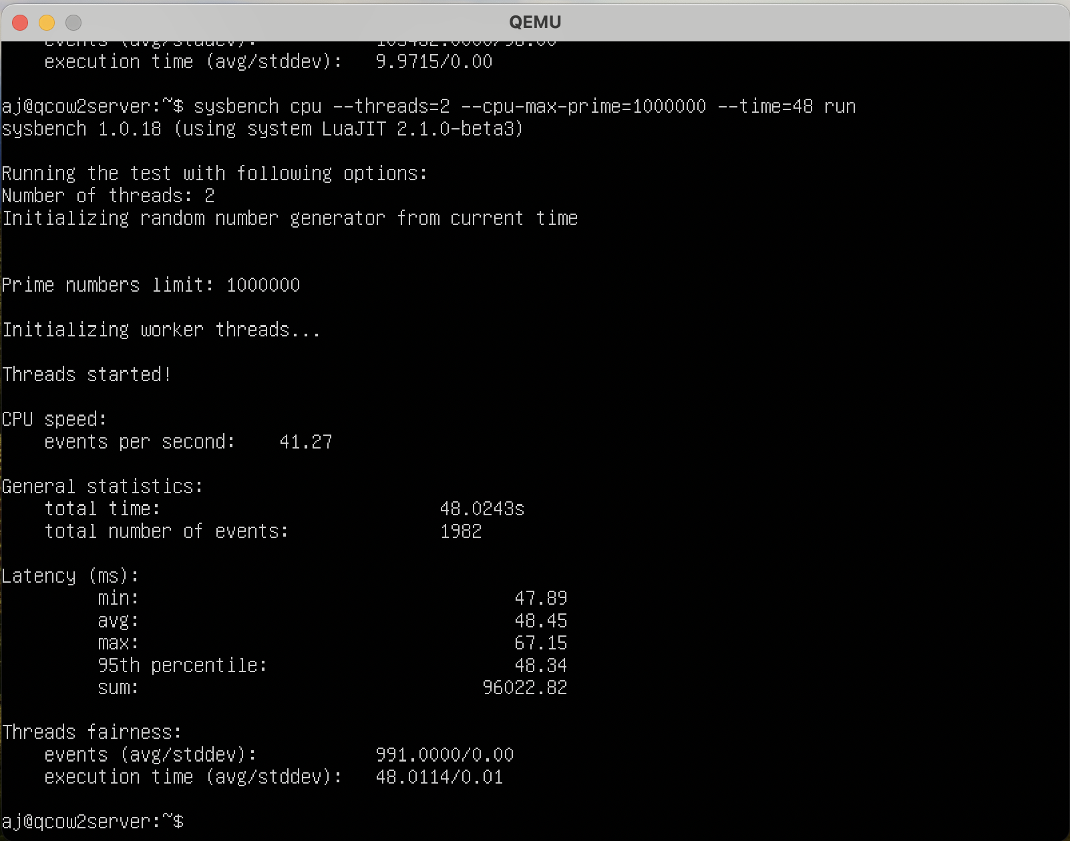

**FILE I/O-**

Prepare command –

sysbench fileio --threads=1--file-total-size=2G --file-test-mode=rndwr prepare

Run command –

sysbench fileio --threads=1--file-total-size=2G --file-test-mode=rndwr run

Cleanup Command –

sysbench fileio --threads=1--file-total-size=2G --file-test-mode=rndwr cleanup

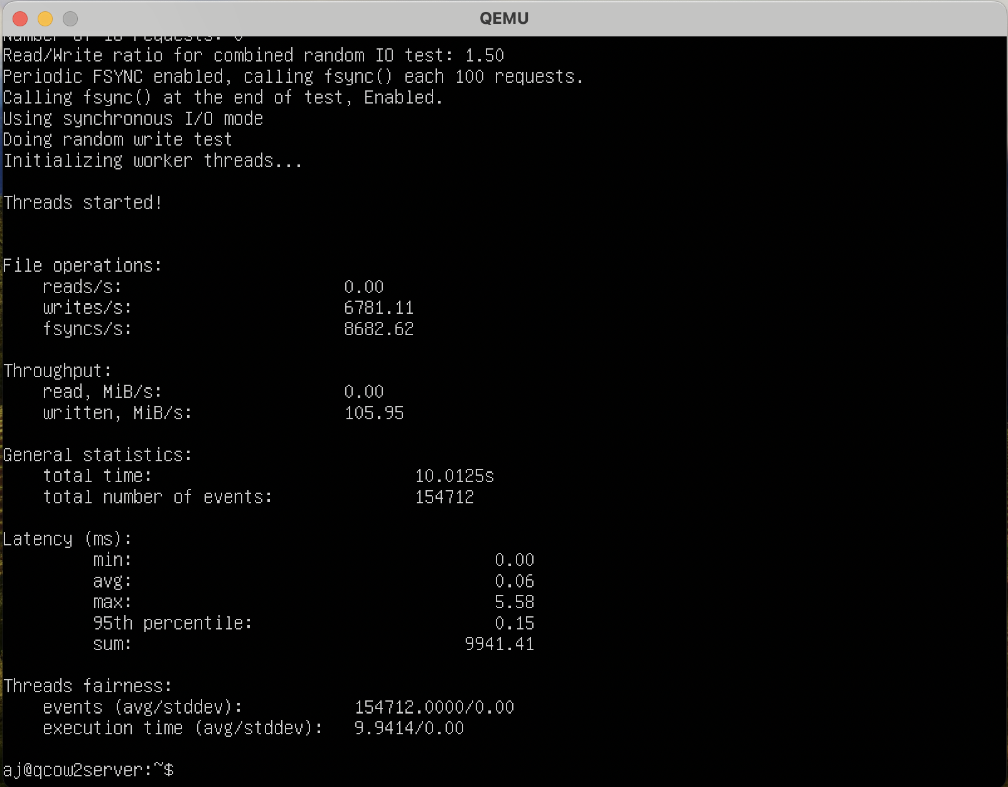

Prepare command –

sysbench fileio --threads=2 --file-total-size=4G --file-test-mode=rndwr prepare

Run command –

sysbench fileio --threads=2 --file-total-size=4G --file-test-mode=rndwr run

Cleanup Command –

sysbench fileio --threads=2 --file-total-size=4G --file-test-mode=rndwr cleanup

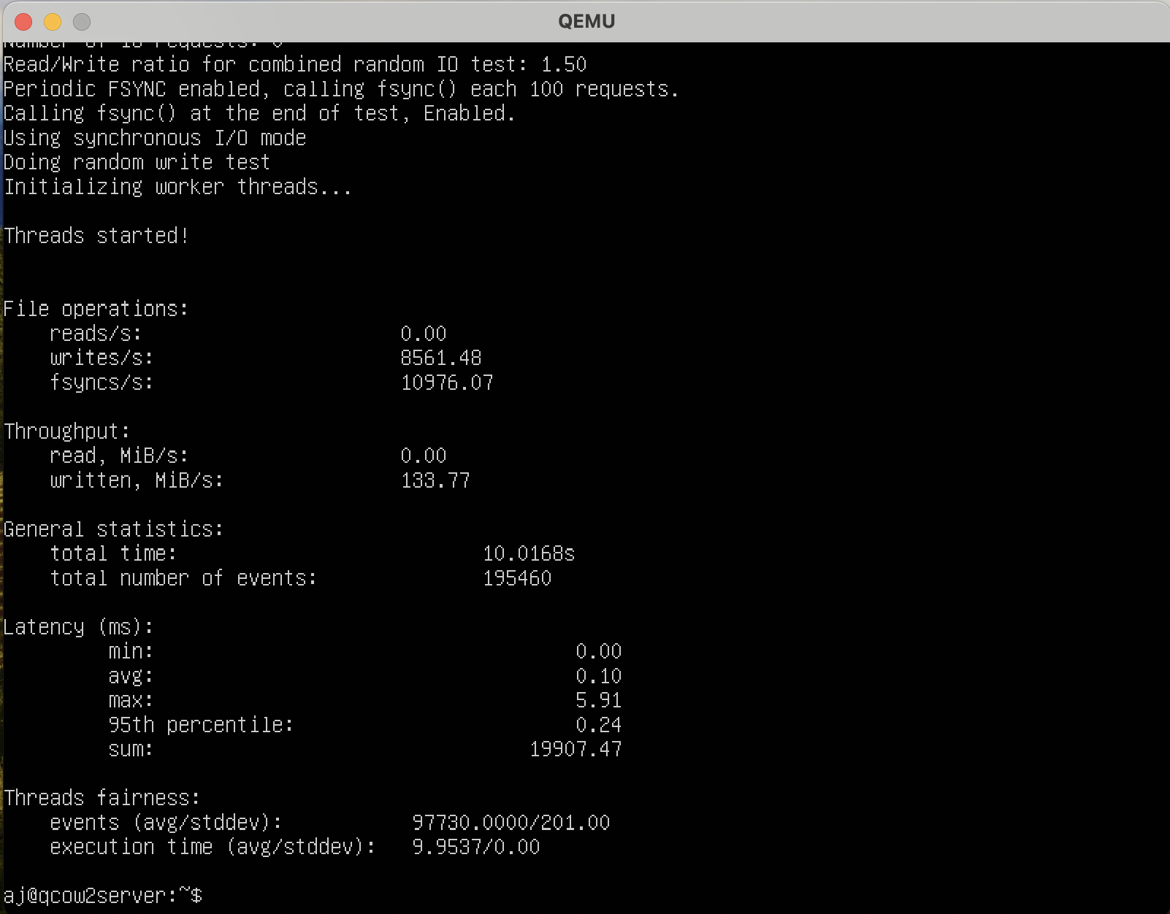

**Memory test**

Command - sysbench memory --memory-block-size=16M run

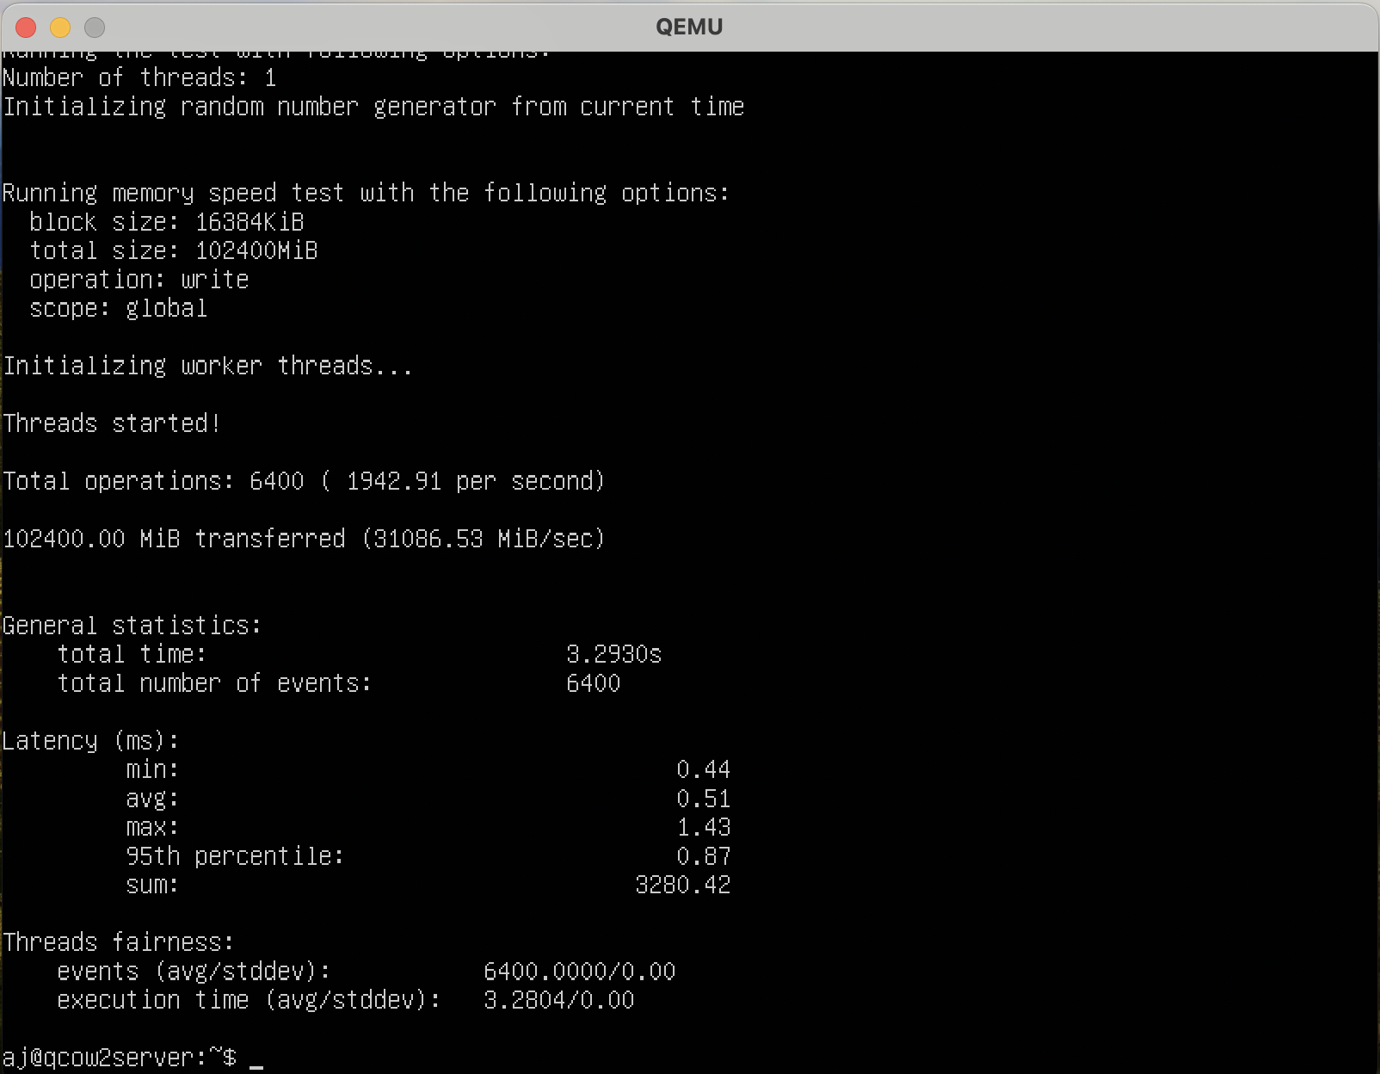

Command - sysbench memory --memory-block-size=32M run

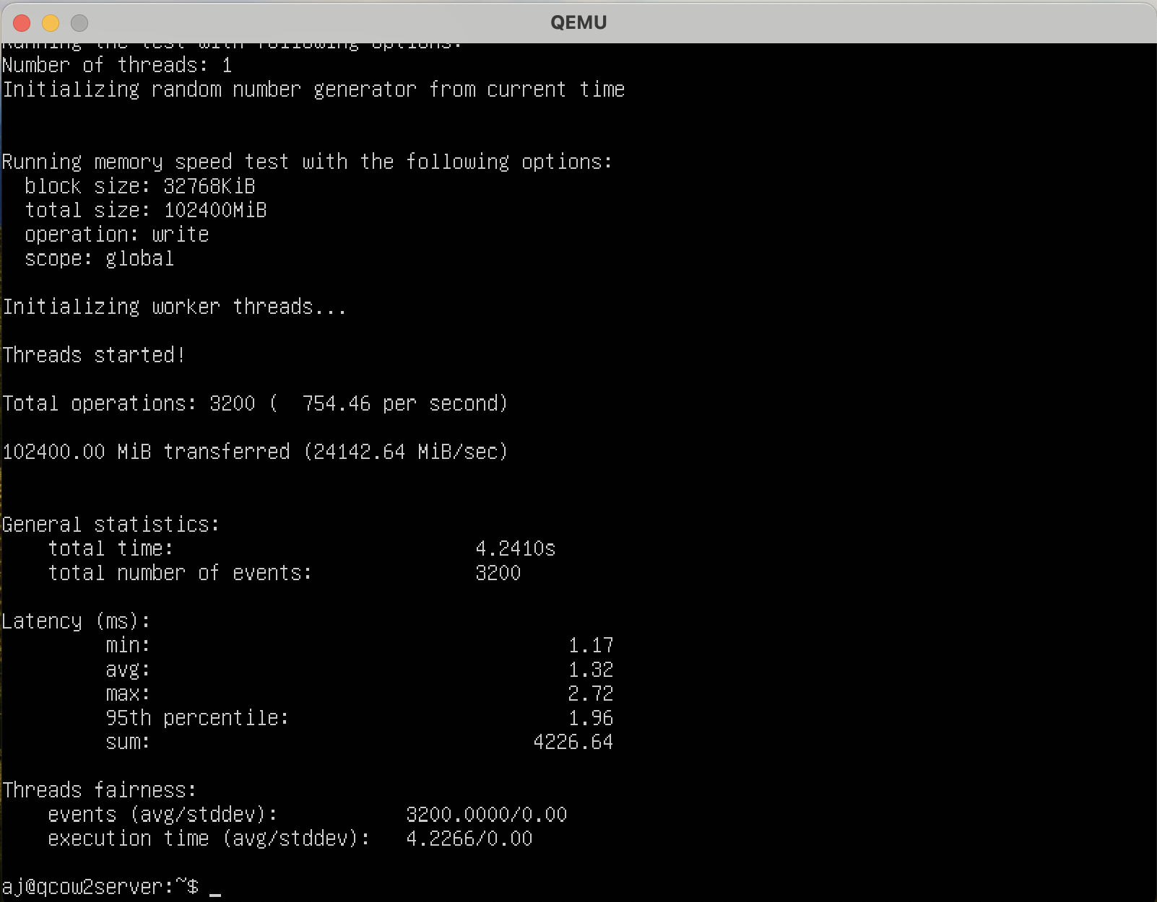

**CPU – 4 cores**

**RAM – 1Gb**

**CPU Test**

Command - sysbench cpu --threads=2 --cpu-max-prime=10000 --time=10 run

Max prime = 10000

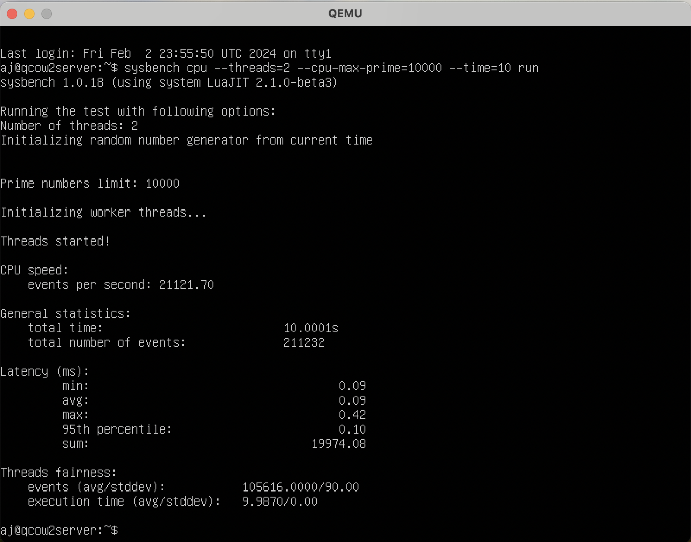

Command - sysbench cpu --threads=2 --cpu-max-prime=1000000 --time=48 run

Max prime = 1000000

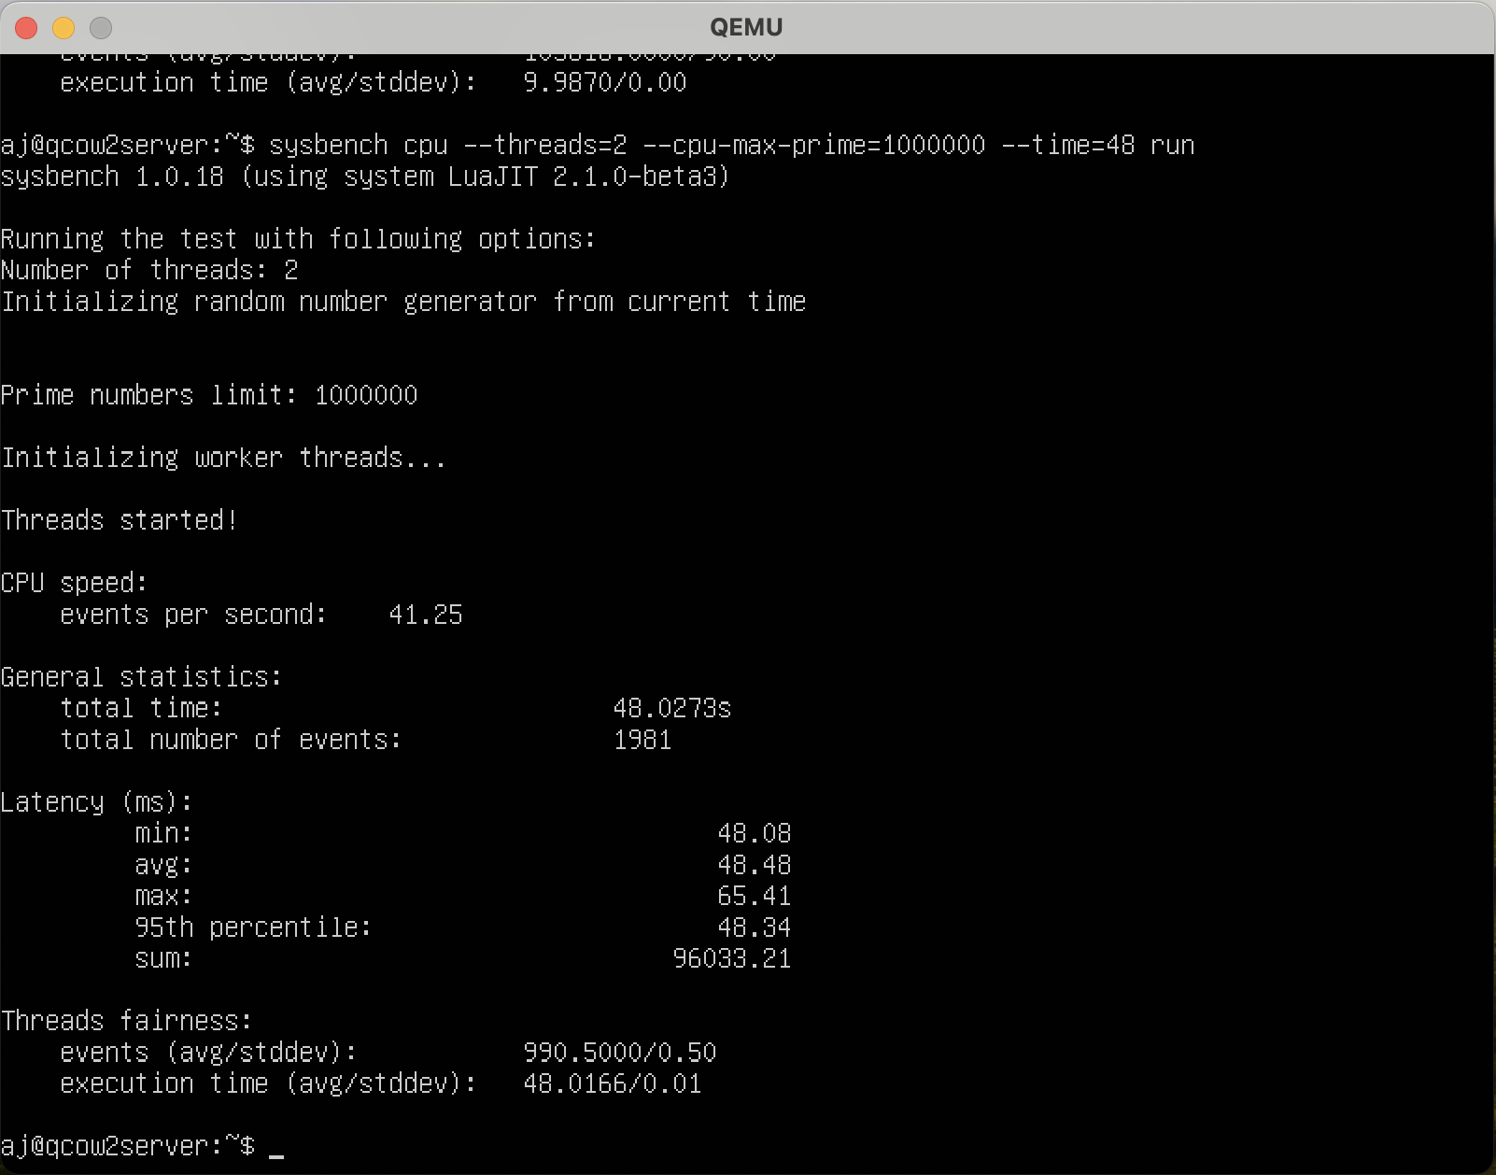

**FILE I/O-**

Prepare command –

sysbench fileio --threads=1--file-total-size=2G --file-test-mode=rndwr prepare

Run command –

sysbench fileio --threads=1 --file-total-size=2G --file-test-mode=rndwr run

Cleanup Command –

sysbench fileio --threads=1 --file-total-size=2G --file-test-mode=rndwr cleanup

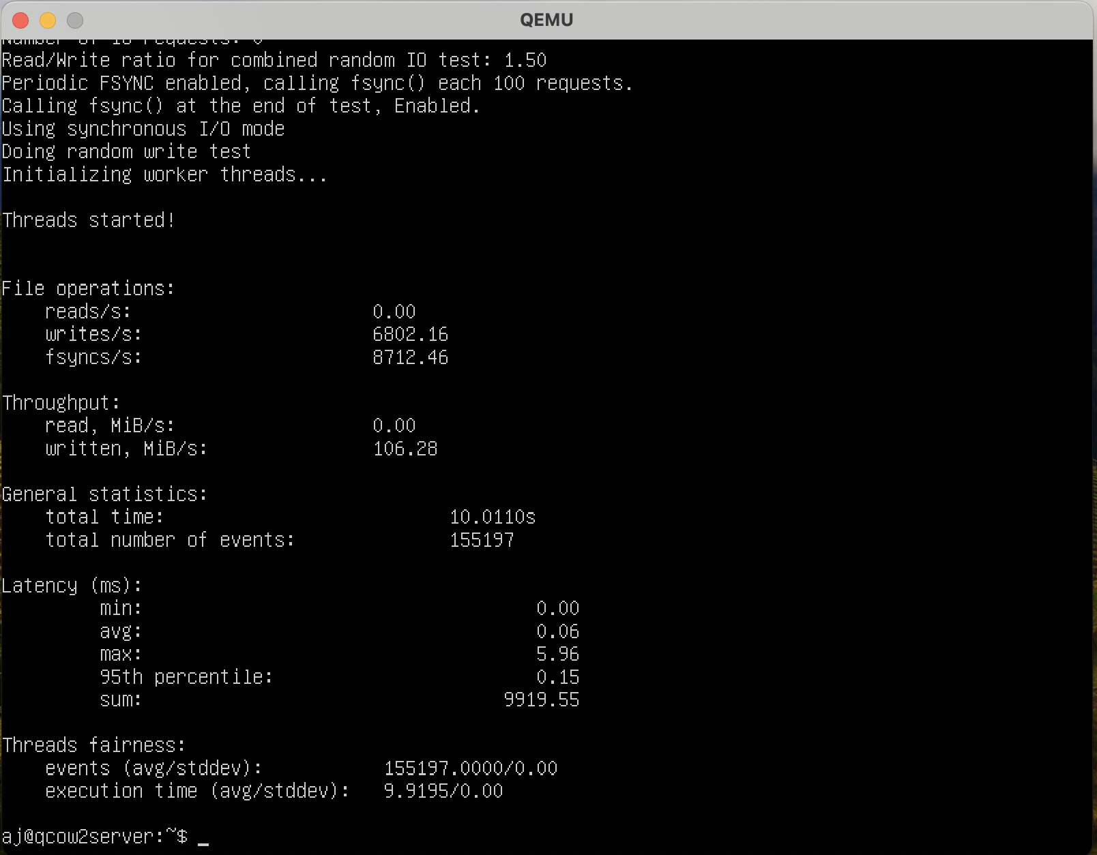

Prepare command –

sysbench fileio --threads=2 --file-total-size=4G --file-test-mode=rndwr prepare

Run command –

sysbench fileio --threads=2 --file-total-size=4G --file-test-mode=rndwr run

Cleanup Command –

sysbench fileio --threads=2 --file-total-size=4G --file-test-mode=rndwr cleanup

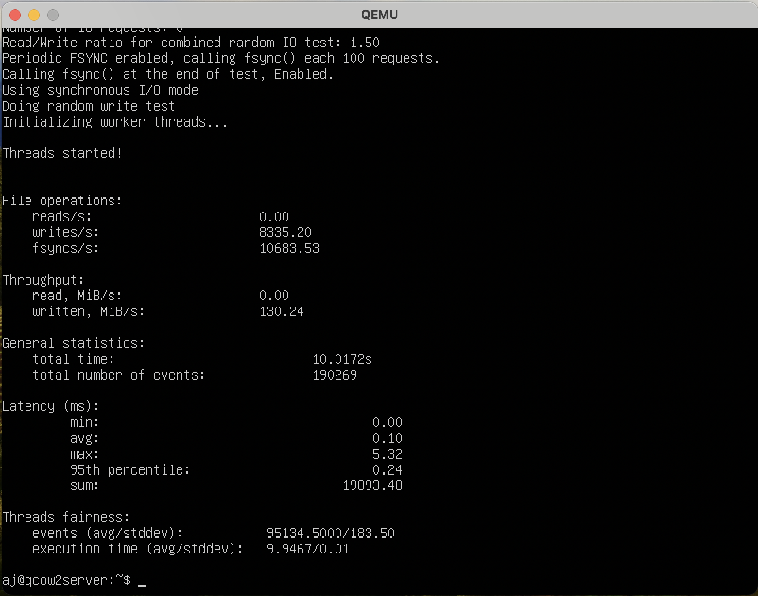

**Memory test**

Command - sysbench memory --memory-block-size=16M run

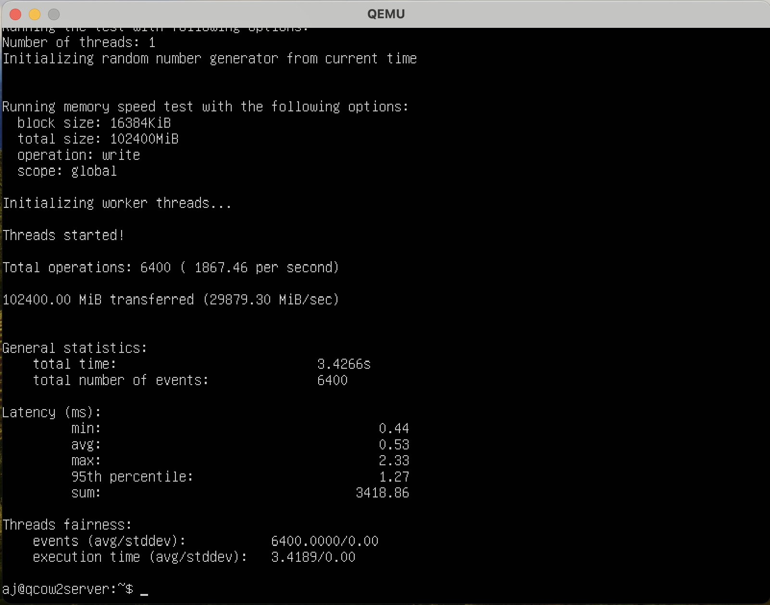

Command - sysbench memory --memory-block-size=32M run

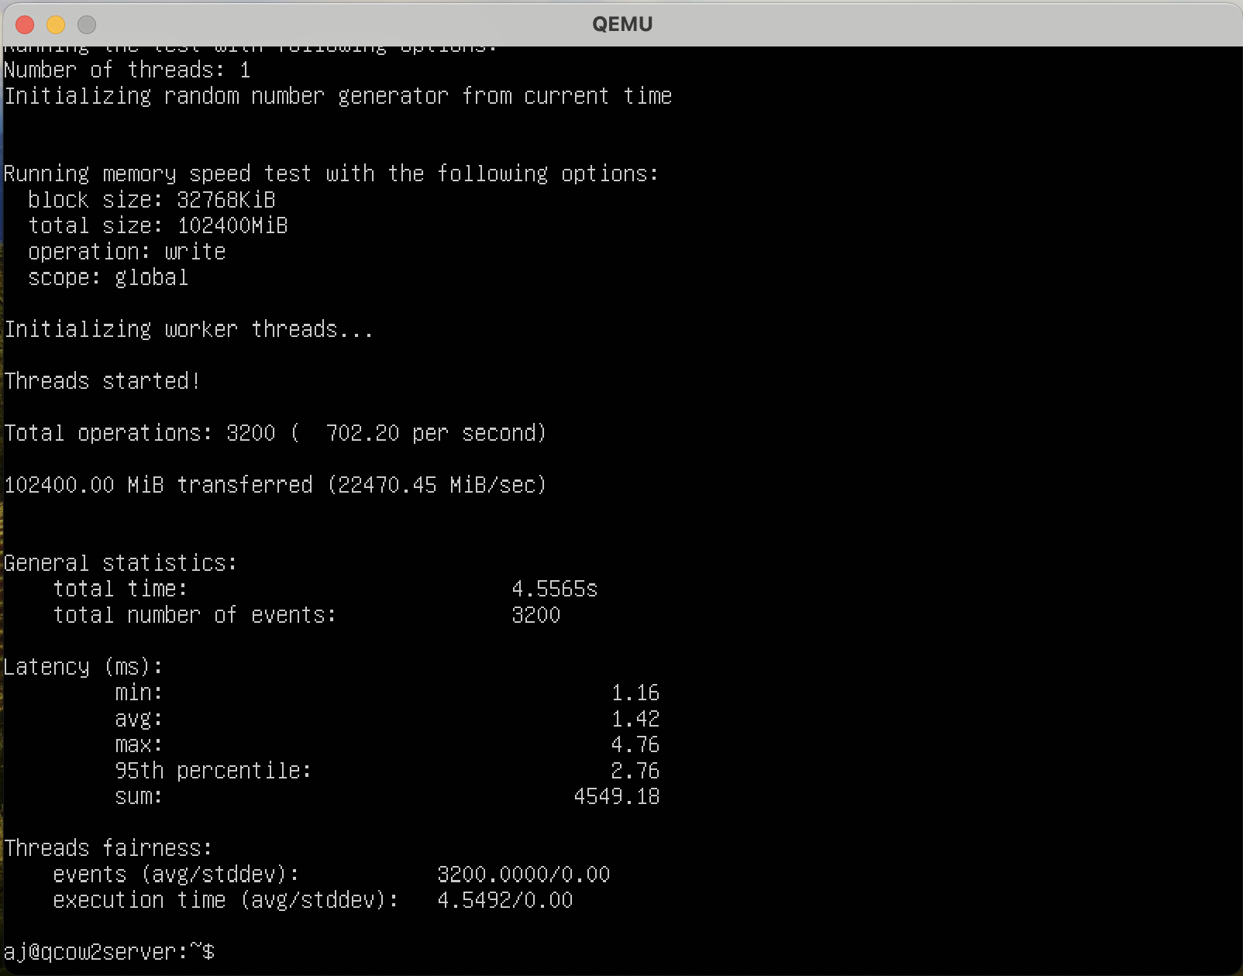

**CPU – 2 cores**

**RAM – 1Gb**

**CPU Test**

Command - sysbench cpu --threads=2 --cpu-max-prime=10000 --time=10 run

Max prime = 10000

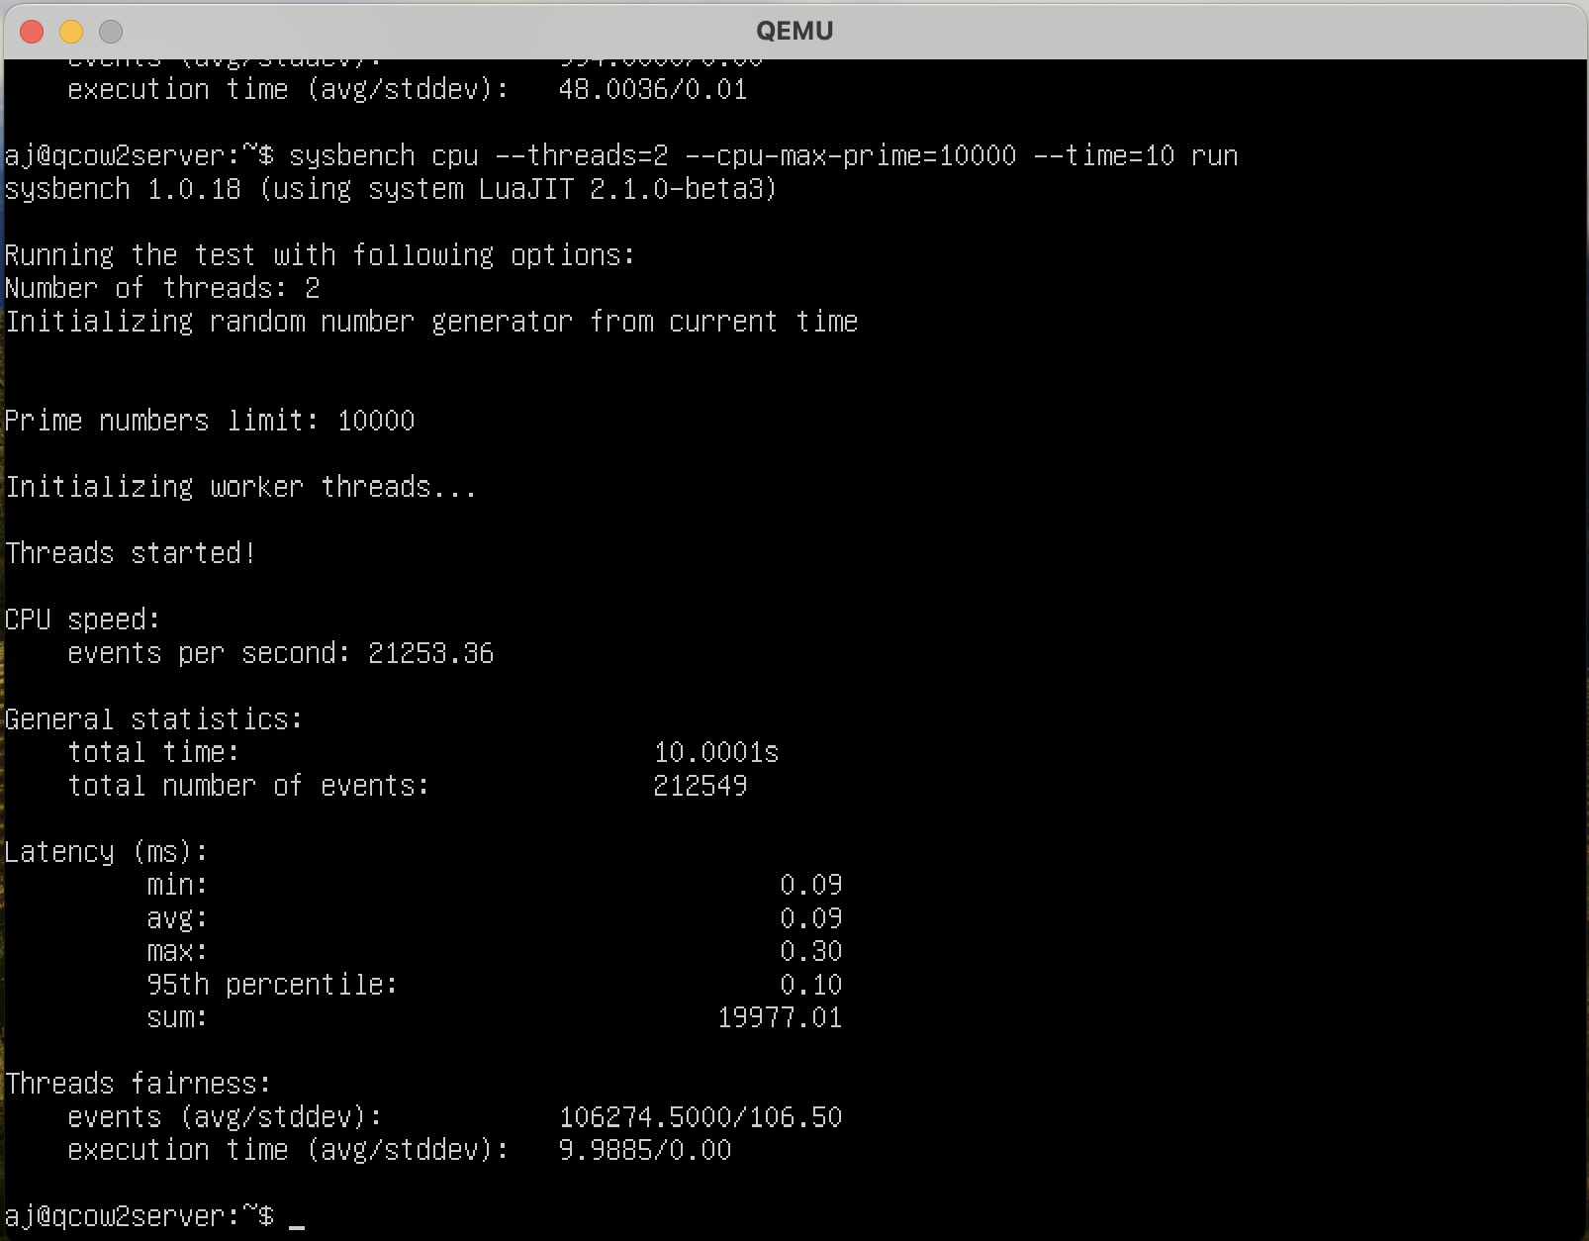

Command - sysbench cpu --threads=2 --cpu-max-prime=1000000 --time=48 run

Max prime = 1000000

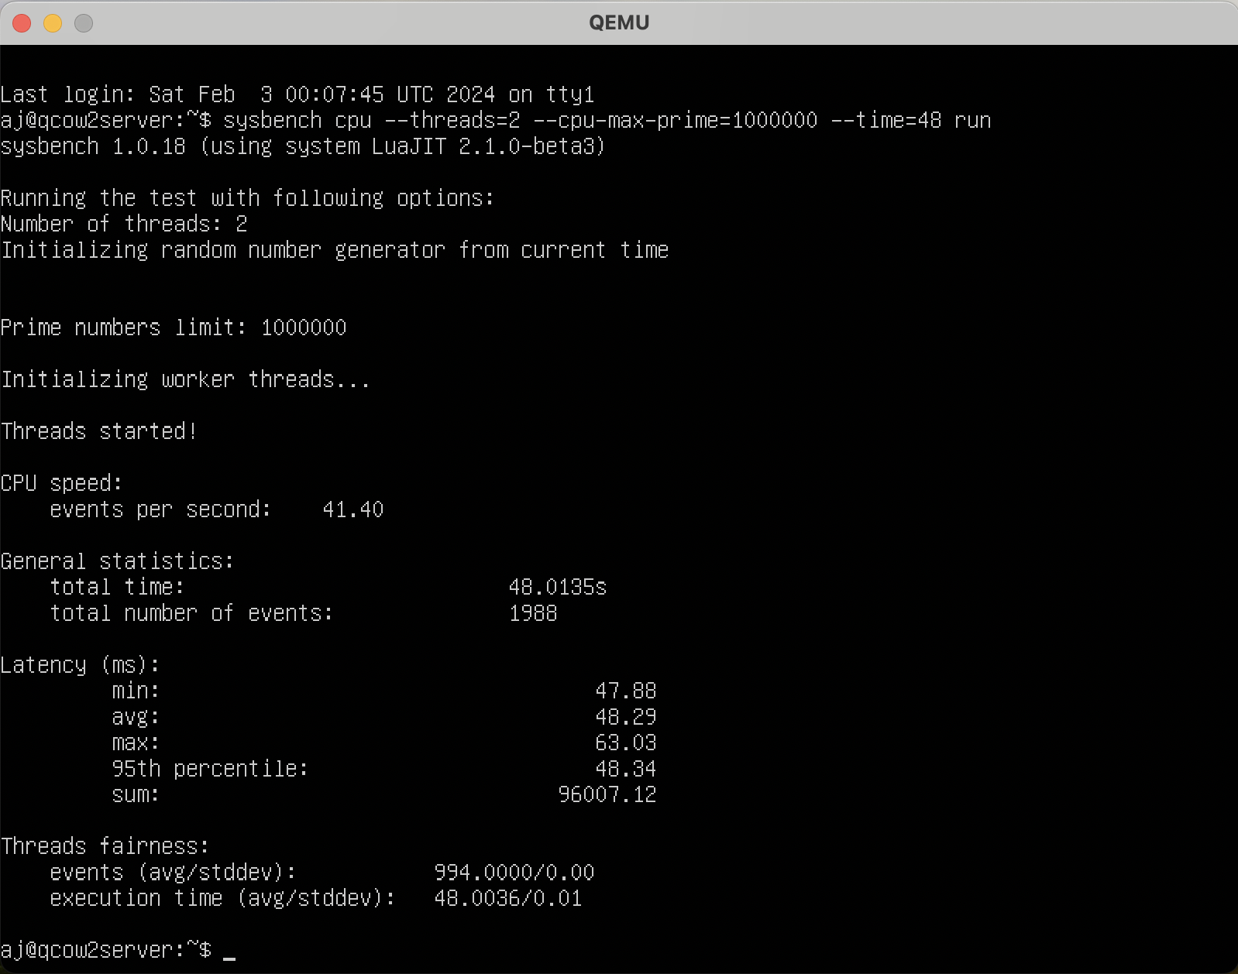

**FILE I/O-**

Prepare command –

sysbench fileio --threads=1--file-total-size=2G --file-test-mode=rndwr prepare

Run command –

sysbench fileio --threads=1 --file-total-size=2G --file-test-mode=rndwr run

Cleanup Command –

sysbench fileio --threads=1 --file-total-size=2G --file-test-mode=rndwr cleanup

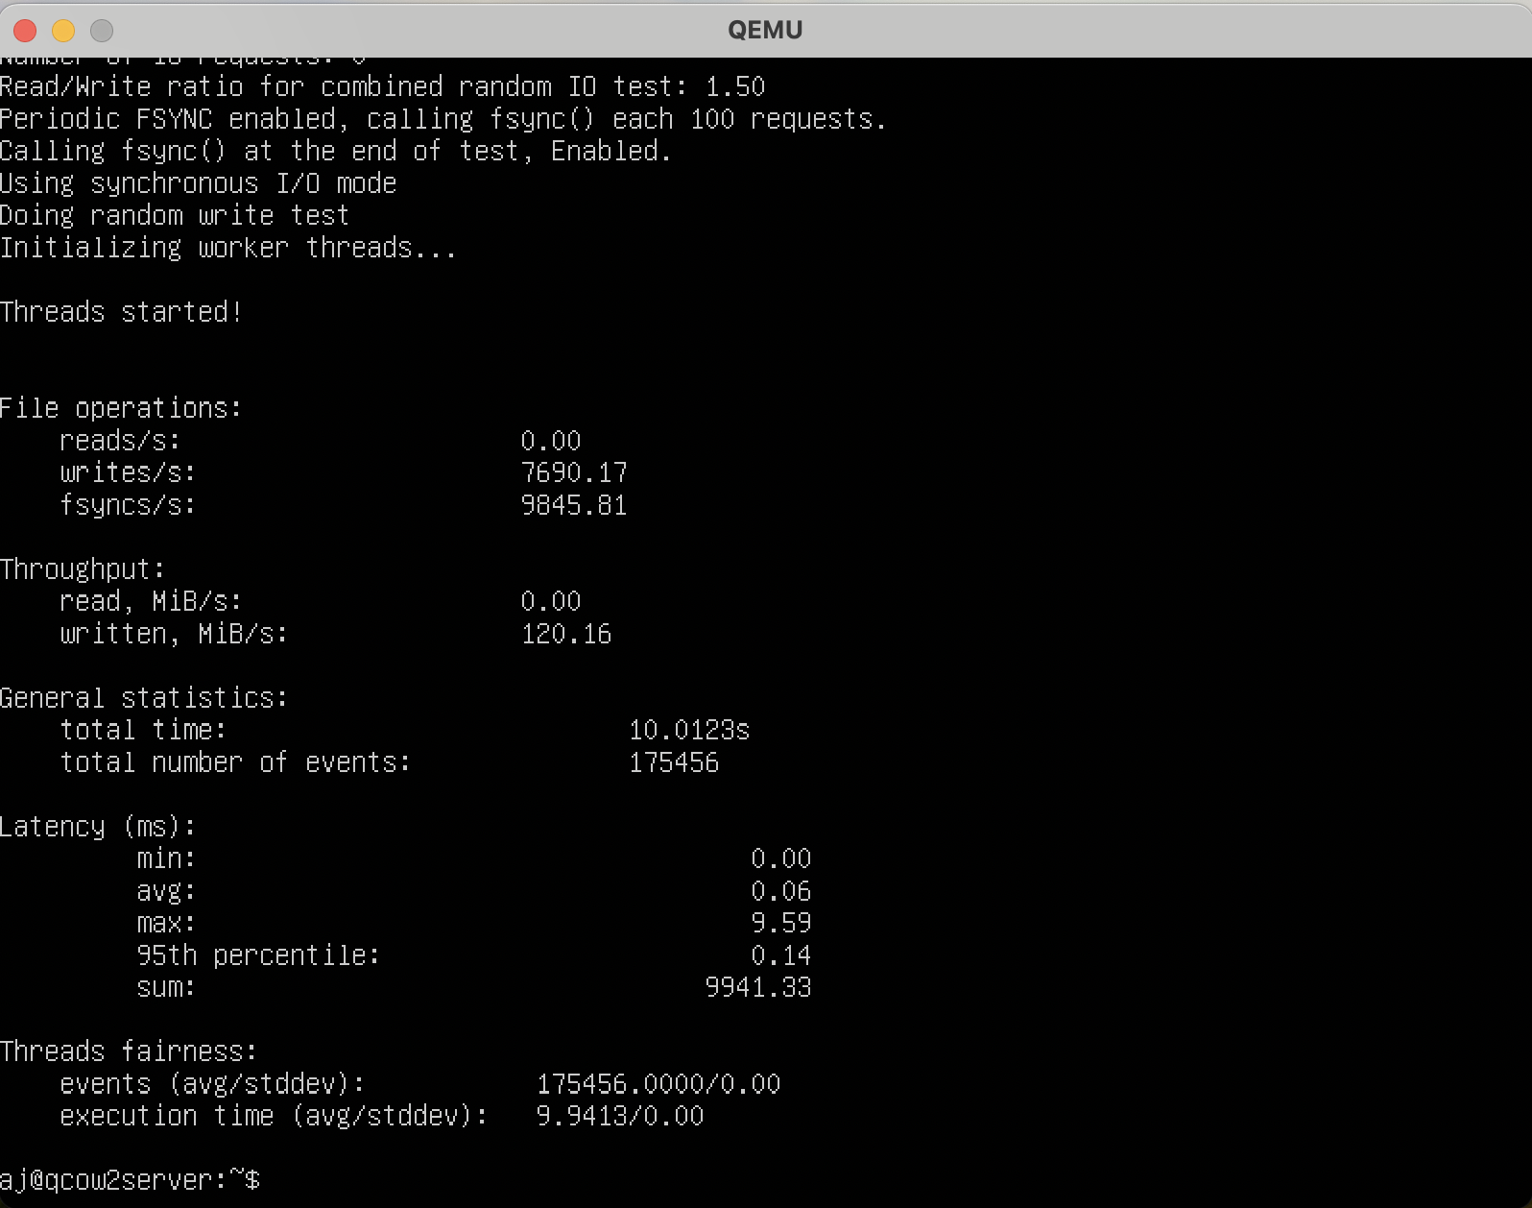

Prepare command –

sysbench fileio --threads=1--file-total-size=2G --file-test-mode=rndwr prepare

Run command –

sysbench fileio --threads=1 --file-total-size=2G --file-test-mode=rndwr run

Cleanup Command –

sysbench fileio --threads=1 --file-total-size=2G --file-test-mode=rndwr cleanup

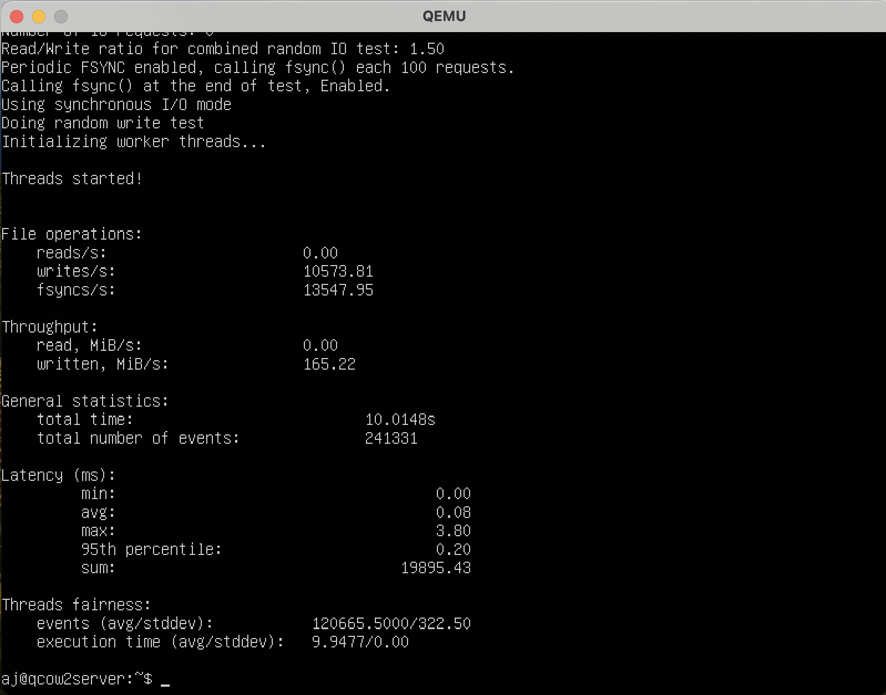

**Memory test**

Command - sysbench memory --memory-block-size=16M run

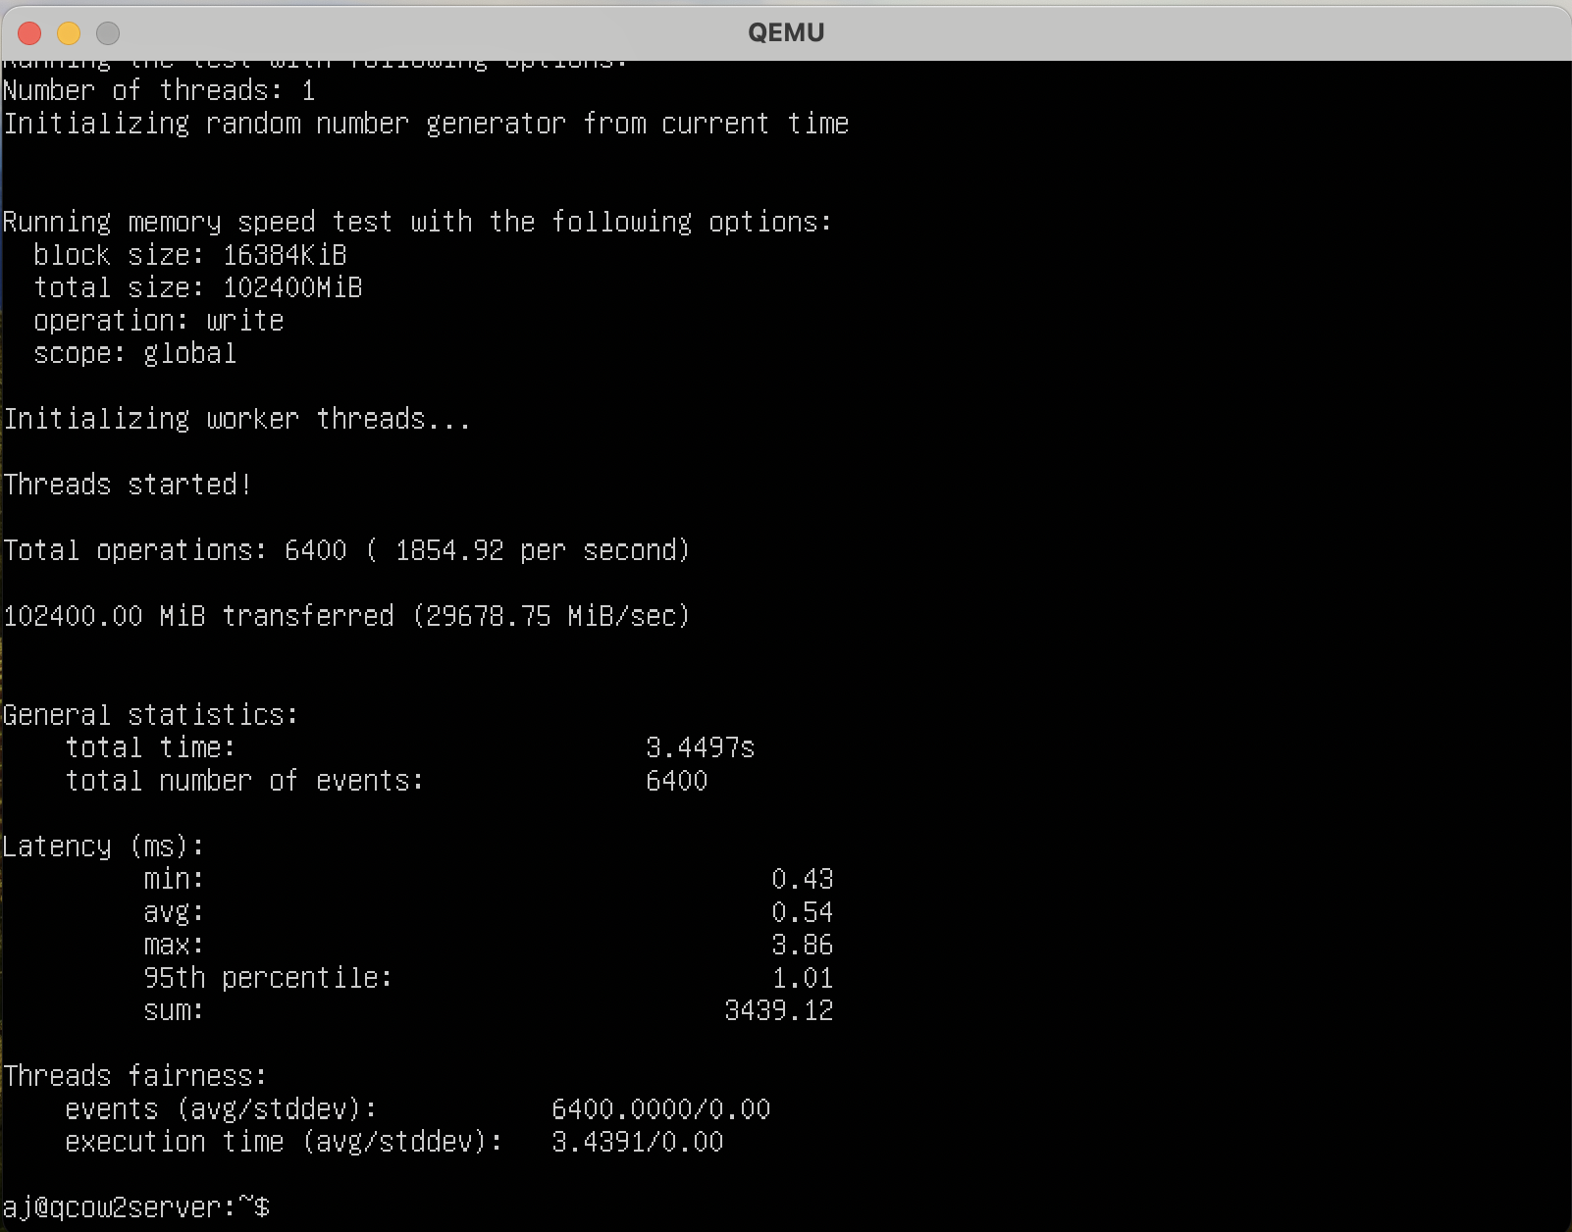

sysbench memory --memory-block-size=32M run

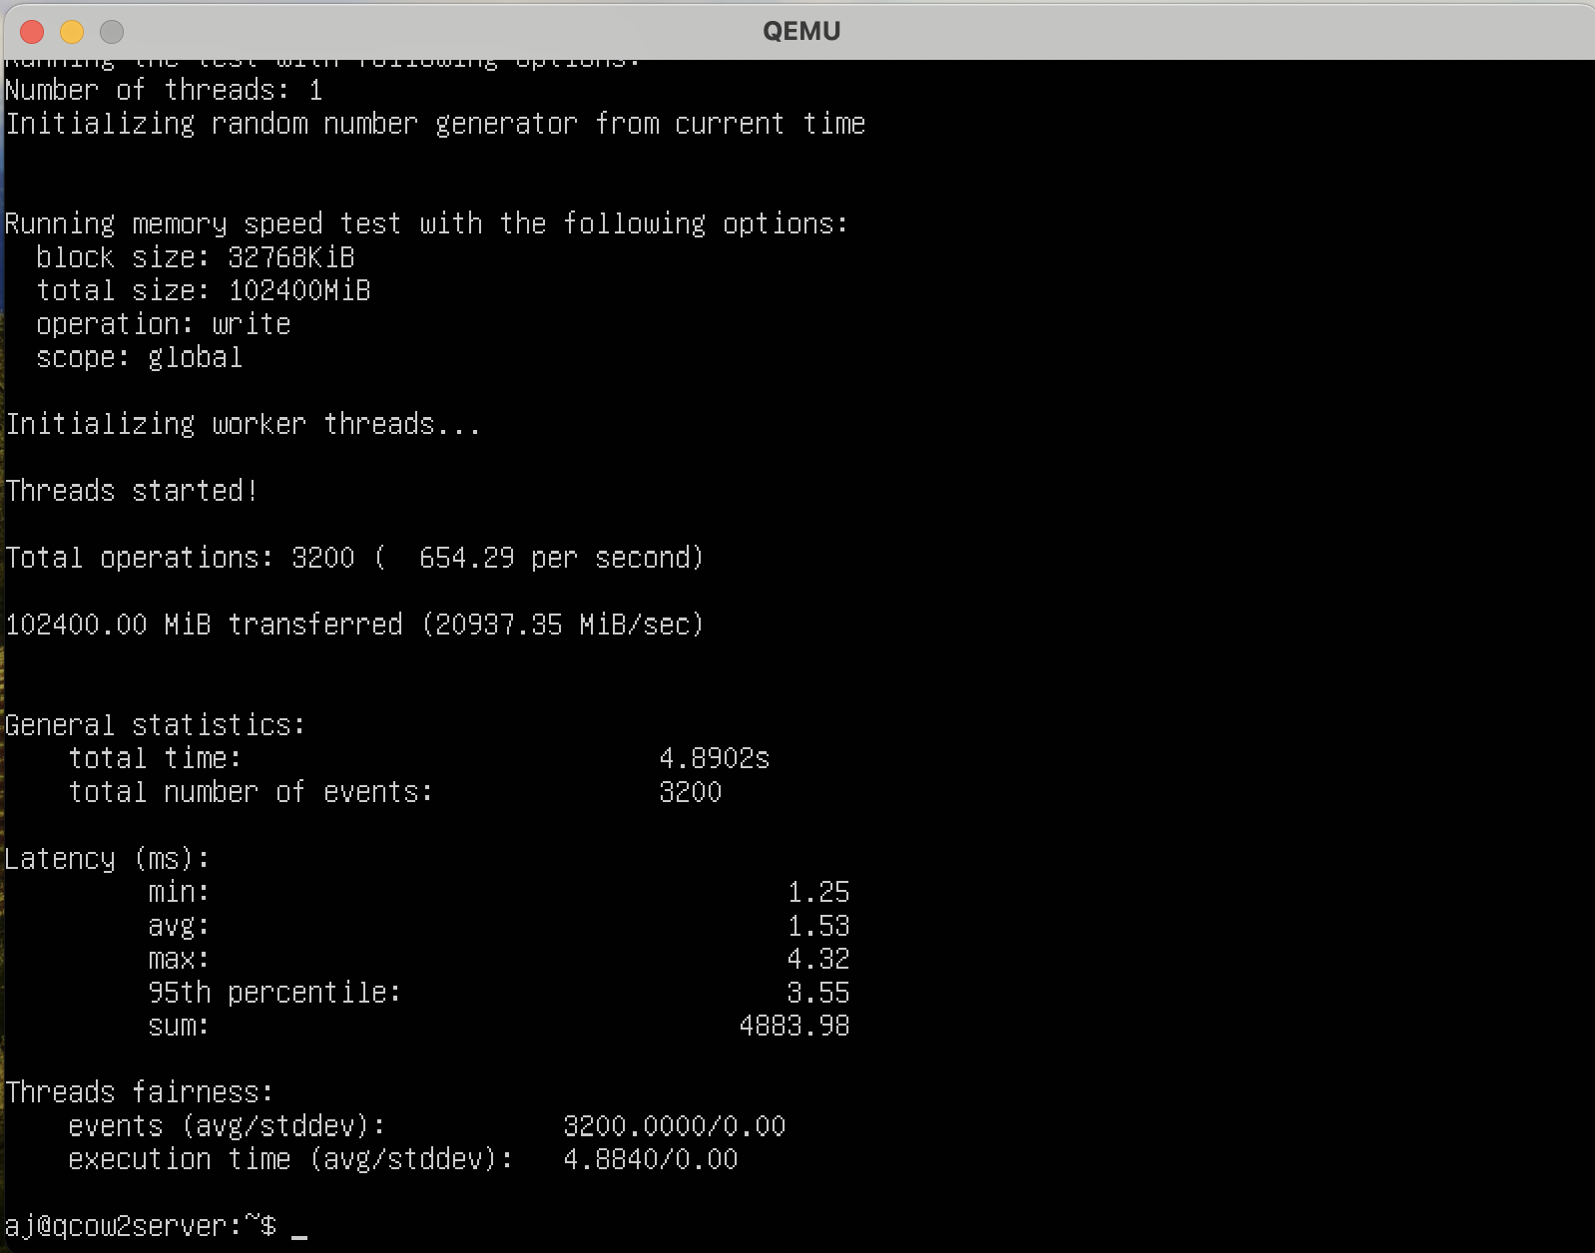

**Docker**

**Cpu - 2 cores**

**Ram – 2gb**

**CPU test**

Command - sysbench cpu --threads=2 --cpu-max-prime=10000 --time=10 run

Max prime = 10000

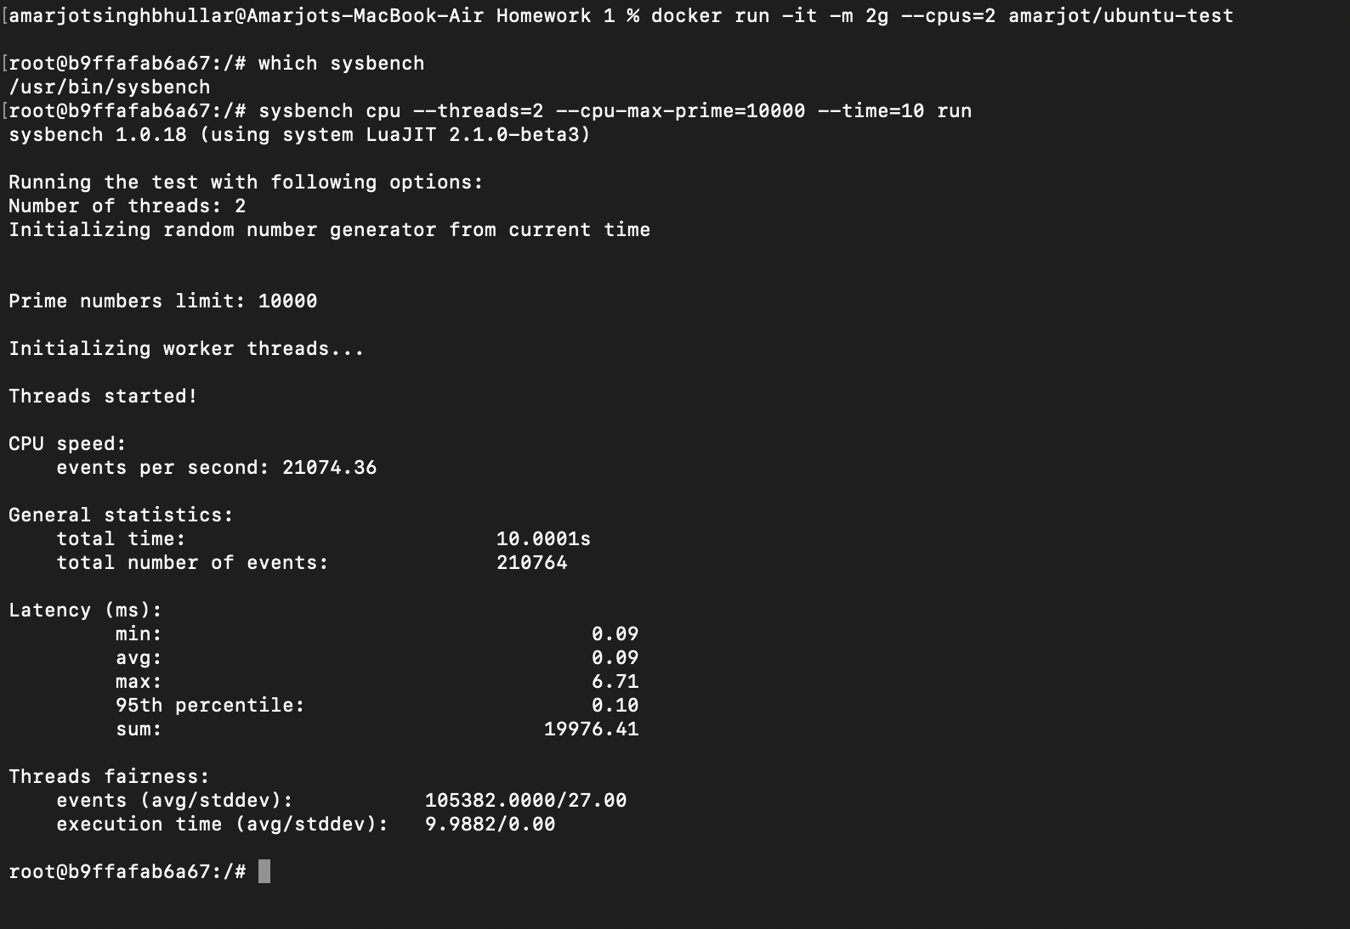

Command - sysbench cpu --threads=2 --cpu-max-prime=1000000 --time=48 run

Max prime = 1000000

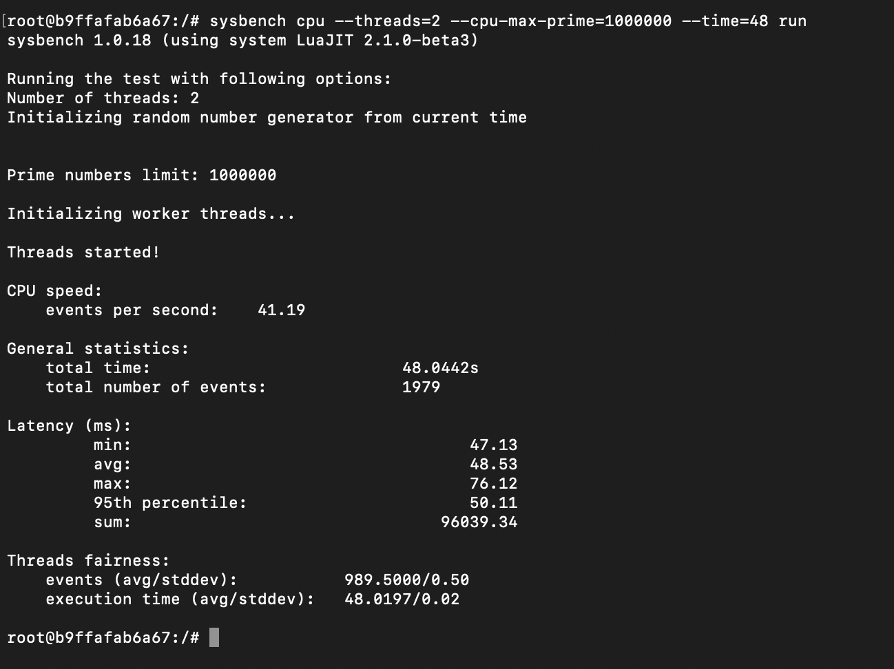

**FILE I/O-**

Prepare command –

sysbench fileio --threads=1--file-total-size=2G --file-test-mode=rndwr prepare

Run command –

sysbench fileio --threads=1 --file-total-size=2G --file-test-mode=rndwr run

Cleanup Command –

sysbench fileio --threads=1 --file-total-size=2G --file-test-mode=rndwr cleanup

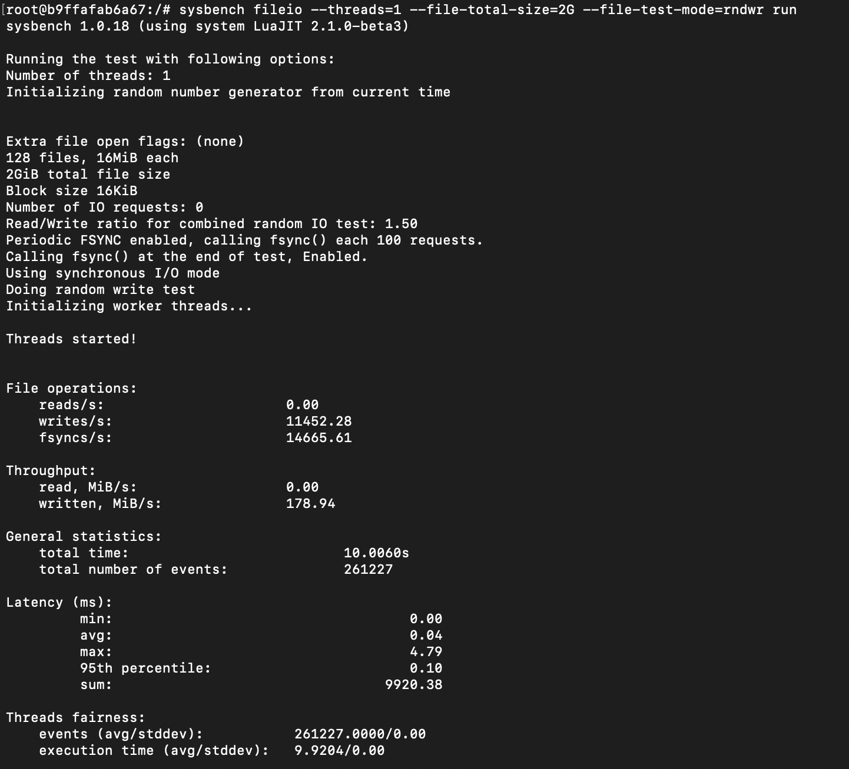

Prepare command –

sysbench fileio --threads=2 --file-total-size=4G --file-test-mode=rndwr prepare

Run command –

sysbench fileio --threads=2 --file-total-size=4G --file-test-mode=rndwr run

Cleanup Command –

sysbench fileio --threads=2 --file-total-size=4G --file-test-mode=rndwr cleanup

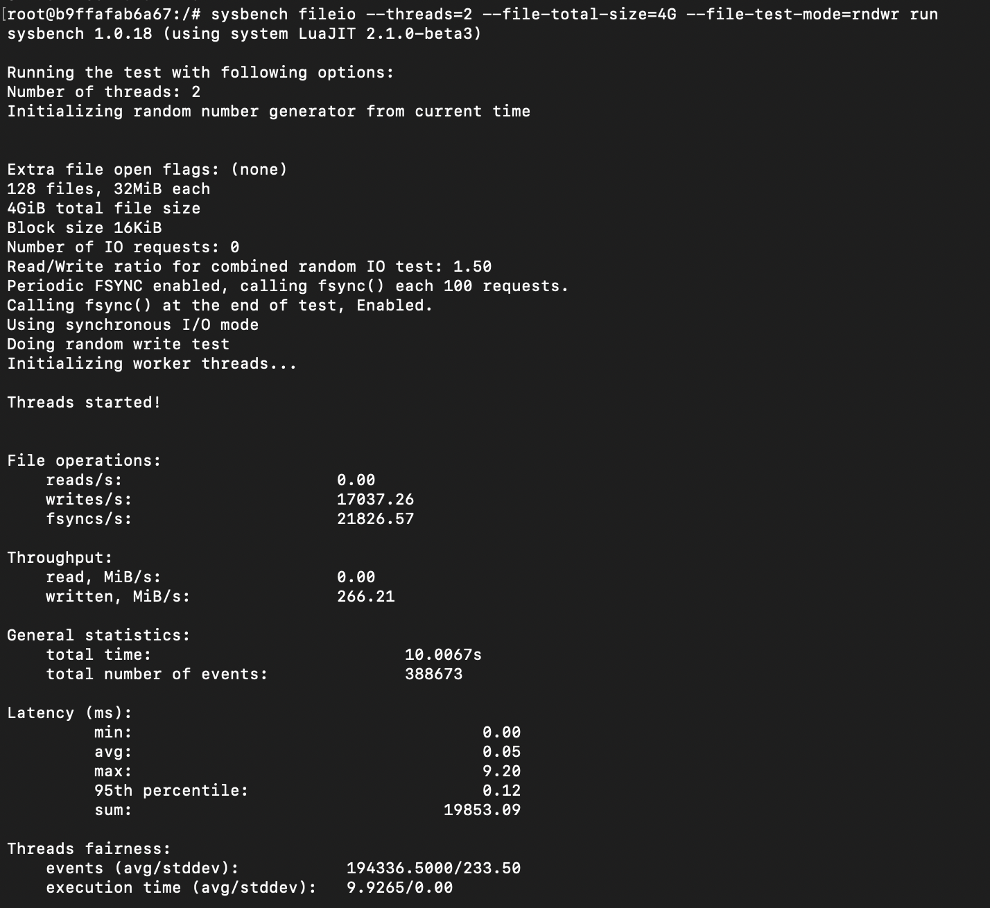

**Memory test**

Command - sysbench memory --memory-block-size=16M run

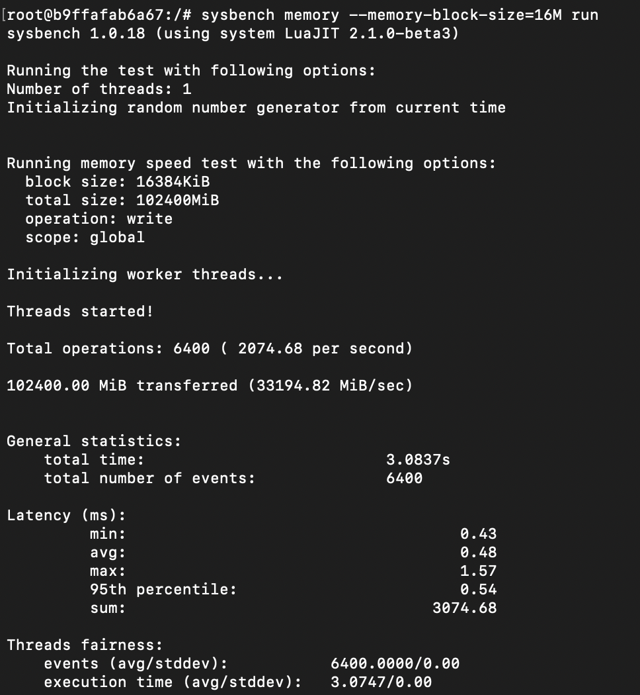

Command - sysbench memory --memory-block-size=32M run

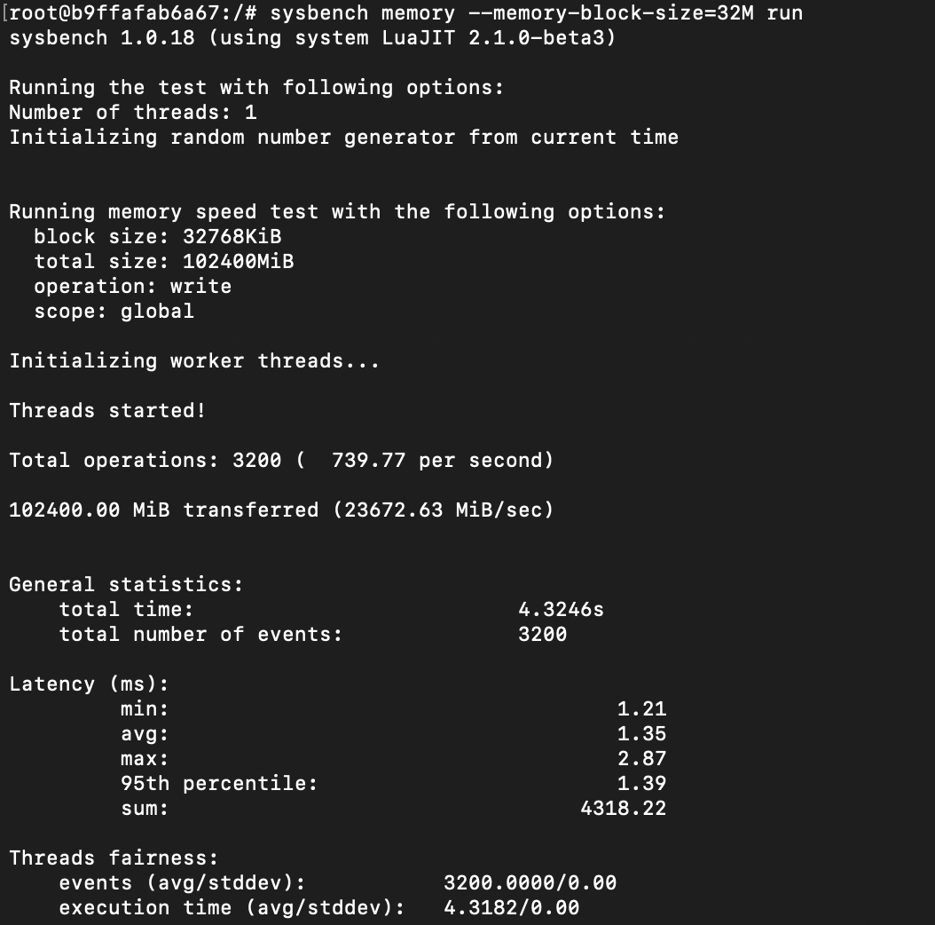

**Cpu - 4 cores**

**Ram – 2gb**

**CPU test**

Command - sysbench cpu --threads=2 --cpu-max-prime=10000 --time=10 run

Max prime = 10000

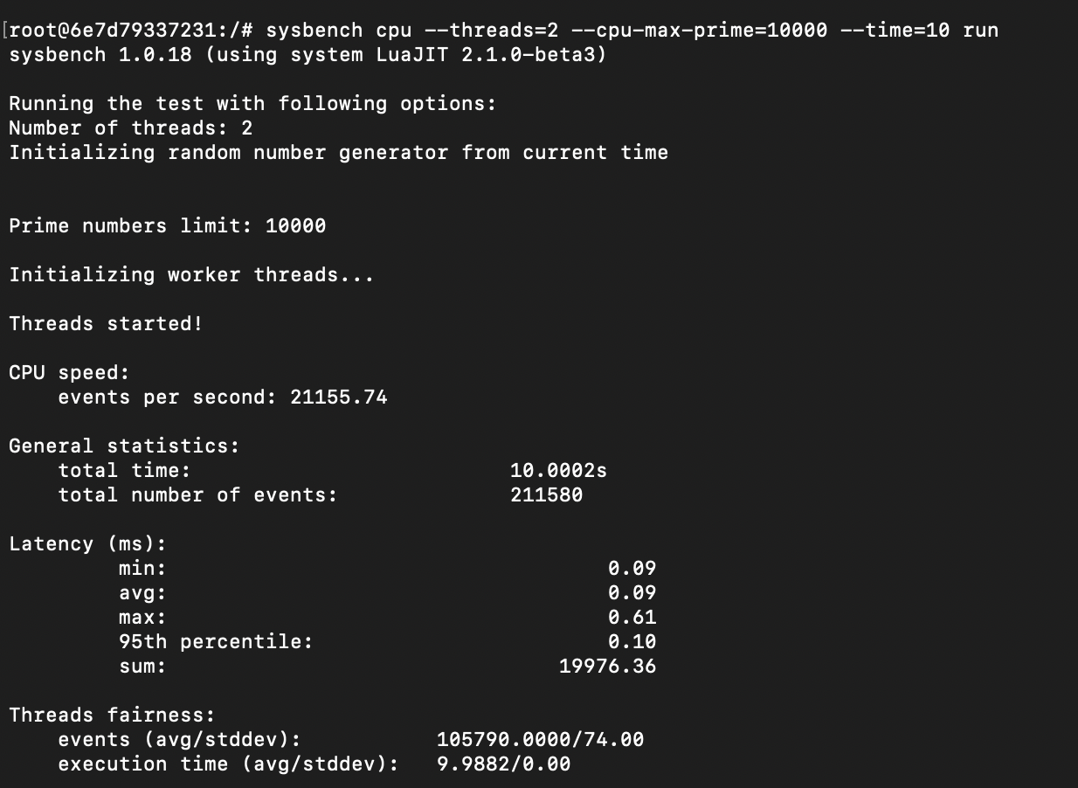

Command - sysbench cpu --threads=2 --cpu-max-prime=1000000 --time=48 run

Max prime = 1000000

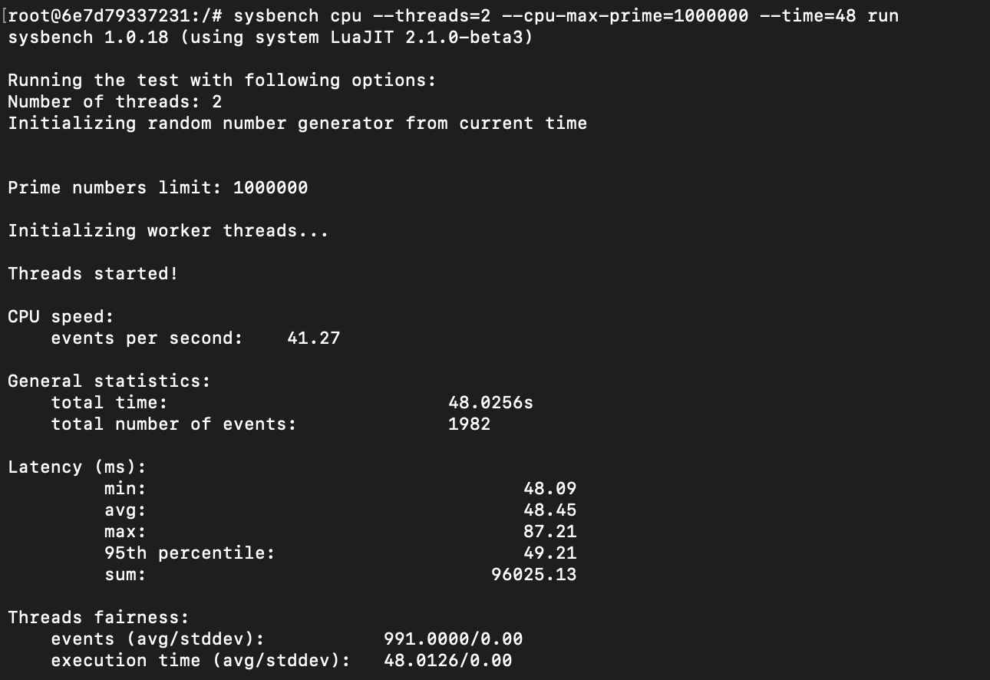

**File I/O test**

Prepare command –

sysbench fileio --threads=1 --file-total-size=2G --file-test-mode=rndwr prepare

Run command –

sysbench fileio --threads=1 --file-total-size=2G --file-test-mode=rndwr run

Cleanup Command –

sysbench fileio --threads=1 --file-total-size=2G --file-test-mode=rndwr cleanup

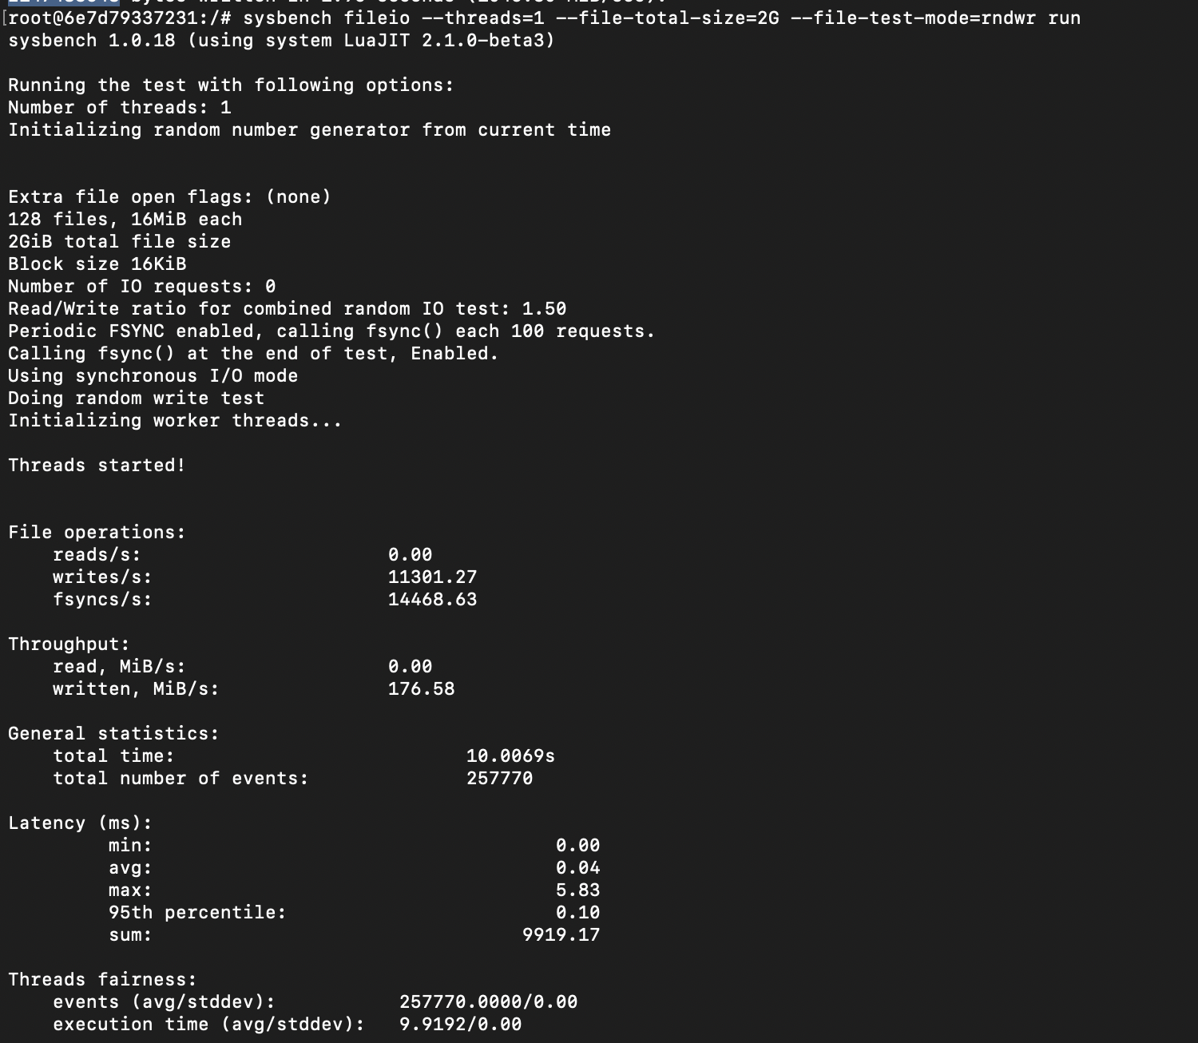

Prepare command –

sysbench fileio --threads=2 --file-total-size=4G --file-test-mode=rndwr prepare

Run command –

sysbench fileio --threads=2 --file-total-size=4G --file-test-mode=rndwr run

Cleanup Command –

sysbench fileio --threads=2 --file-total-size=4G --file-test-mode=rndwr cleanup

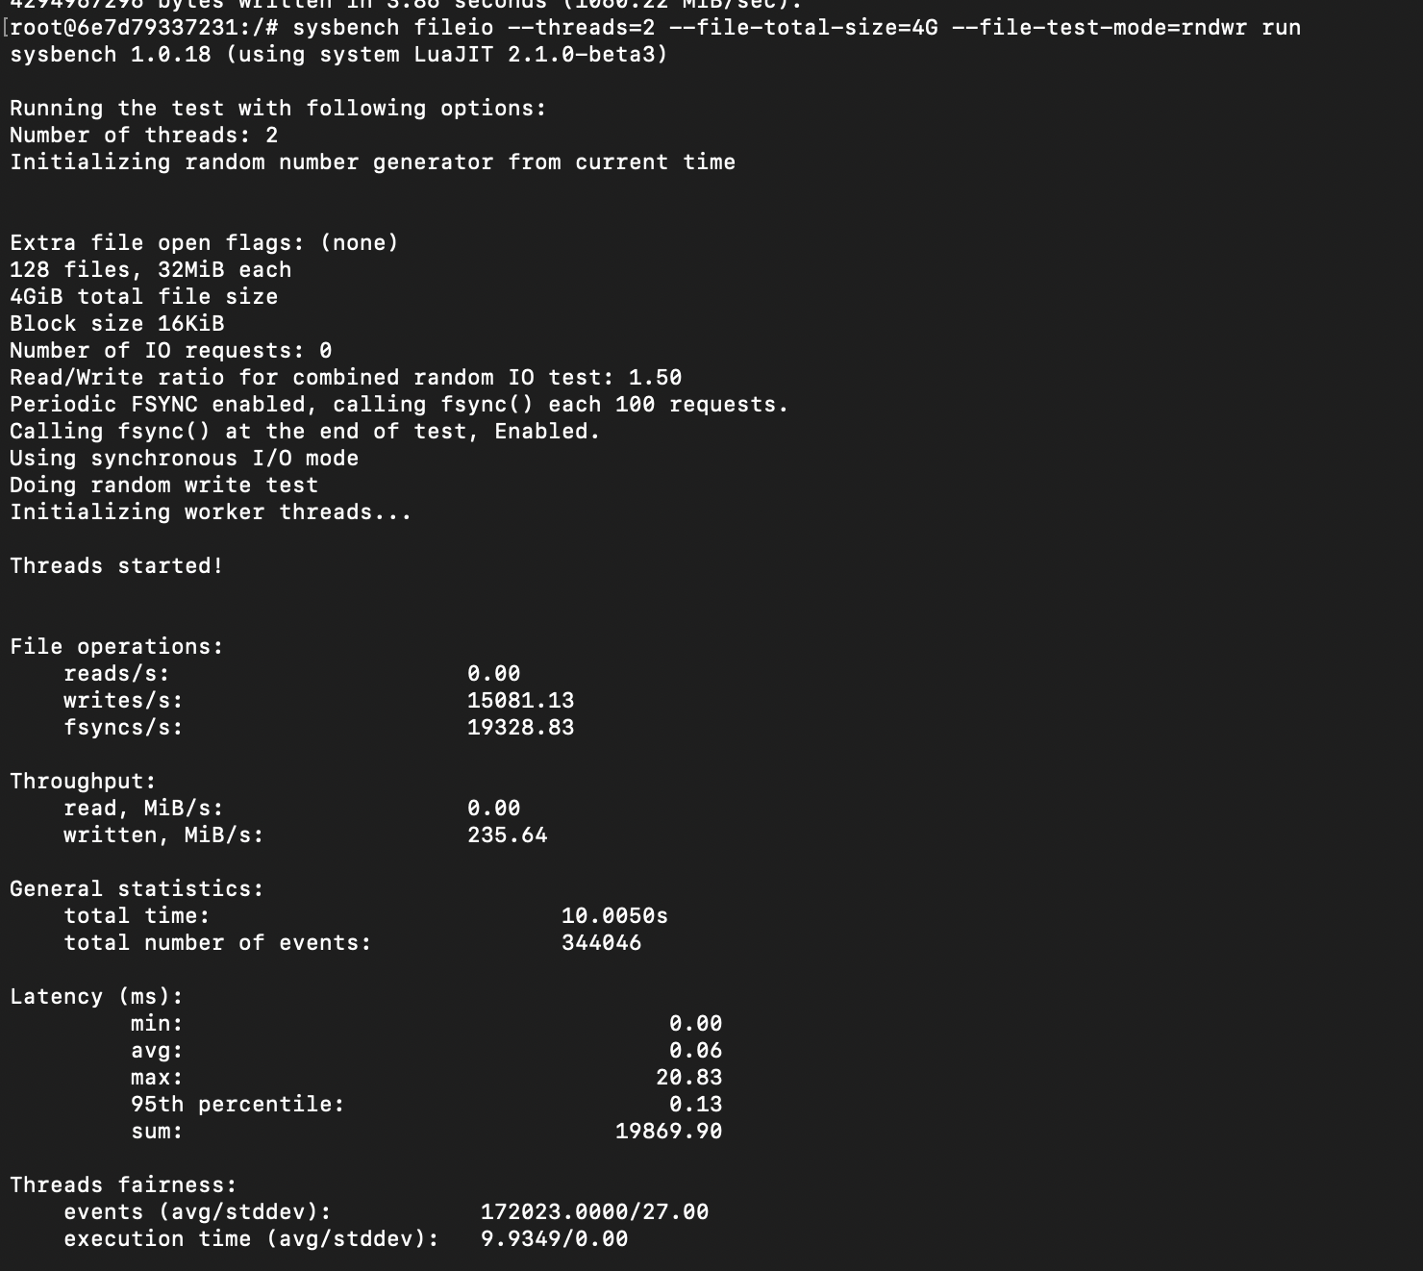

**Memory test**

Command - sysbench memory --memory-block-size=16M run

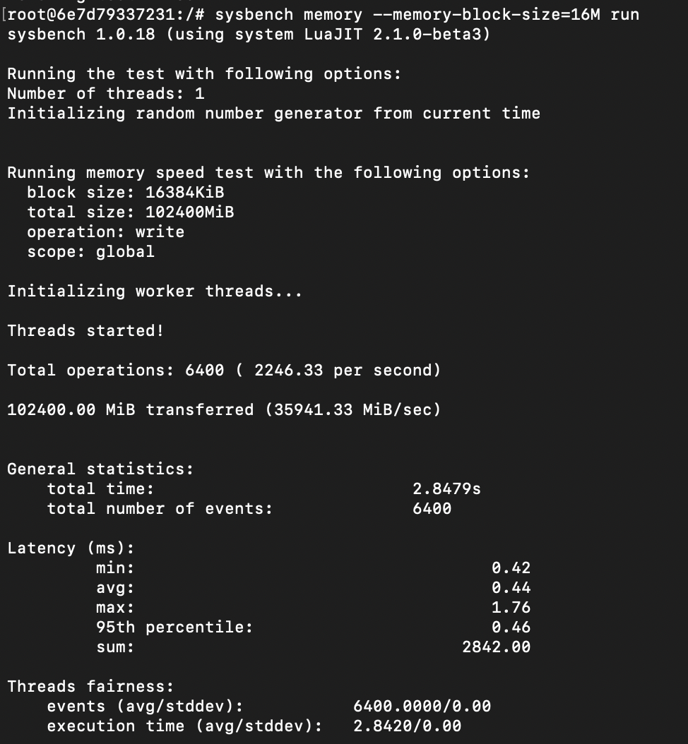

sysbench memory --memory-block-size=32M run

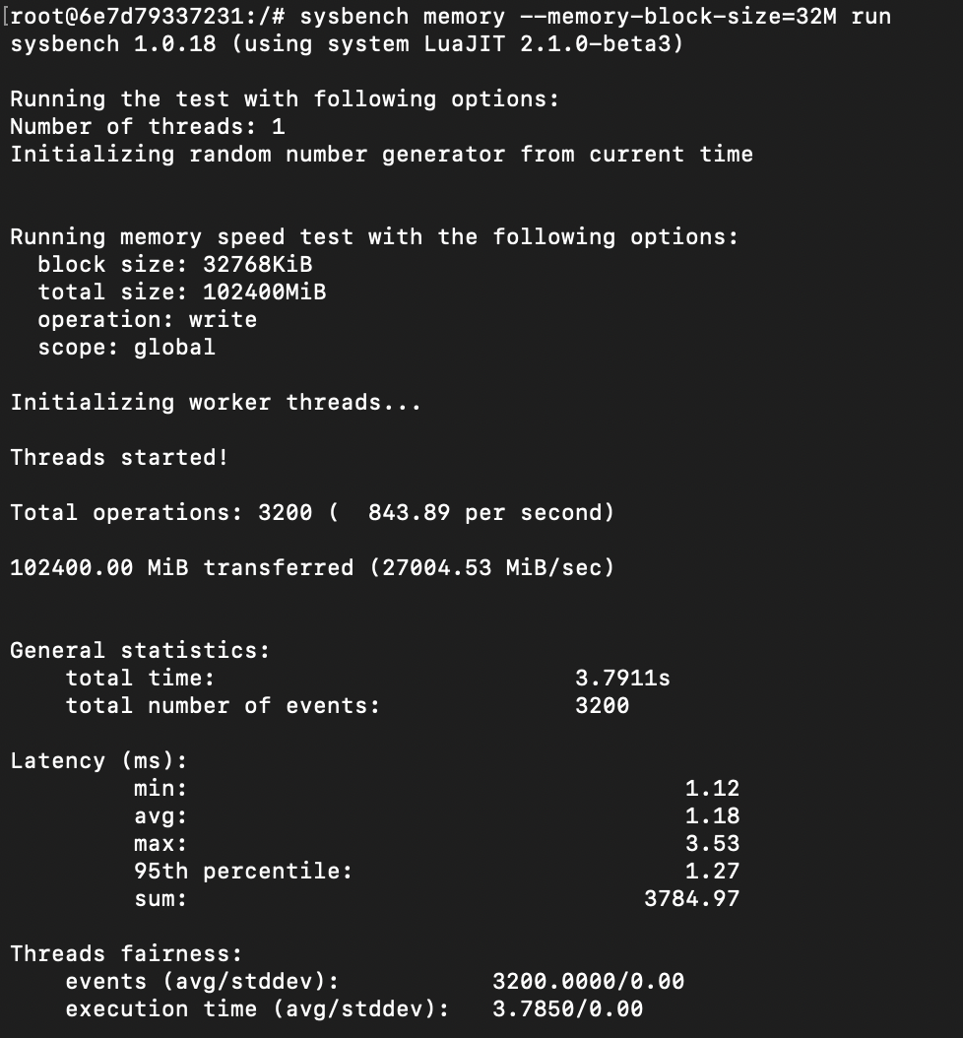

**Cpu - 4 cores**

**Ram – 1gb**

**CPU test**

Command - sysbench cpu --threads=2 --cpu-max-prime=10000 --time=10 run

Max prime = 10000

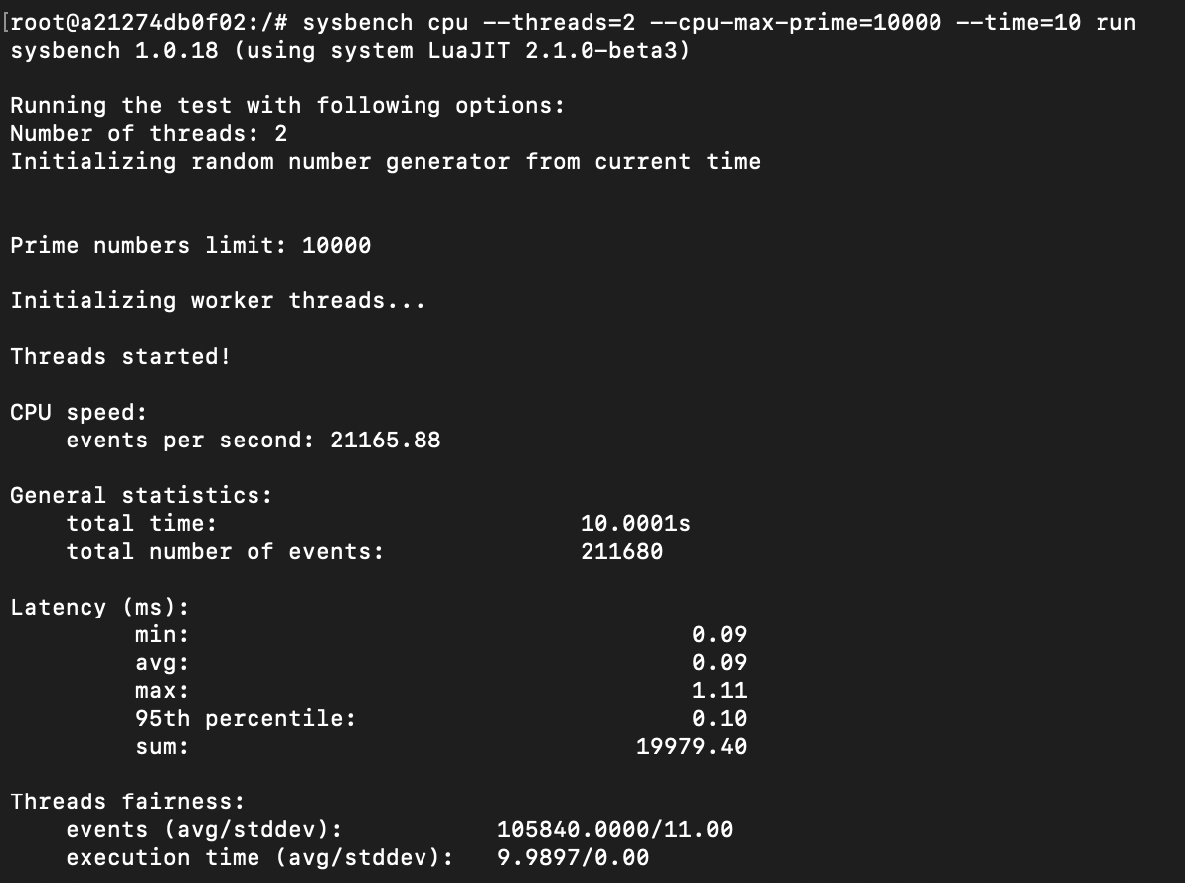

Command - sysbench cpu --threads=2 --cpu-max-prime=1000000 --time=48 run

Max prime = 1000000

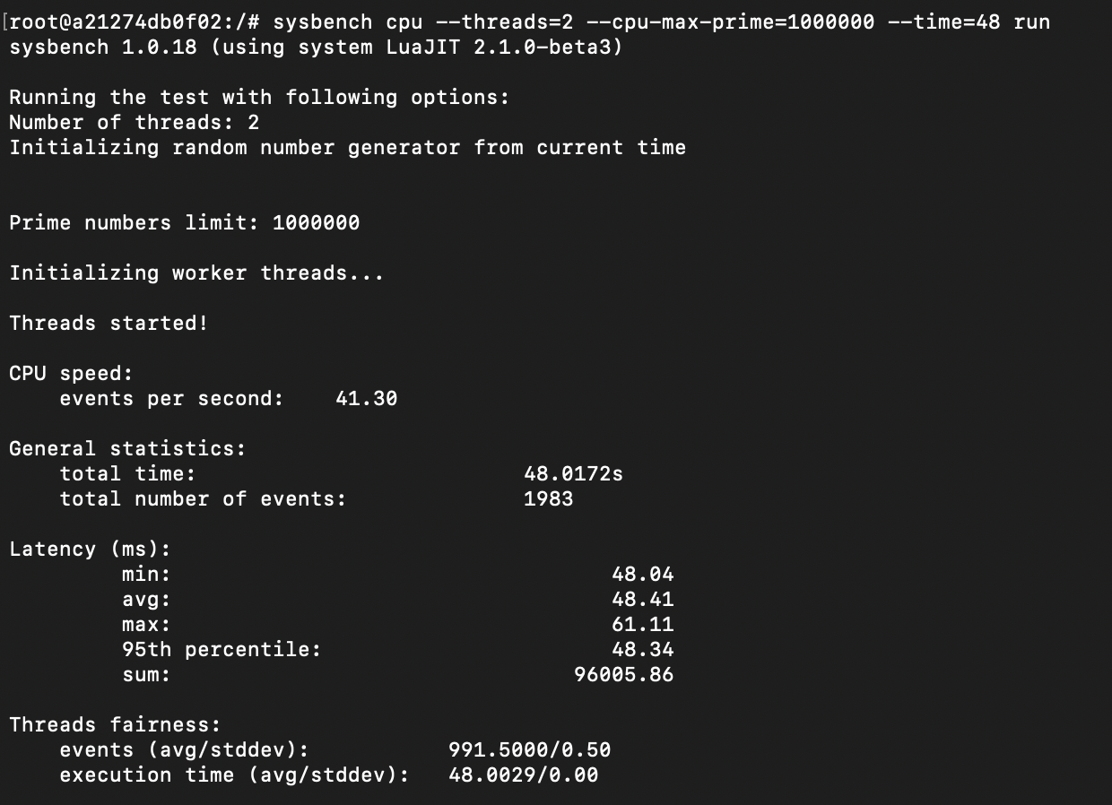

**File I/O test**

Prepare command –

sysbench fileio --threads=1 --file-total-size=2G --file-test-mode=rndwr prepare

Run command –

sysbench fileio --threads=1 --file-total-size=2G --file-test-mode=rndwr run

Cleanup Command –

sysbench fileio --threads=1 --file-total-size=2G --file-test-mode=rndwr cleanup

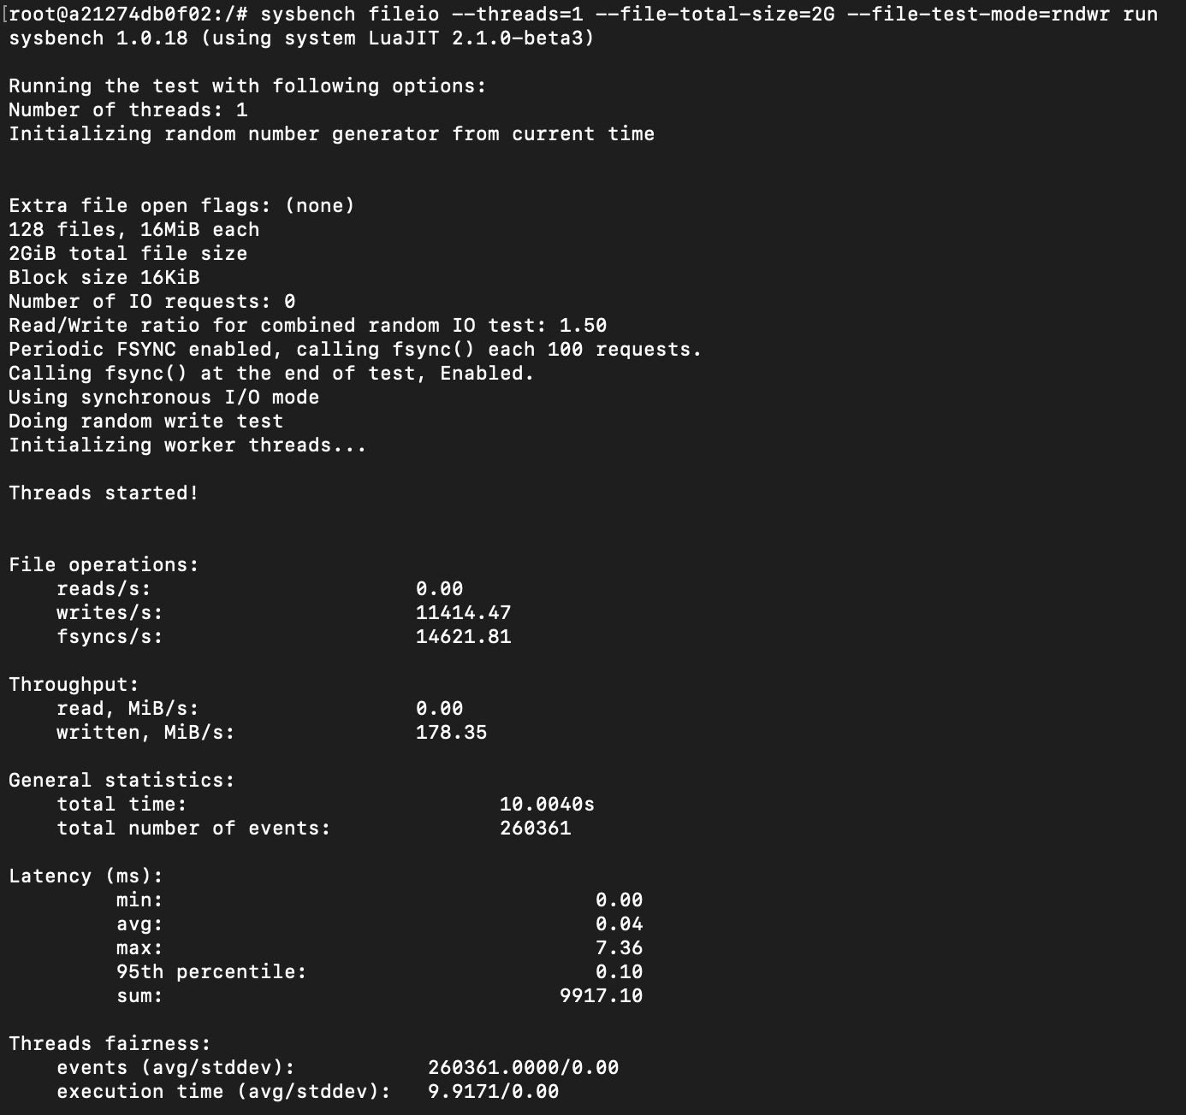

Prepare command –

sysbench fileio --threads=2 --file-total-size=4G --file-test-mode=rndwr prepare

Run command –

sysbench fileio --threads=2 --file-total-size=4G --file-test-mode=rndwr run

Cleanup Command –

sysbench fileio --threads=2 --file-total-size=4G --file-test-mode=rndwr cleanup

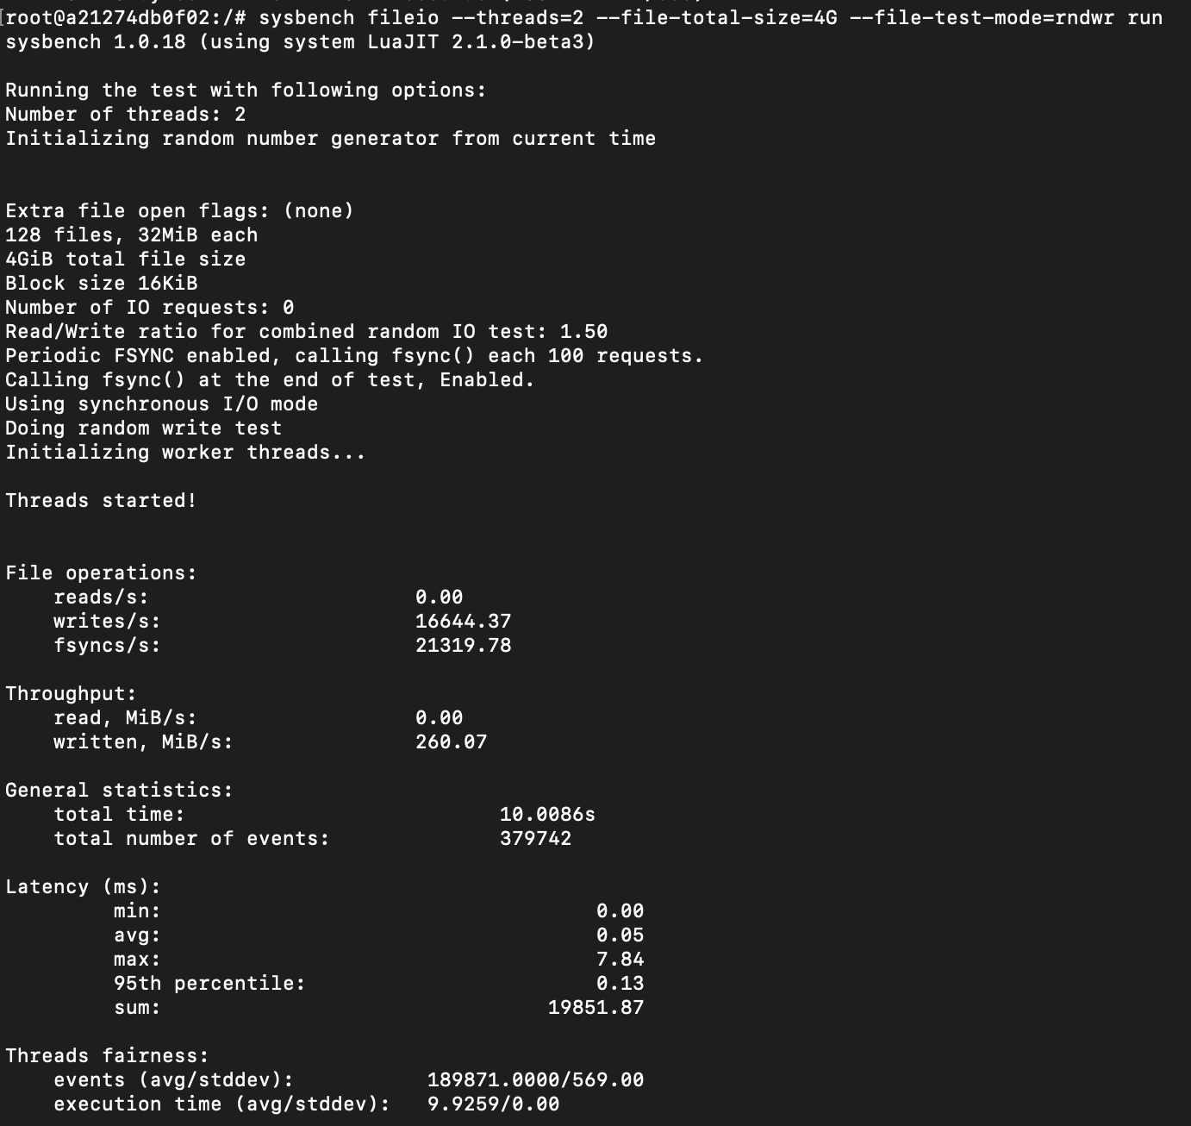

**Memory test**

Command - sysbench memory --memory-block-size=16M run

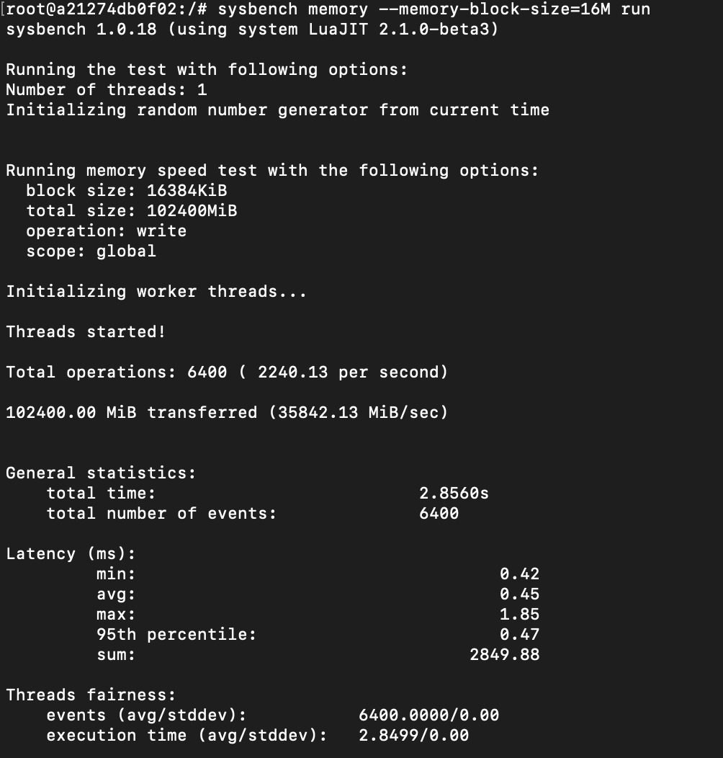

sysbench memory --memory-block-size=32M run

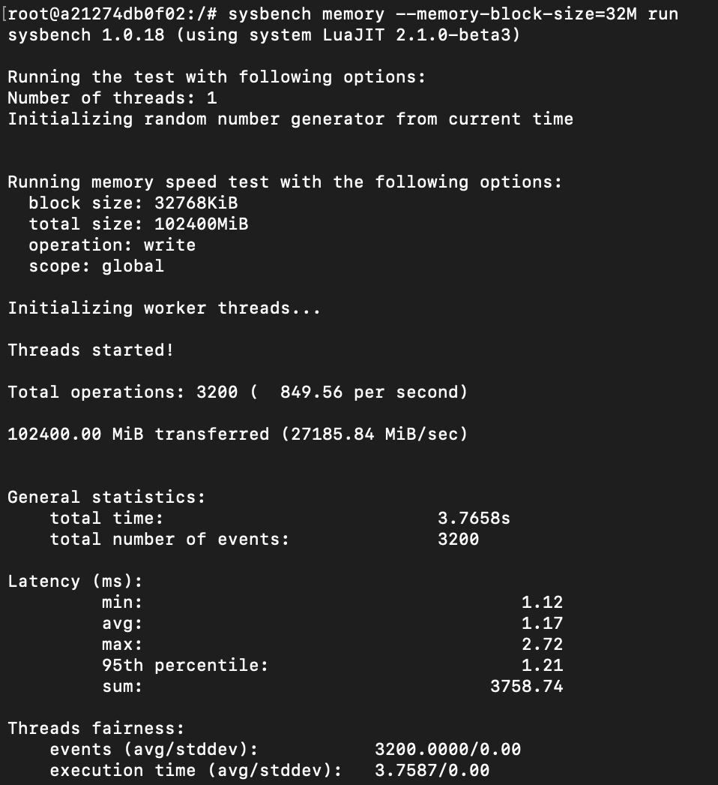

**Cpu - 2 cores**

**Ram – 1gb**

**CPU test**

Command - sysbench cpu --threads=2 --cpu-max-prime=10000 --time=10 run

Max prime = 10000

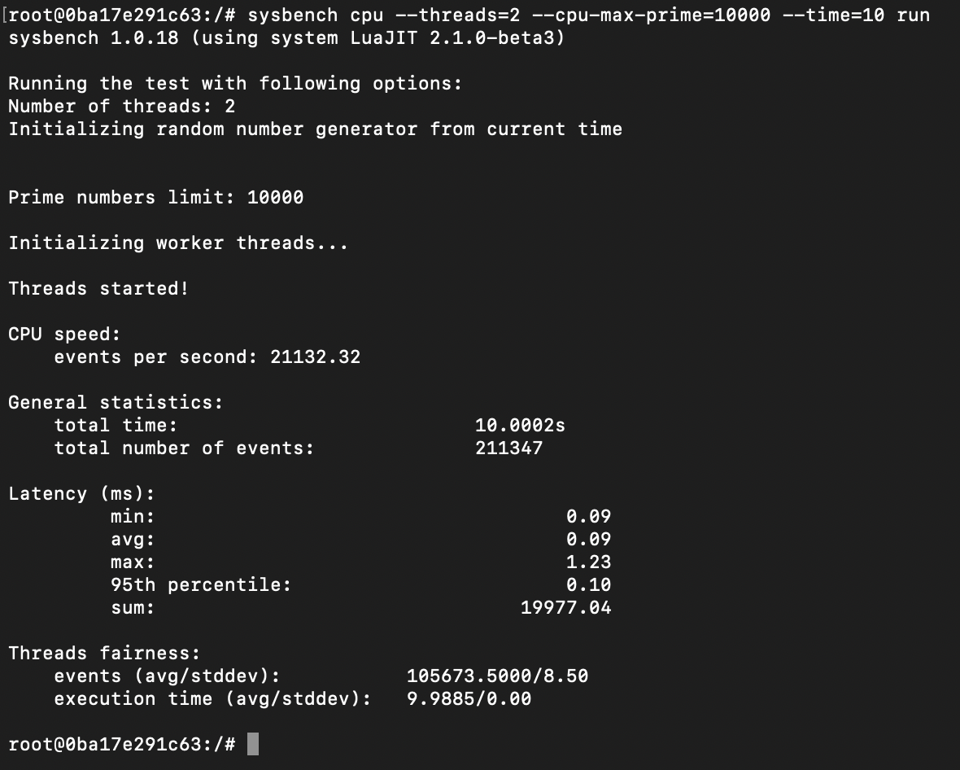

Command - sysbench cpu --threads=2 --cpu-max-prime=1000000 --time=48 run

Max prime = 1000000

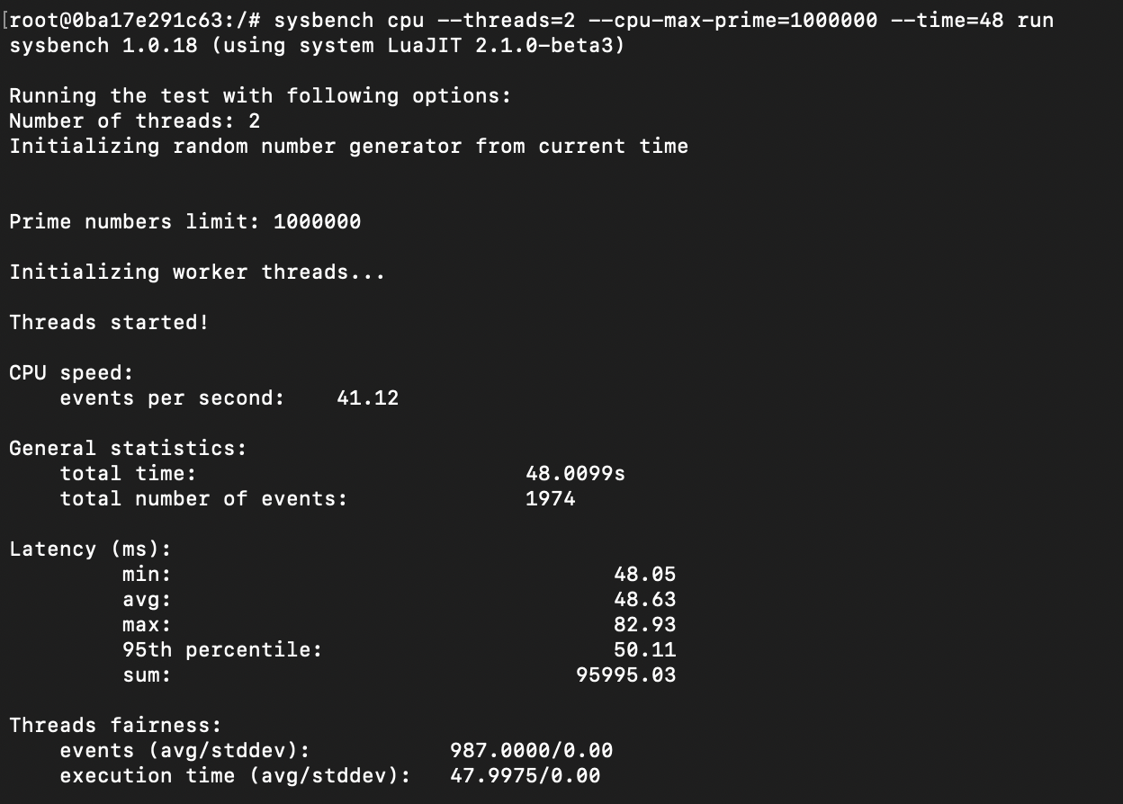

**File I/O test**

Prepare command –

sysbench fileio --threads=1 --file-total-size=2G --file-test-mode=rndwr prepare

Run command –

sysbench fileio --threads=1 --file-total-size=2G --file-test-mode=rndwr run

Cleanup Command –

sysbench fileio --threads=1 --file-total-size=2G --file-test-mode=rndwr cleanup

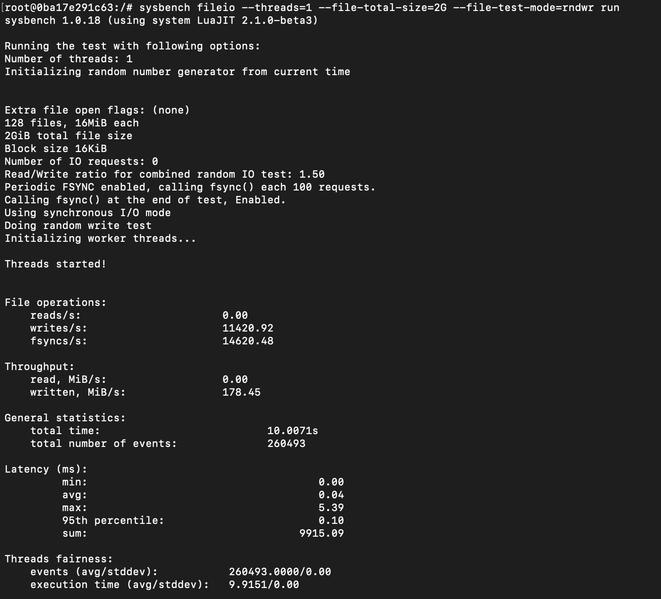

Prepare command –

sysbench fileio --threads=2 --file-total-size=4G --file-test-mode=rndwr prepare

Run command –

sysbench fileio --threads=2 --file-total-size=4G --file-test-mode=rndwr run

Cleanup Command –

sysbench fileio --threads=2 --file-total-size=4G --file-test-mode=rndwr cleanup

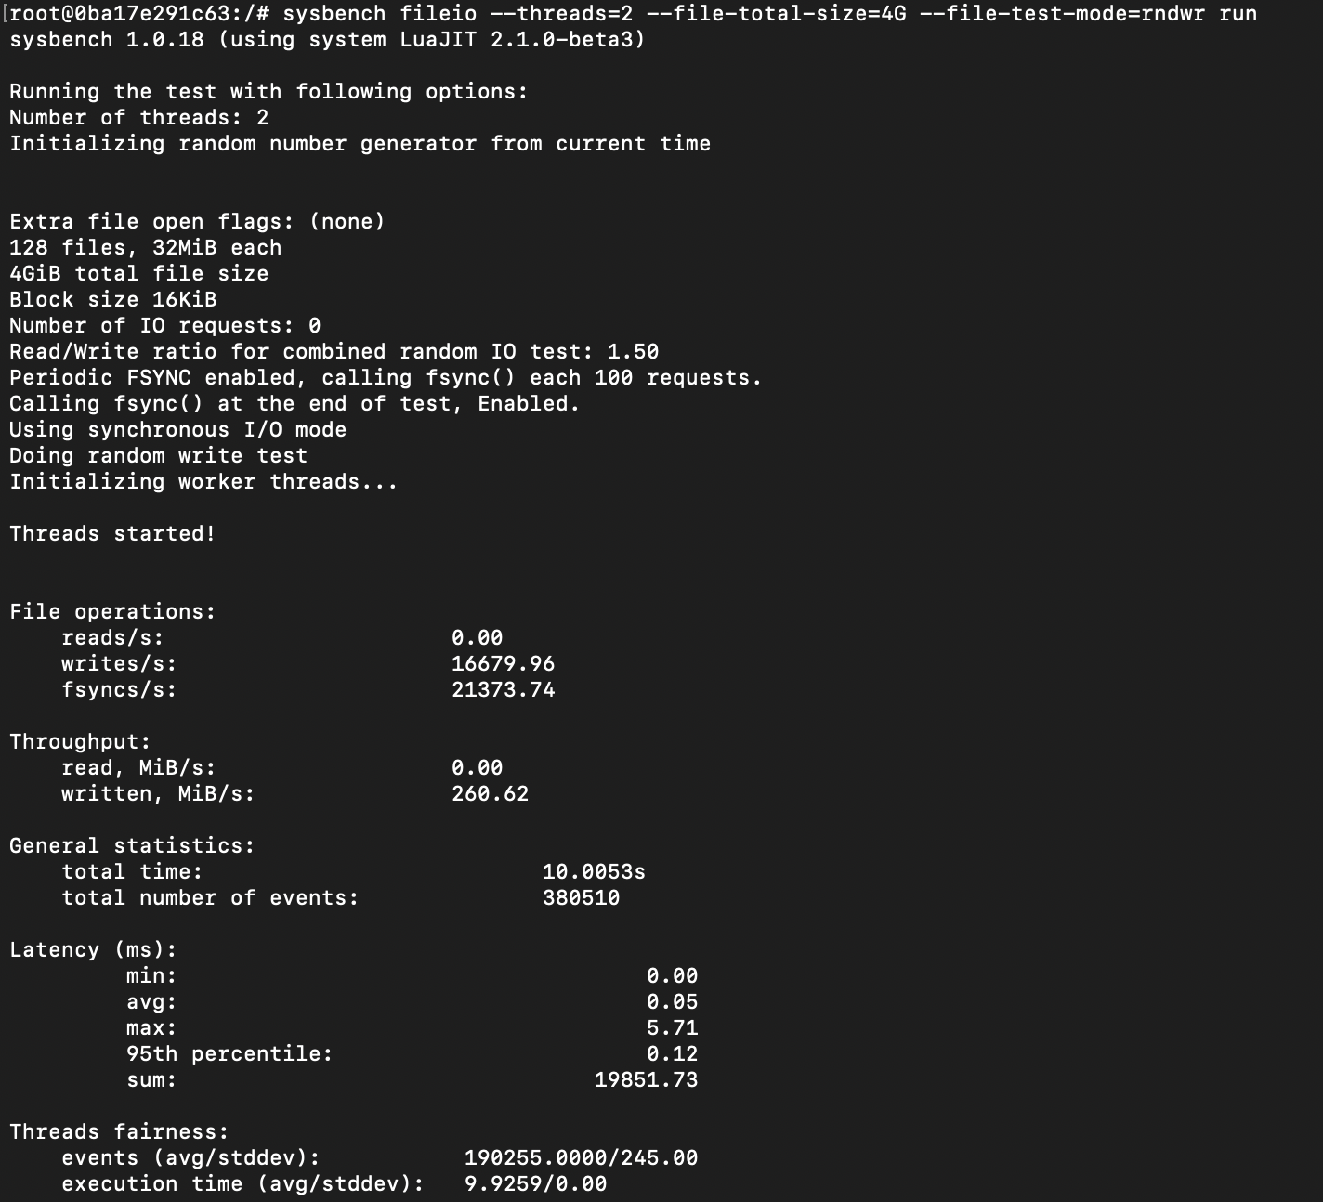

**Memory test**

Command - sysbench memory --memory-block-size=16M run

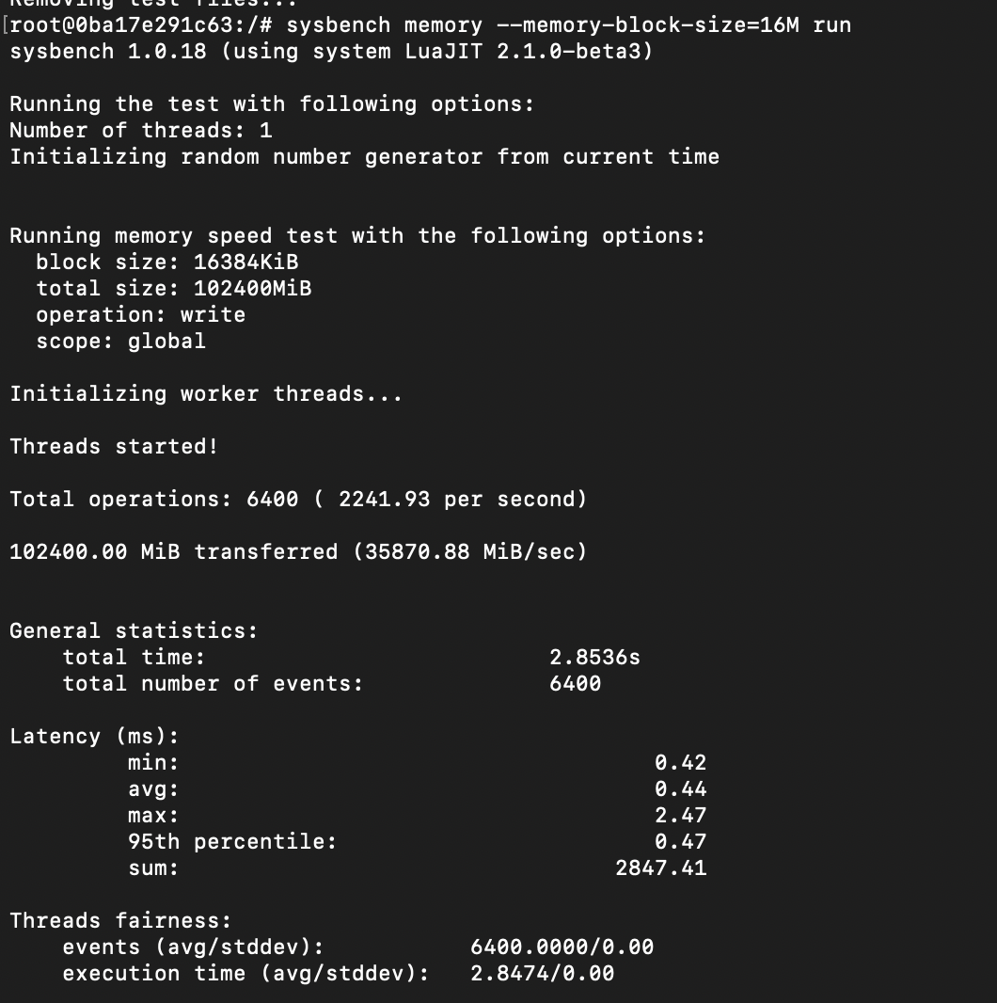

sysbench memory --memory-block-size=32M run

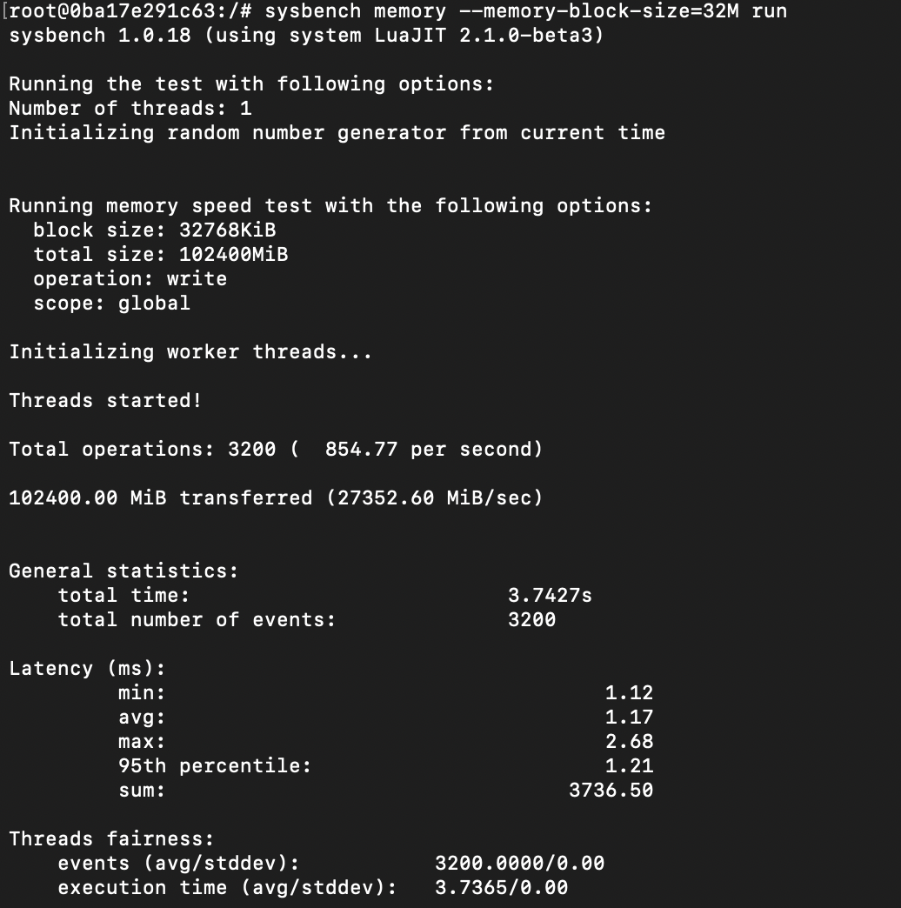

**Analysis of Results**

**CPU Test**:

The following factors are considered when running the CPU test:

a. --cpu-max-prime: This setting determines the highest prime number that the CPU tests will look for.

b. --time: This parameter determines the test's overall duration in seconds.

c. --threads: This setting determines how many parallel threads will be used during the test in order to determine the average, min, max, and standard values of the results, the experiment involves changing the values of the above mentioned parameters and executing each test case three times.